Map Creation Document
The map creation process is a multi-task, multi-person undertaking for Atomic Games. It is about 66% of the artwork that is created (in man-hours). This is a brief look at the process used in the creation of maps for “Close Combat III: The Russian Front”.
First we started with a map created by our historian. This map is either an actual battlefield, or a composite of terrain that is representative of where and when the operation was fought. This map will show placement for all major terrain features; rivers, buildings, roads, etc. Also, elevation contours show us the 3D “shape” of the map features.
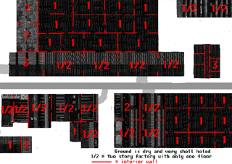
From this one artist will begin the creation of the ground. Basically, anything that has no significant height (except trees) is drawn in 2D.
Simultaneously, another artist will begin the creation of the 3D objects. For buildings with roofs, two separate images are created. This shows both buildings with roofs and interiors of those buildings. These have either been pre-made, prior to this map, or uniquely created for this map. These buildings are rendered (with an alpha channel) and then composited, with their shadows, onto the 2D terrain.
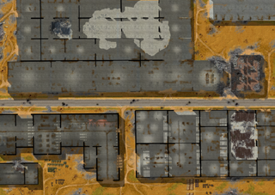

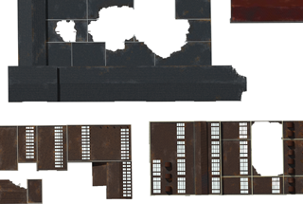

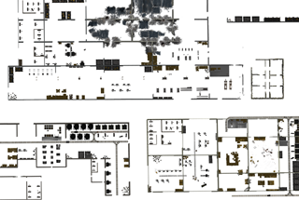
At this time an elevation map (grayscale image) is also produced. This map shows all the shadows created by depressions and hills, and also highlights for crests and the tops of riverbanks. Selections are used from this image to place on the map to show the player the height of terrain features.
Trees are now placed. We only place the shadows, the actual treetops are like sprites and can pop on and off. The shadow image contains information regarding which tree to place at the correct point.
The next step is the creation of all the 2D blending and creation of the fine details, the polishing of the maps. This includes first the blending of the 3D objects into the terrain. Finally, adding the hundreds of details that cannot readily be created in 3D, that goes into making the maps look alive.
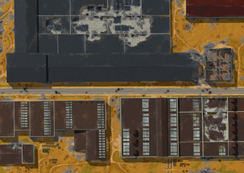
The last step is the creation of translating the artwork into a format that the game engine can understand. This requires the conversion of all the maps into underlying elements and heights. We utilize a proprietary tool for this process.

