The Main Screen
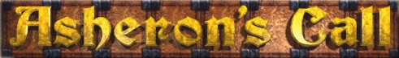
How to Play
Copyright © 1998 Turbine Entertainment Software Corporation
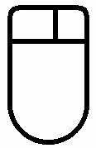
Using The Mouse

Left Button
Normal Use:
Click to select items.
Double-click to use items.
Drag items OFF the View Window to pick them up.
Drag items ONTO the View Window to put them down.
Right Button
Right-Click IN THE VIEW WINDOW
to move (see below).

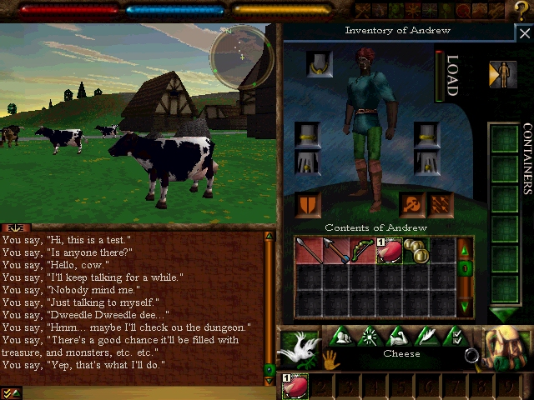
(Health)
(Stamina)

Using Items
• Click on items to select them.
• Drag items from the View Window to pick them up.
• Drag items to the View Window to put them down.
• Double-click on items to use them. (Some need to be picked up first.)

(Radar)
Close Panel

(View Window)

Entering Combat
To Attack Enemies:
• Enter Combat Mode via the Combat Mode Icon or Key.
• Click once to select a target.
• With a target selected,
• Click ANYWHERE other than on selectable items to attack.
• Click AND DRAG to attack at different heights.
• Click AND HOLD to attack with more power.
(Inventory Panel)

Shrink
/ Extend Chat Log

Mouse Movement Zones
Right-click in these parts of the View Window to move in different directions.

Inventory Panel / Backpack
Enter / Exit Combat Mode
Skills Panel
Options Panel
(Chat Log)
Social (disabled)
Magic (disabled)
Map Panel

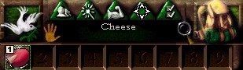

(Selected Item Display)
(Use Item)
Forward and left
Forward
Forward and right
(Examine Item)

Chat Box
Click here or press Enter to enter chat mode.
Then type, and press Enter to "say" your message.
Type "@tell <character>, <message>" to send private chat.
(This costs 10 stamina points over long distances.)
Also try typing emotes like *wave* and *bow*.
(Item Shortcuts – drag commonly-used items here to make "shortcuts" to them.)
Turn left
Stop
Turn right

Chat Menu
Click here for more options.

FOR FULL SCREEN MODE...
Select the currently open panel again to close it.
Sidestep left
Backward
Sidestep right

Keyboard Controls

`
toggle combat mode

1
use shortcut 1

2
use shortcut 2

3
use shortcut 3

4
use shortcut 4

5
use shortcut 5

6
use shortcut 6

7
use shortcut 7

ESC
cancel / options panel

F9
raise camera

F10
move camera back

F11
move camera forward

F12
wave

8
use shortcut 8

9
use shortcut 9

0
create shortcut

-
select previous creature

=
select next creature

BACKSPACE
select closest creature

-
attack
high

Num lock

/
mouse look

*
look
down

F1

F2
reset view

F3
move camera

F4
look down

F5
mouse look

F6
spin camera left

F7
spin camera right

F8
lower camera

TAB
leave / resume chat mode

Q

W
move forward

E
examine item

R

T
split selected item

Y

U
use
item

I

O

P
select previous selection

[
select previous item

]
select next
item

\
select closest item

A
turn left

S
stand

D
turn right

F

G
lie down

H
sit down

J
crouch

K
stand

L
attack
low

;
attack medium

'
attack high

ENTER
enter chat mode / send chat message

CAPS LOCK

Z
sidestep left

X
move backward

C
sidestep right

V

B
place item in backpack

N

M
map
view

,

.

/
mouse look

SHIFT
hold this to run

SHIFT
hold this to run

CTRL





CTRL

SPACE
jump

ALT
hold this to sidestep



ALT
hold this to sidestep

↑
move forward

Enter
attack
low

←
turn left

↓
move backward

→
turn right

7

8
move forward

9

4
turn left

5
stand

6
turn right

1
sidestep left

2
move backward

3
sidestep right

0
jump

+
attack
medium

.

Special Keys:

Ctrl-Space
Refresh screen (use in case of interface "glitches")

Shift-ESC
Logout immediately
Enter in Chat Box:

@location
Show/hide location

@framerate
Show/hide frame rate

@throughput
Show/hide throughput

@version
Show Version info

@stuck
Emergency measure if “stuck” in place or in mid-air. (May not always work.)

Move with these
Fight with these (in combat mode)
Enter/Exit Combat Mode
Also move with these
Valid Chat Poses
*akimbo* *angry* *applause*
*bcingu* *beckon* *big laugh*
*bow* *clap* *cringe*
*cry* *drink* *eat*
*grovel* *heroic* *kiss*
*kneel* *laugh* *nod*
*plead* *point* *sad*
*salute* *scratch head*
*shake fist* *shake head*
*shiver* *shoo* *shrug*
*slouch* *smack head*
*spit* *stop* *stretch*
*surrender* *tap foot*
*wave high* *wave low*
*wave* *winded* *yawn*

