Historical Images from the Microsoft Museum Collection
Contact: museum@microsoft.com
Compiled 4/2000

File name: Lakeside.jpg
Paul Allen and Bill Gates at an ASR-33 teletype in the computer room at Lakeside School, Seattle, WA, ca. 1968. (Museum item #3)

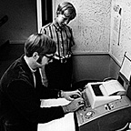

File name: popularelectronics.jpg
The January 1975 issue of Popular Electronics magazine featured the Altair 8800. The article about the Altair inspired Bill Gates and Paul Allen to develop a BASIC Interpreter for the Altair. (Museum item #2169)

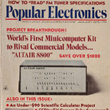

File name: altairwithbasictape.jpg
Altair 8800 minicomputer with computer punch tape; first manufactured in 1975. (Museum item # 48)

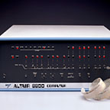

File name: basictape.jpg
Paper tape, the main storage medium at the time, with Bill Gates’ and Paul Allen’s first program on it – a BASIC language for the MITS Altair.
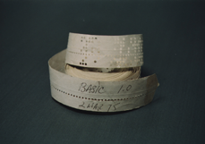

File name: albuquerquegroup.jpg
The Albuquerque group, taken December 7, 1978: top row: Steve Wood, Bob Wallace, Jim Lane. Second row: Bob O’Rear, Bob Greenberg, Marc McDonald, Gordon Letwin. Front row: Bill Gates Andrea Lewis, Marla Wood, Paul Allen. Formal portrait of Microsoft employees before the company moved to Bellevue, WA. Rick Weiland and Miriam Lubow were not present for the photo. (Museum item # 62)

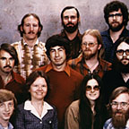

File name: Msdosad.jpg
Advertisement for MS-DOS 1.0, ca. 1981-1983. (Museum #291)

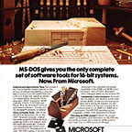

File name: Gatesandallen.jpg
Microsoft co-founders Paul Allen and Bill Gates surrounded by personal computers, shortly after signing a major contract with IBM to write software for their line of personal computers. This image is featured in the Seattle Business Journal’s October 19, 1981 article, “Building on success, Microsoft owners shoot for $100 million target.” (Museum item #45)

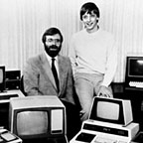

File name: billandsteve.jpg
Steve Ballmer and Bill Gates, ca. 1983 (Museum item #1794)

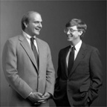

File name: Wordwithmouse.jpg
Advertisement for Word 1.0 for MS-DOS featuring the Green Eyed Mouse, ca. 1984. (Museum item #1666)

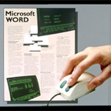

File name: ibmpc.jpg
IBM PC running Microsoft Word for MS-DOS, ca. 1983. (Museum item # 1652)

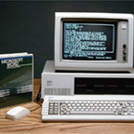

File name: excelformac.jpg
Excel 1.0 for Macintosh, screen shot, ca. 1985. (Museum item #3211)

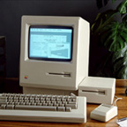

File name: tenthanniversary.jpg
In August 1985, Microsoft celebrates its 10th anniversary. This poster commemorates the company’s achievements and culture. Microsoft has $40 million in revenue and 900 employees. (Museum item # 58)

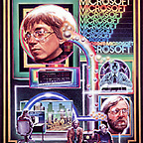

File name: Windows1box.jpg
Windows 1.0 for MS-DOS box shot. Shipped November 1985. (Museum item #47)

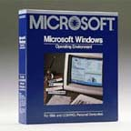

File name: campus.jpg
Aerial view of the Redmond Campus, ca. August 1989. (Museum item #727)

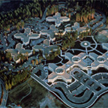

File name: Windows3.jpg
Poster advertising Windows 3.0, ca. 1990. (Museum item #108)

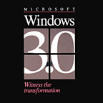

File name: officebox.jpg
Office 1.0 for Windows box shot, ca. 1990. (Museum item #407)

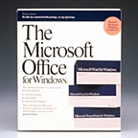

File name: excel3.jpg
Excel for Windows 3.0 box shot, 1991. (Museum item #59)

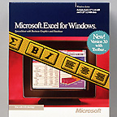

File name: windowsntbox.jpg
Windows NT 3.1 box shot, ca. 1993. (Museum item #244)

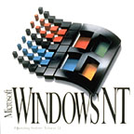

File name: Windows95box.jpg
Windows 95 Upgrade box shot, ca. 1995. (Museum item #398)

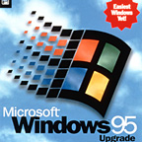

File name: Windows95launch.jpg
Bill Gates on stage at the Windows 95 Launch, held on the Redmond campus, August 24, 1995. (Museum item #2562)

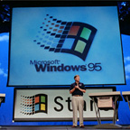

File name: Win95launch.jpg
Brad Silverberg and Bill Gates on stage at the presentation for the Windows 95 Launch, held on August 24, 1995. (MicroNews August 25, 1995). (Museum item # 686)

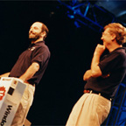

File name: Internetstrategyday.jpg
Nathan Myhrvold, Pete Higgins, Bill Gates, and Paul Maritz on stage at the Internet Strategy Workshop, held at the Seattle Center, December 7, 1995. (MicroNews December 15, 1995). At the Internet Strategy Workshop, held at the Seattle Center on December 7, 1995, Bill Gates outlined Microsoft`s wide-ranging commitment to supporting and enhancing the Internet by integrating the PC platform with the public network. Gates noted that businesses will adopt the Internet for internal business use-`the Intranet`-for communication with employees, suppliers, and customers, and Intranet applications will likely emerge faster than those for the general consumer market. (Museum item #619)

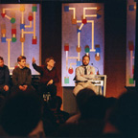

File name: Windows20001box.jpg
Windows 2000 box shot. Shipped February 2000.

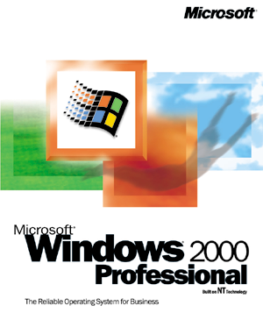

File name: windows2000box.jpg
Windows 2000 box shot. Shipped February 2000

