DAN’S EARTHSCAPE

Dan’s Earthscape

Landscaping Services
58978 Hawthorne Avenue
San Diego, California 92056
Tel: (760) 555-1212 Fax: (760) 555-1213
E-mail: dan-earthscape@earthscape.com
www.companyname.com
2003
DOM | LUN | MAR | MIER | JUE | VIE | SAB
 |  | 1 | 2 | 3 | 4 | 5
6 | 7 | 8 | 9 | 10 | 11 | 12
13 | 14 | 15 | 16 | 17 | 18 | 19
20 | 21 | 22 | 23 | 24 | 25 | 26
27 | 28 | 29 | 30 | 31

JULIO

AUGOSTO
DOM | LUN | MAR | MIER | JUE | VIE | SAB
 | 1 | 2 | 3 | 4 | 5 | 6
7 | 8 | 9 | 10 | 11 | 12 | 13
14 | 15 | 16 | 17 | 18 | 19 | 20
21 | 22 | 23 | 24 | 25 | 26 | 27
28 | 29 | 30

SEPTIEMBRE

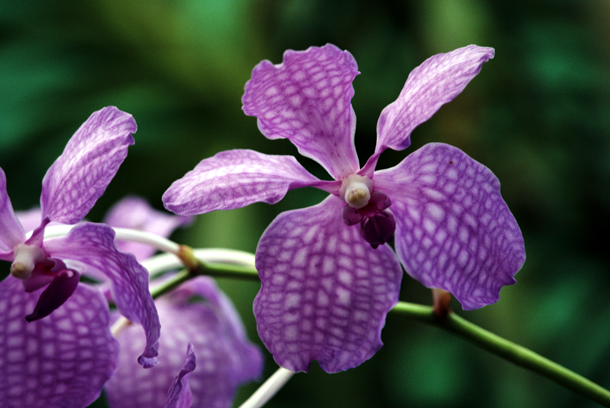
DOM | LUN | MAR | MIER | JUE | VIE | SAB
 |  |  |  |  | 1 | 2
3 | 4 | 5 | 6 | 7 | 8 | 9
10 | 11 | 12 | 13 | 14 | 15 | 16
17 | 18 | 19 | 20 | 21 | 22 | 23
24 | 25 | 26 | 27 | 28 | 29 | 30
31

