Urban Eco System Project
Sharing Our Information

NEXT:
We will write a report of our findings for the Portland Audubon Society. We will also:
- Create a wiki that explains this data. Audubon will link their Web page to ours so people can learn about the results of our study.
- Create a newsletter explaining our results. Each student will be in charge of a section. We will send this as a press release to our local newspapers.
Urban Eco System Project: Apply classroom learning to the community

Community need:
Portland Audubon Wildlife Care Center needs our help!

The Situation:

The Wildlife Care Center is a hospital for injured birds and wildlife. For the last 5 years, the center has collected data on what is hurting urban wildlife. When a bird or mammal enters the center, the cause of injury is recorded.

The Problem:

The problem is, the staff is too busy caring for the animals to analyze their data and find out the main reasons for these injuries.

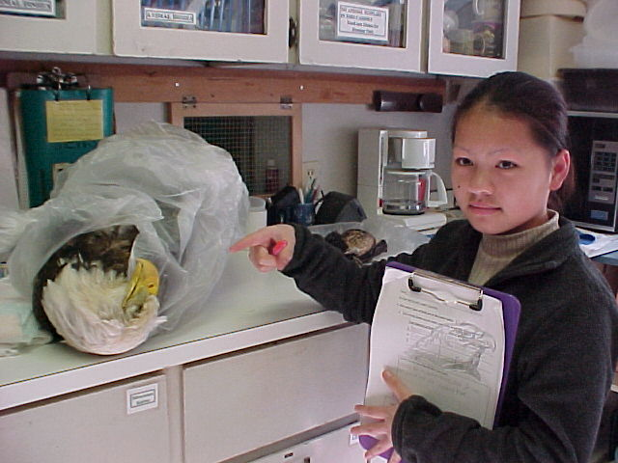
This eagle was killed by a power pole. What other ways do birds get injured?
Look inside to see how our class will help the Wildlife Care Center!
First Step:

- Field trip to Wildlife Care Center:
We will visit the hospital and learn
about its operations. We will see
some of the wildlife that is in the
center.

Next:
- Bob Salinger from the Wildlife Care Center will visit our school and give
us the information from his database. A visiting peregrine falcon will come with him. The falcon was hit by a car.

Learn New Technology:
- Ms. Carter will teach us how to use a spreadsheet.
- We will enter data on spreadsheets.
- We will graph the information as a
bar graph for the actual numbers
and as a pie chart for percentages.

OUR GRAPHS WILL SHOW THE MAJOR REASONS URBAN WILDLIFE ARE INJURED AND KILLED.

Our class will create a multimedia presentation. We will go out to the public and share our results with them.

Since George Middle School Students study graphs and computers… Since we study birds and wildlife in science… Since we are trained as scientists to analyze data…

We will:

- Use the data Audubon has col-lected for the last 5 years, enter it on a spreadsheet, graph the information, and help the Wildlife Care Center find out what are the major causes of injuries to urban wildlife.

- We will present our information to the center, and to other public audiences throughout Portland, Oregon.

- We will get the public’s reaction to the data and ask them for their in-put on how we can help prevent these injuries.

- We will return this public input to the Audubon Society and put it on a wiki site. We will also write a press release for The Oregonian Newspaper to help get information out to the community.

Our Solution:
PUBLIC PRESENTATION
Each student will be assigned to a public presentation. In this presentation, you will:
1. Share the class presentation that demonstrates our class project with the Wildlife Care Center.
2. Answer questions about the data and the Wildlife Care Center.
3. Work with the audience to brainstorm ideas as to what can be done about the things that injure urban wildlife.
Examples of places where you can do your presentation:
1. Audubon Society monthly meeting
2. Neighborhood association meeting
3. School classrooms of your choice
4. A church group
5. The Oregon Humane Society
6. The Feral Cat Society monthly meeting

You will learn:
- How to make graphs on a spreadsheet
- What are the major causes of injury to our urban wildlife
- How data helps people understand a public problem

Knowledge is the first step to making a difference in your world!

*These brands and trademarks are property of their respective owners.

Project partner: Portland Audubon Wildlife Care Center

Our research on what is injuring urban wildlife will help the public realize ways that we can help!
You will:
1. Design one page of the multimedia presentation.
2. Prepare a speech based on the presentation.

