Assessing Projects: Monitoring Progress
Plant Data Log

Sample Learning Log
Below is an example of a learning log for recording data from the Unit Plan, The Great Bean Race in Designing Effective Projects.
Plant Data Log

Name:____________________________Group Member Names:______________________________________________
Date Seeds Planted:_________ Date First Growth Appeared: _________ Final Measurement Date: ___________

Week 1  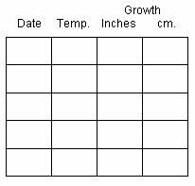 | Week 2 | Week 3

Notes:
Plant Growth Graph
