
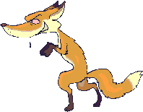
Project Checklist

TASK | Completed?  Yes | Completed?  NO
I wrote my name of my project.
I wrote at least two sentences that explained if I think the DeSotos were justified in not treating the fox.
In my sentences, I gave evidence from the book or a personal experience.
I drew a picture to illustrate my sentences.

I practiced what I was going to say to the class.

