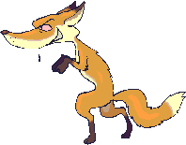

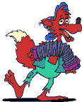
Drawing Checklist

 | All of the time | Most of the time | Never | Teacher Notes
Student is able to explain drawings.

Drawing stays focused.

Drawing is detailed.

Drawing serves as a trigger to extend to other ideas or scaffolding.

Students use drawing to visually show and express their thinking, observations, and to justify their answers. Teachers use drawing to help interpret the writings or thoughts of students and to assess the levels of their understanding. This helps in planning future lessons and in re-teaching the concept if necessary.

