Label 2 Rubric

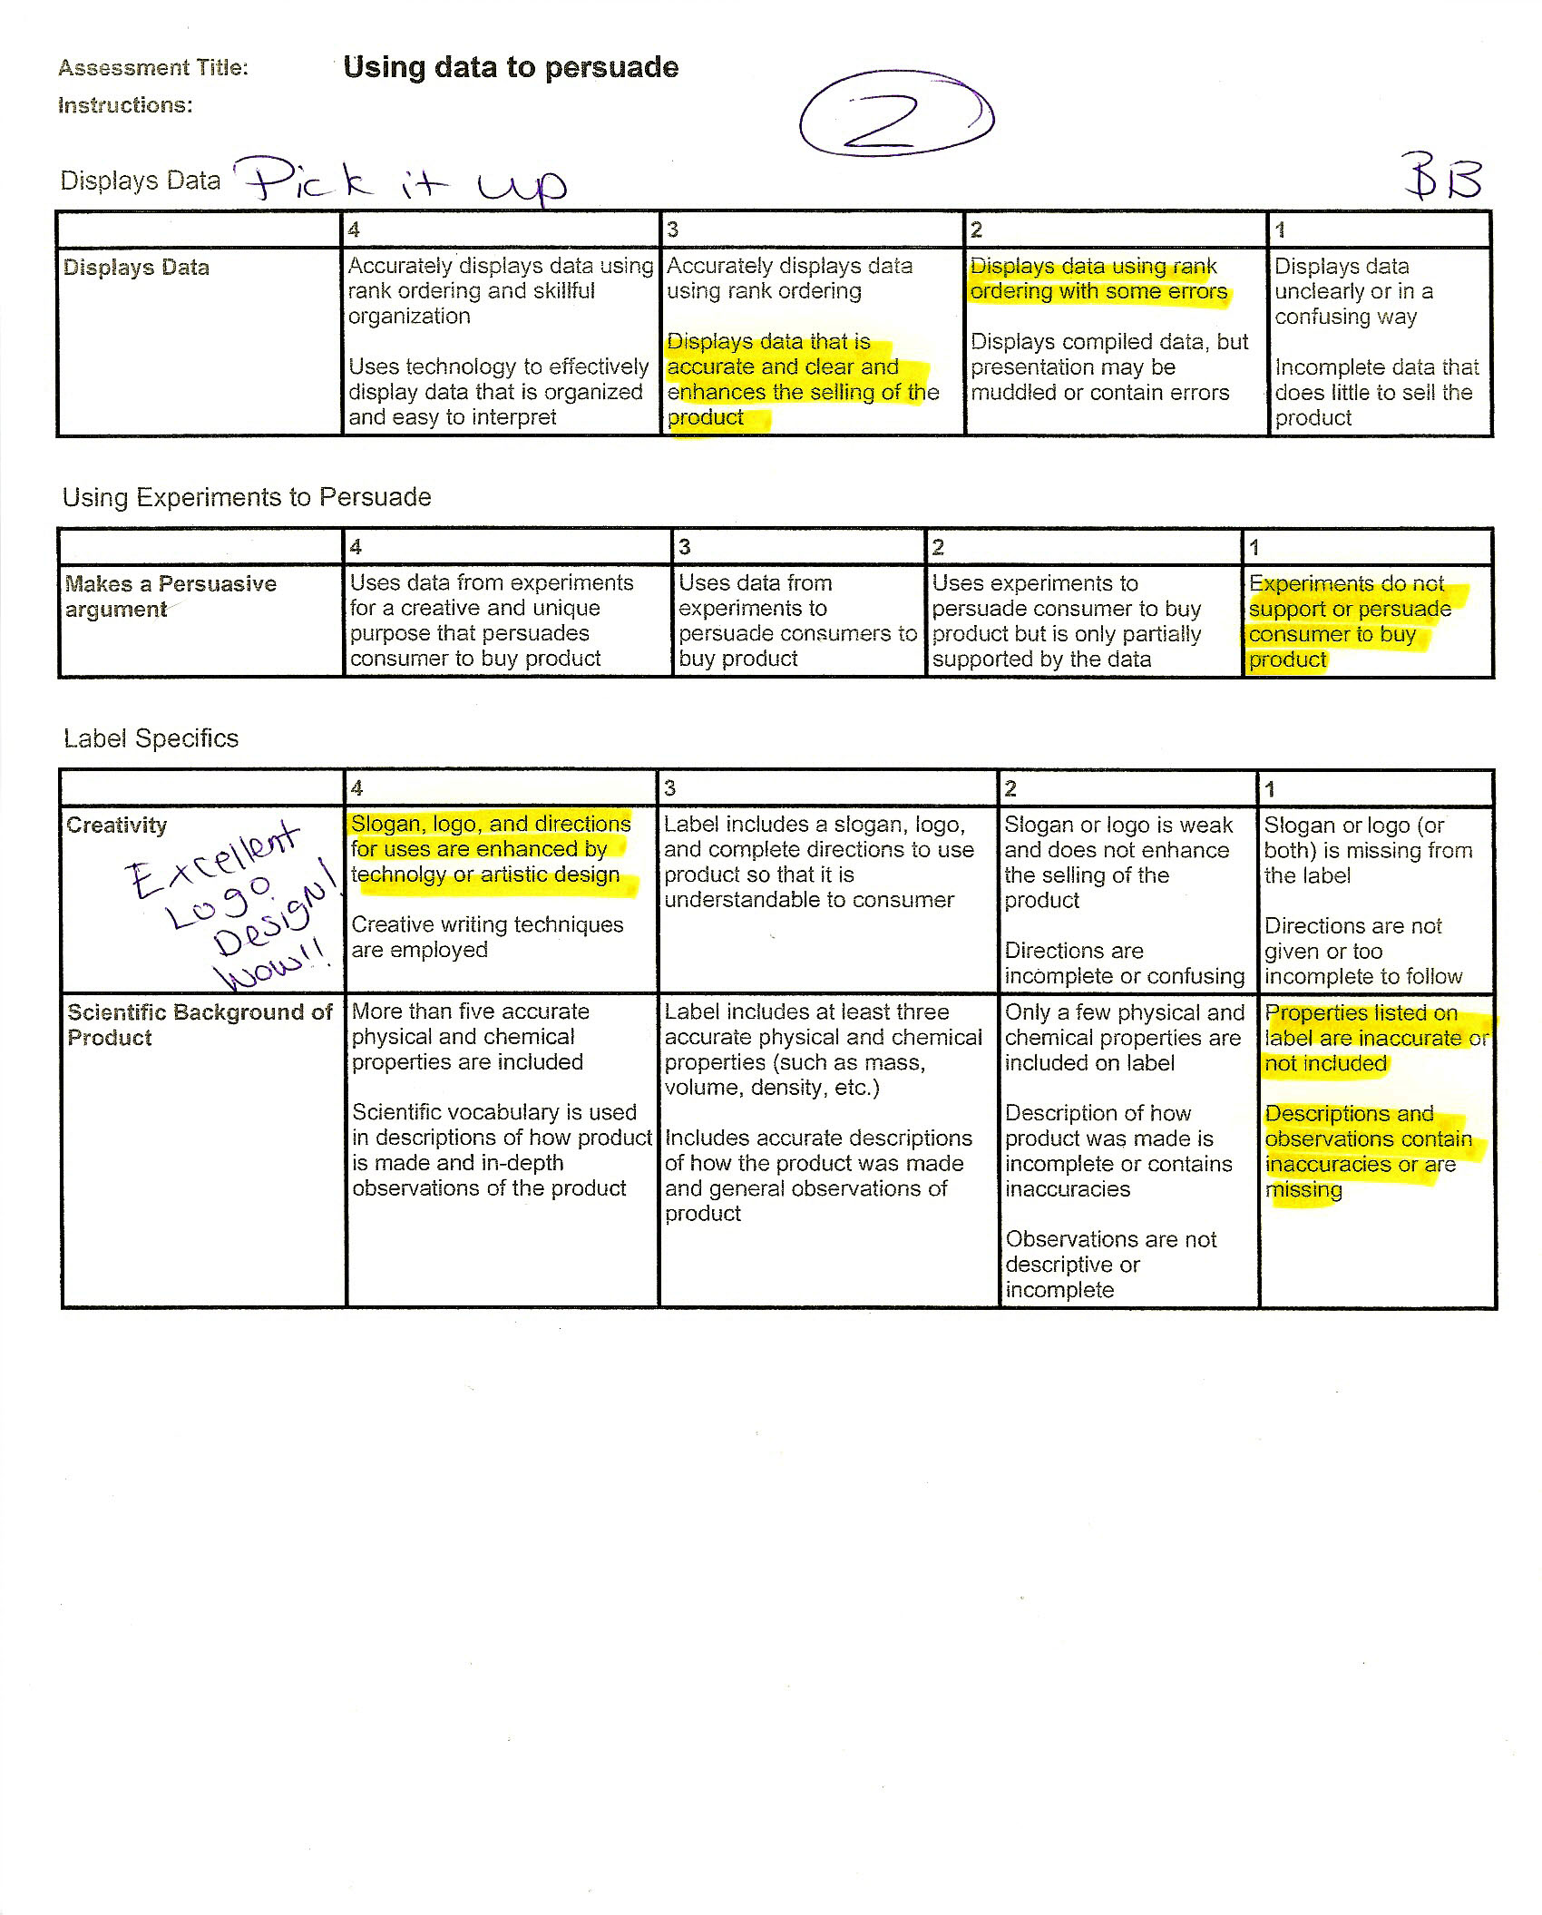
Label 2 Rubric

