Tutorial for 21classes.com* for the
Intel® Teach Essentials Online Course Facilitator

This document includes the steps and suggestions for setting up a blogging site for the Intel® Teach Essentials Online Course or your own personal classroom. These instructions apply to the blog site, www.21classes.com*. Rather than just having unconnected individual blogging accounts like most sites, 21classes provides a “blog portal”—a community of connected blog accounts. Every blog portal consists of two layers: The first layer is a class homepage where users can login, easily access the other blogs in the course (and only their course), and participate in a course blog together with the admin (facilitator) as the author. Other information such as classroom news, assignments, favorite links, and so forth can also be added to the home page in the left or right sidebars. The second layer consists of all of the individual user blogs and is easily accessible from the Home Page through a drop down menu. When users register for the site, they are automatically assigned a blog space. Participants may choose to develop and explore their individual blog on their own time.
21classes is specifically designed for education use. Teachers can have as little or as much control over how blog content is published and the amount of outside contact/accessibility as desired. 21classes gives teachers complete control over security settings for their students’ accounts.
For other questions, visit the FAQ at 21classes: www.21classes.com/shop/support*

Registering for a Blog Portal

- Go to: www.21classes.com
- Click Sign up for Free!
- Type your e-mail address.
- Type a name for your blogging community. This name will become a part of the URL for your blog portal, such as essentials-singh or intelteach-kvsdel. The URL for those examples would then be essentials-singh.21classes.com and intelteach-kvsdel.21classes.com, respectively.
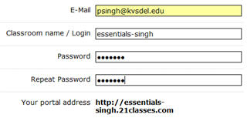
The Classroom name/Login becomes a part of the URL (or portal address).
- Type your password and confirm it.
- Note your portal address.
- Enter the remaining information.
- Read the terms of service and click to place a checkmark that you agree to the terms.
- Click Proceed.
- Review your account details and then click Set up my portal. Do not click any links or close the window until you are redirected to your blog portal.

Setting Up Your Portal Preferences

- Click the All Features link on the right hand side.
Click All Features.
- Scroll down and click Blog directory.
- Click to place a checkmark at Show member list on portal. This will allow easy access to member blogs from the home page of your blog portal.
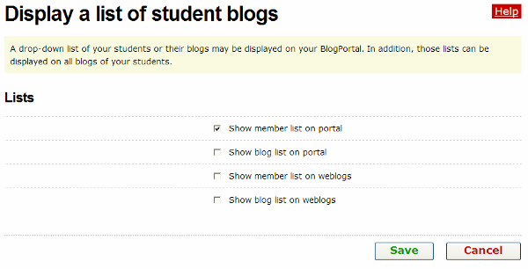
Click to place a checkmark at Show member list on portal.
- Click Save.
- The default settings of a blog portal on 21classes is to show the first few lines of up to ten of the most recent blog entries in one’s own community on the home page of the portal. For the purpose of the Intel® Teach Essentials Online Course, you will probably not want this feature. You will use the home page to direct teachers to the course blog instead. If you do not want “Recent Posts” from other blogs to appear on the home page of your portal, complete the following steps:
  - Mouse over Classroom Homepage, and then click Categories.
  - Next to the category of Home, click Edit Category.
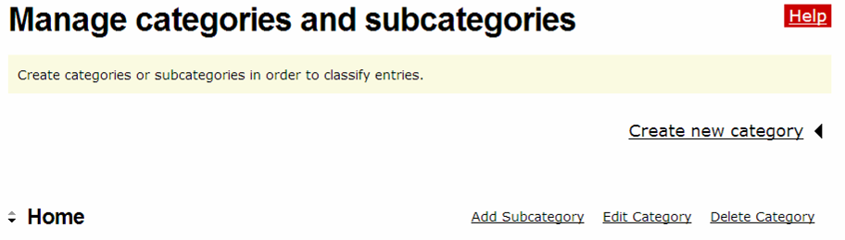
Click Edit Category.
  - Under Type settings, click the down-arrow and select Displays entries.
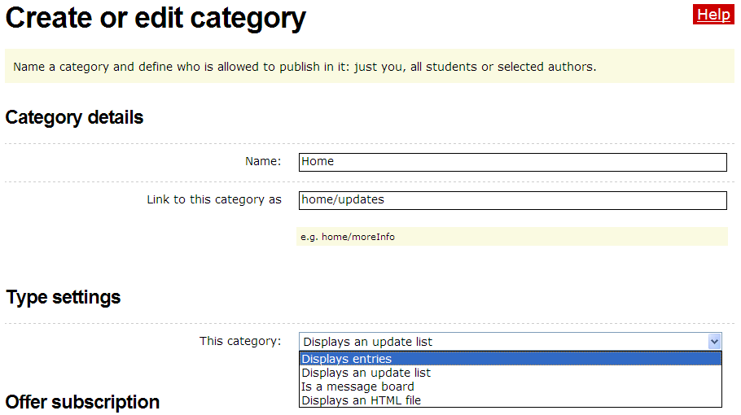
Select Displays entries.

  - Click Save.
Editing Your Home Page Message

- Mouse over Classroom Homepage, and then click Welcome text / about.
- Delete the placeholder text and replace with your own. A sample introduction is found in the Setting Up a Blog document in the Resources tab > Prepare for Course link.
- To insert an image, click the insert/edit image button.
- Click Browse and locate the image to upload, and then click Open.
- Click Upload image.
- Edit the size or appearance of the image, if needed, by editing the settings on the Appearance tab.
- Click Insert.
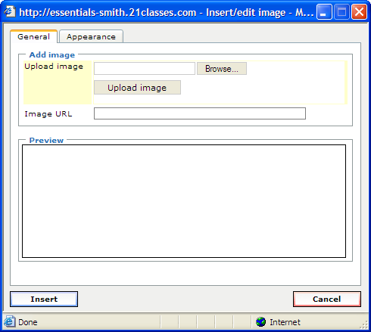

Click the Browse button to locate the image on your computer.
Click Upload image.

Click the Appearance tab to edit the size or appearance of the image.

Click Insert to add the image to your current page.
- Click Save.

Adding an Entry for the Course Blog
- To add entries for the course blog, mouse over Classroom Homepage, and then click New Entry. Refer to the Blog Prompts document found in the Facilitation Guide> Section 7: Accessing Facilitation Resources for sample text.
- Add title and text. The entry will automatically link to the home page and entries will display from most recent to oldest.
- Leave the Entry category set for Home so that you will see the blog entry on the home page.
- If you want others outside the course to be able to view all the entries and comments, leave the default to Public. If you want only your participants to view the blogs, change the setting to Members only.
- Leave the default setting so that only members can leave comments.
- Click Publish. Participants can now view the post on the home page of the blogging community and respond when directed during the course.

Customizing the Sidebar of Your Course Blog (Optional)
You can customize your right sidebar and add links and other categories.
- To add a category:
  - Mouse over Classroom Homepage, and then click Categories.
  - Click Create New Category and enter an appropriate category title (such as Technology Tid Bits, off-topic discussions, and so forth).
  - Under Type settings, click the down-arrow and select Displays entries.
  - Click Save.
- To add links:
  - Mouse over Classroom Homepage, and then click Links/blogroll.
  - Click Add New Link.
  - Type the title of the link.
  - Type or paste the URL of the Web site.
  - Click Save.
  - If you want to list several links under a category title, click Add New List.
  - Enter a title for the list (such as project-based learning, Intel sites, and so forth.) and click Save.
  - Now you can add links to this list simply by clicking Add New Link.
- To upload a file:
  - Mouse over Classroom Homepage, and then click Manage Images and Files.
  - Click the Click here in the message that says, “You have not uploaded any files yet. Click here to upload a file from your PC.”
  - Click Browse and find the file you would like to upload. Click Open.
  - Click Upload.
  - Once the file is uploaded, you will be returned to the Manage Images and Files page. Click the link to the file you uploaded to copy the URL.
  - When you want to link to this file when creating a blog entry or editing the home page, click the button on the html editor.
  - Paste the URL into the Link URL box and enter a title.
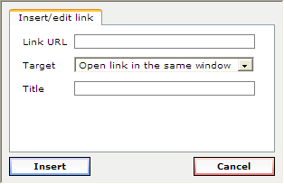
  - Click Insert.
Creating Accounts
Users can be added to your blog portal in three ways:
- Sign them up directly yourself,
- Invite users through e-mail to create accounts themselves, and/or
- Provide a link on your blog portal home page to allow users to sign up from there
For the Essentials Online Course, you may want to sign them up directly, as well as allow users to sign up themselves in case you have any last minute additions to your class.

Adding User Accounts Directly
The easiest way to create user accounts is to create the accounts directly for your users. They can then edit their preferences and settings once their account is set up. In addition, you might want to have a personal blog for yourself even though you are the administrator of this portal. If so, create a personal account with a new login and a different e-mail for yourself.
- Mouse over Student accounts, and then click Manage and add student accounts.
- Click Create account.
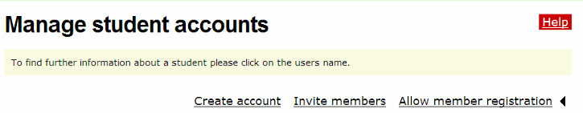
Click Create account.
- Enter the number of accounts you need to create using the drop-down box.
Note: Do not choose a number higher than you actually need. You will receive an error message if any of the account fields are left blank
- If you want the account information sent by e-mail to the user(s), select the checkbox at Send login data by E-Mail. If your users are students, you may not want an e-mail to be sent.
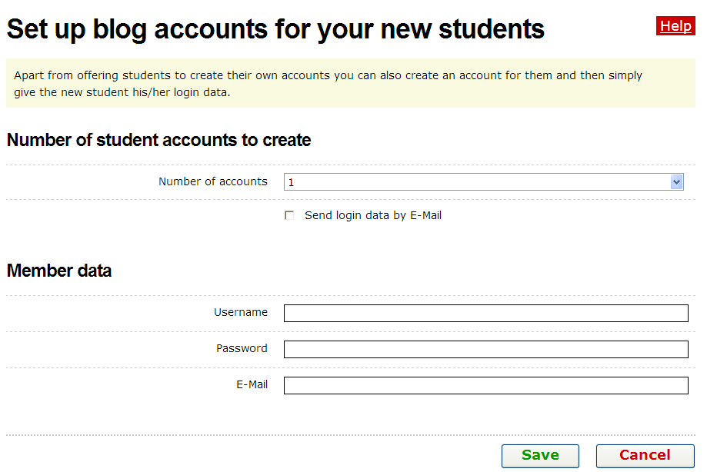
E-mail addresses are not required to set up a blog account if this checkbox is left unchecked.
- Enter the Username, password, and E-mail address for each user, using a standardized method such as first initial last name or first name with last name initial for both username and password (examples: psingh or premans).
Note: The e-mail address field is optional if you do not select the box for send login data by E-Mail.
- Click Save.

Inviting Users to Sign Up for an Account
You can invite users through an automated e-mail to sign up for an account or allow users to go directly to your blog portal and create an account directly.
- Mouse over Student accounts, and then click Manage and add student accounts.
- Click Invite members.
- Click the box to Enter more E-Mail addresses as many times as needed.
- Add a message in the Additional text for invitation box to let the recipients know what this invitation is for and who it is from.
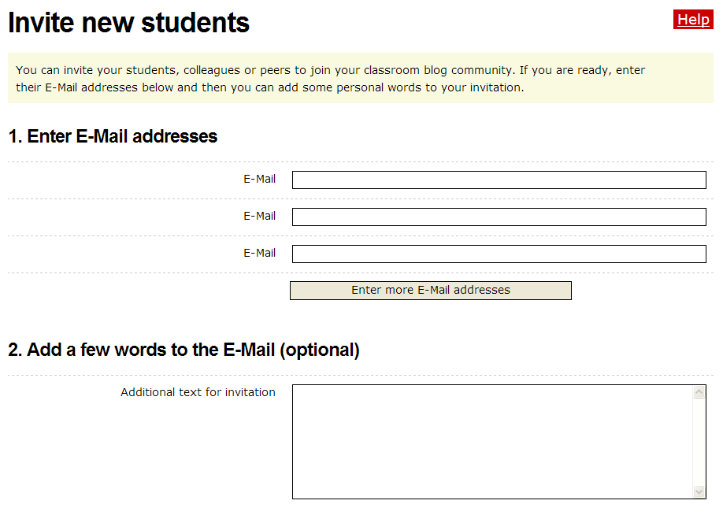
- Preview the blog invitation and then Click Send.

Allowing Member Registration from Your Blog Portal Home Page
You can invite users through an automated e-mail to sign up for an account or allow users to go directly to your blog portal and create an account directly.
- Mouse over Student accounts, and then click Manage and add student accounts.
- Click Allow member registration.
- Click the box to Provide link for members to register themselves.
- Under the confirmation settings, click the desired settings:
  - By selecting Registration requires clicking a link in an E-Mail, you may eliminate malicious users from trying to access your blog portal. However, if you are in a training and are trying to sign up users quickly, this will slow down the process, especially if users do not have access to their e-mail accounts.
  - By selecting Registrations need to be confirmed through teacher, you must approve new users who request membership. Again, if you are in a training and are trying to sign up users quickly, this will slow down the process, but this option provides you with the most control if you allow users to sign up directly from the blog portal home page.
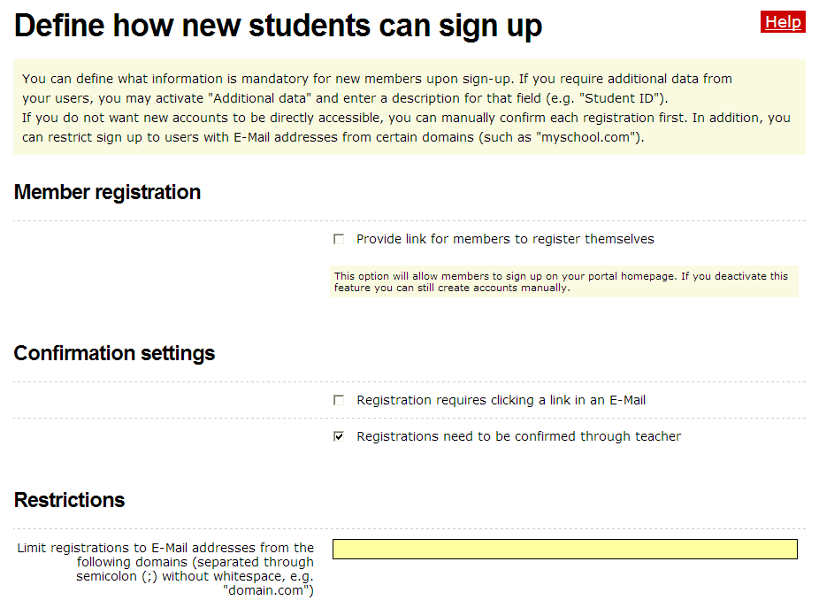
- Another way of providing control without the extra confirmation steps is to only allow registration to those who have a certain e-mail address. This restriction should only be used if all users have e-mail addresses from the same domain (example, kvsdel.k12.nd.in or kvsdel.edu)—or just a few domains.
- Click the desired checkboxes to select the fields that you want potential users to fill out so that you can either approve them or know who has signed up: First name, Last name, Address, City, State, Pincode, Country, and/or Additional data.
- Click Save.
Setting Up Your User Account Settings for an Essentials Online Course
- Mouse over Student accounts, and then click Students’ blog settings.
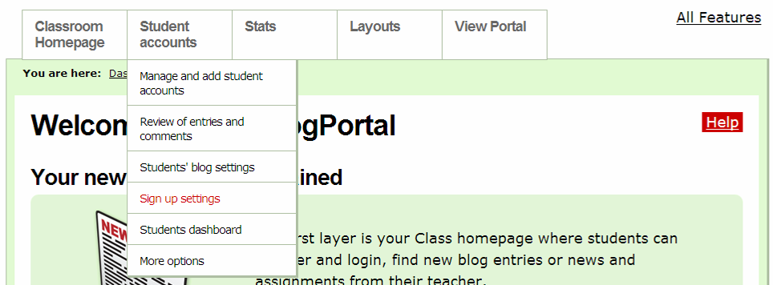
- For the use in the Essentials Online Course, you will probably want to keep the default settings in the Student interaction section:
  - Leave unchecked: New entries need to be reviewed by teacher before they are published
  - Leave unchecked: New comments in all blogs need to be approved by teacher
  - Leave checked: E-Mail functionality enabled
- For the use in the Essentials Online Course, you will probably want to keep the default settings in the Default blog settings for new blogs section.
- You will probably want to keep the default settings in the Default blog settings for new blogs section.
- In the Entry Visibility section, select either All Internet Users to allow anyone who goes to your Blog portal to view the blogs (however, your users can also choose to keep their blog entries private or only for blog portal members) or select the option to allow members only to view the blogs.
- In the Comments section, select either All Internet Users to allow anyone who goes to your Blog portal to comment on the blogs (however, your users can also choose to keep their blog entries private or only for blog portal members) or select the option to allow members only to comment on the blogs.
- Keep the checkmark at Members may override visibility and comment settings for their entries.
- Click Save.
- If you would like to include a welcome message that your Participant Teachers will see when they log in to their blog, edit the default message:
  - Mouse over Student accounts, and then click Students dashboard.
  - Enter your own or the following suggested text: You are now logged on to your dashboard where you can manage your blog. You will use this blog site as a journal where you can reflect on the activities, skills, and approaches addressed in each module of the course. Feel free to look around and see all the features of your blog account.
  - Click Save.
Creating Additional Editors for Your Blogging Community
If you have a co-facilitator, you will want to allow that person to also publish blogs entries—and not just comment—under his or her own name.
- Mouse over Student accounts, and then click More options.
- Click Manage Co-Authors for this Portal.
- Next to Manage Editors for this portal, click Invite editor.
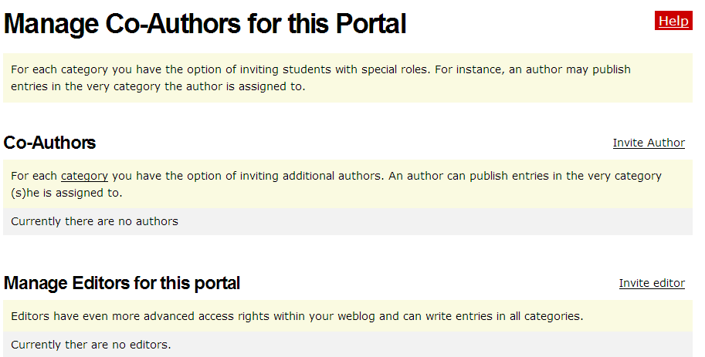
Select Invite editor.

- Type the username of your co-facilitator.
- Click Save. Now both of you can publish blogs in all categories.
Setting Up User Account Settings for a K-12 Classroom
Review the following instructions and make changes to the default settings according to your school or district’s Acceptable Use Policies (AUPs) and your own students’ needs. Decide which options you will require in the categories of Student interaction, Define available features, Default blog settings, Entry Visibility, Comments, and User content rights. Consider carefully whether you want student blogs visible to anyone on the Internet or only to one’s own blogging community. Similarly, consider whether comments will be allowed for anyone who accesses the site or only for your own blogging community. Suggested settings are listed below.
- Mouse over Student accounts, and then click Students’ blog settings.
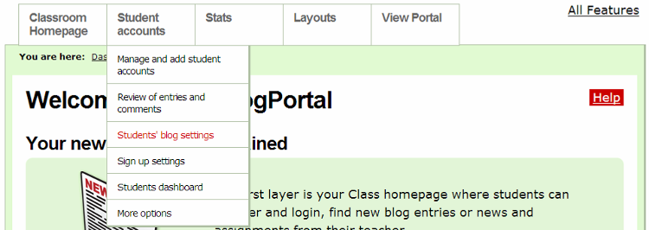
- Depending on the age of your students, the level of trust established in your classroom, and your students’ understanding of appropriate use, make your selections in the Student interaction section. For the highest level of control, make the following selections:
  - Click to place a checkmark: New entries need to be reviewed by teacher before they are published
  - Click to place a checkmark: New comments in all blogs need to be approved by teacher
  - Click to remove the checkmark: E-Mail functionality enabled
- Review the settings in the Define available features section. You may want to place a checkmark next to Activity report for all members to have a report sent to you on the students’ activity.
- You will probably want to keep the default settings in the Default blog settings for new blogs section.
- In the Entry Visibility section, select the option to allow members only to view the blogs.
- In the Comments section, select the option to allow members only to comment on the blogs.
- Decide whether you want your students to keep their entries public or private. If you do not want them to have that option, click to clear the checkmark at Members may override visibility and comment settings for their entries.
- Click Save.
- Mouse over Student accounts, and then click Students dashboard.
- Edit the welcome message that students will see when they log in to their blog. This is where you should include any specific instructions or expectations that they should follow.
- Click Save.

