Section 2.5: Reviewing Course Progress
The Review Course Progress feature records participants’ self-evaluation of course activities. The data assists with monitoring which participants are preceding through the course. You can check progress across all teachers, by individual participant, and by activity details. Messages regarding course progress can be sent from this feature to either individual Master Teachers or groups of Master Teachers. Sample Progress Reports> Resource tab > Manage Communication contains sample progress reporting and message text.

To review course progress:

- Click the Manage tab and select Review Course Progress, which lists all of the course activities.
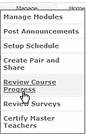
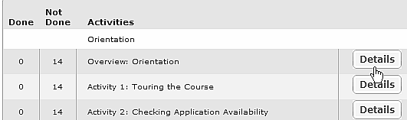
- Click Details to determine which participants have Done a specific activity and which participants have Not Done the activity.

- Click a participant’s name in the Class List to review the individual’s progress.
- Evaluate and contact each participant, if necessary.
- Download results by clicking Download CSV. To view downloaded results, open Microsoft Excel*, click Download CSV, adjust formatting if necessary, and save the worksheet.

To send a message to a group:
- Select Congratulate Group to congratulate the group that has achieved activity completion.

Note: Those who have already been congratulated will not be included in the group message.
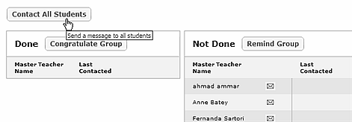
- Select Remind Group to encourage Master Teachers to finish their assignments.

- Click Contact All Students to message all Master Teachers. You may want to reference this action in an announcement as a reminder to MT’s to check their e-mail.

A list of Sample messages > Resource Tab in the Training Community > Manage Communication can be modified to meet the needs of the course and individual participants.

