Tutorial for 21Classes.com

This document includes the steps and suggestions for setting up a blogging site for the Intel® Teach Essentials Course or your own personal classroom. These instructions apply to the 21Classes* blog site (www.21classes.com). Rather than just having unconnected individual blogging accounts like most sites, 21Classes provides a “blog portal”—a community of connected blog accounts. Every blog portal consists of two layers. The first layer is a class home page where users can log on, easily access the other blogs in the community (and only their community), and find out about classroom news and assignments. The second layer consists of the individual user blogs.
21Classes is specifically designed for education use. Teachers can have as little or as much control over how blog content is published and the amount of outside contact/accessibility as desired. 21Classes gives teachers complete control over security settings for their students’ accounts.
For other questions, visit the 21Classes FAQ at: www.21classes.com/shop/support

Registering for a Blog Portal

- Go to: www.21classes.com
- Click Sign up for Free!
- Type your e-mail address.
- Type a name for your blogging community. This name will become a part of the URL for your blog portal, such as essentials-smith or intelteach-oakschool. The URL for those examples would then be essentials-smith.21classes.com and intelteach-oakschool.21classes.com, respectively.
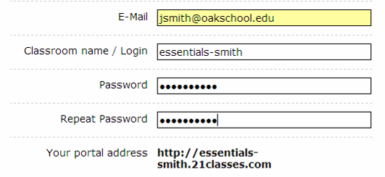
The Classroom name/Login becomes a part of the URL.
- Type your password and confirm it.
- Note your portal address.
- Enter the remaining information.
- Click to place a checkmark that you agree to the terms of service.
- Click Proceed.
- Review your account details and then click Set up my portal. Do not click any links or close the window until you are redirected to your blog portal.

Setting Up Your Portal Preferences
- Click the All Features link on the right-hand side.
Step 1: Click All Features.
- Scroll down and click Blog directory.
- Click to place a checkmark at Show member list on portal. This will allow easy access to member blogs from the home page of your blog portal.
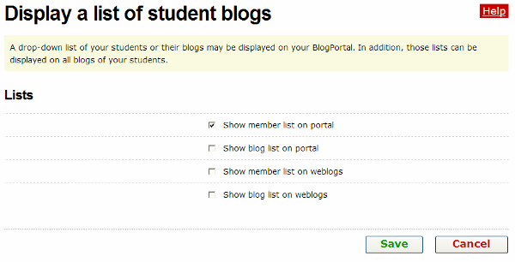
Step 3: Click to place a checkmark next to Show member list on portal.
- Click Save.
- The default settings of a blog portal on 21Classes is to show the first few lines of up to 10 of the most recent blog entries on the home page of the portal. If you do not want “Recent Posts” to appear on your portal’s home page, complete the following steps:
  - Point to Classroom Homepage, and then click Categories.
  - Next to the Home category, click Edit Category.
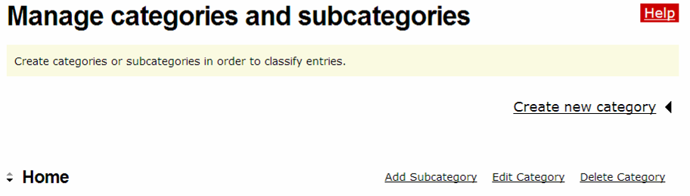
Step 5b: Click Edit Category.
  - In the Type settings area, click the down-arrow and select Displays entries.
  - Click Save.
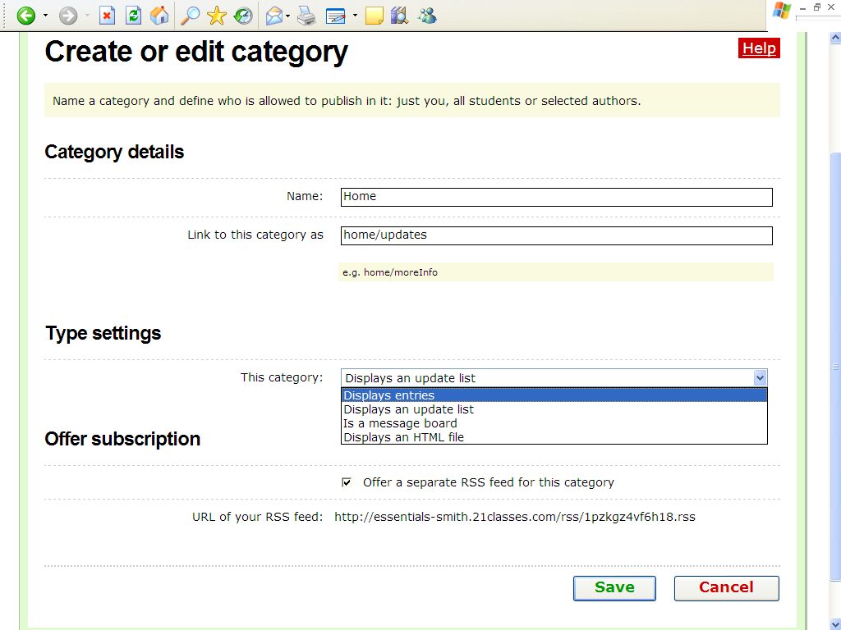
Step 5c: Select Displays entries.

Editing Your Home Page Message
- Point to Classroom Homepage, and then click Welcome text/about.
- Replace the placeholder text with your own text.
- To insert an image, click the Insert/edit image button.
- Click Browse, locate the image to upload, and then click Open.
- Click Upload image.
- Edit the size or appearance of the image, if needed, by editing the settings on the Appearance tab.
- Click Insert.
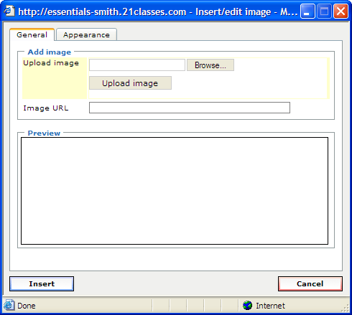

Step 4: Click the Browse button to locate the image on your computer.
Step 5: Click Upload image.

Step 6: Click the Appearance tab to edit the size or appearance of the image.

Step 7: Click Insert to add the image to your current page.
- Click Save.

Creating Accounts
You can add users to your blog portal in three ways:
- Sign them up yourself
- Invite users through e-mail to create accounts
- Provide a link on your blog portal home page to allow users to sign up from there
For the Essentials Course, you may want to sign up users directly as well as allow users to sign up themselves in case you have any last minute additions to your class.

Adding User Accounts Directly
The easiest way to create user accounts is to create the accounts directly for users. They can then edit their preferences and settings after the accounts are set up. In addition, you might want to create a personal blog for yourself even though you are the administrator of the portal. If so, create a personal account with a new logon name and password, and a different e-mail address for yourself. To create user accounts:
- Point to Student accounts, and then click Manage and add student accounts.
- Click Create account.
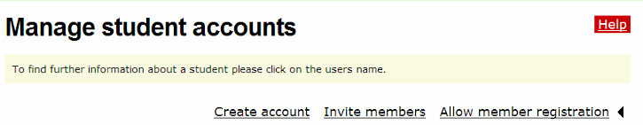
Step 2: Click Create account.
- Enter the number of accounts you need to create using the drop-down box.
Note: Do not choose a number higher than you actually need. You will receive an error message if any of the account fields are left blank.
- If you want the account information sent by e-mail to the users, select the Send login data by E-Mail checkbox. If your users are students, you may not want an e-mail to be sent.
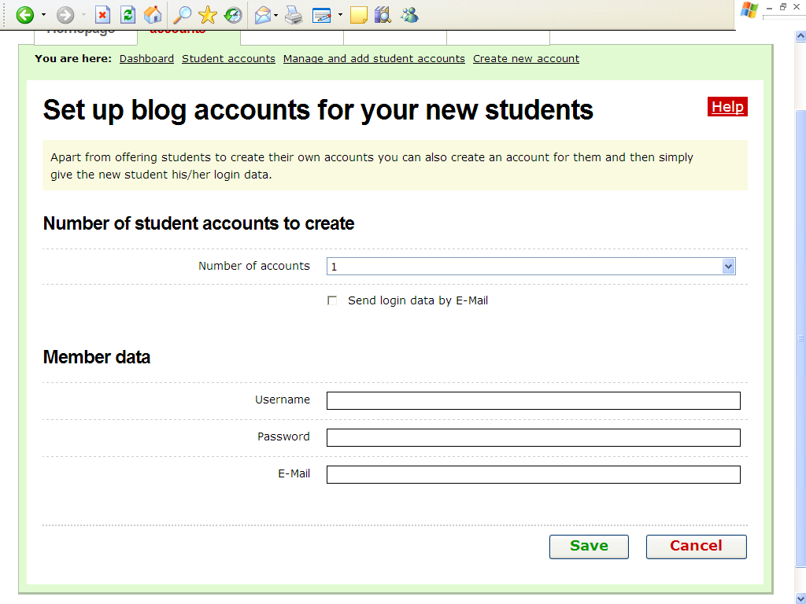
Step 4: E-mail addresses are not required to set up a blog account if this checkbox is left unchecked.
- Complete the Username, Password, and E-mail fields for each user, using a standardized method, such as first initial last name or first name with last name initial for both username and password (examples: jsmith or johns).
Note: The E-mail field is optional if you do not select the Send login data by E-Mail checkbox.
- Click Save.

Inviting Users to Sign Up for an Account
You can invite users through an automated e-mail system to sign up for an account. To invite users to sign up for an account:
- Point to Student accounts, and then click Manage and add student accounts.
- Click Invite members.
- Click the Enter more E-Mail addresses button as many times as needed.
- Add a message in the Additional text for invitation box to let the recipients know who you are and why are sending them an invitation.
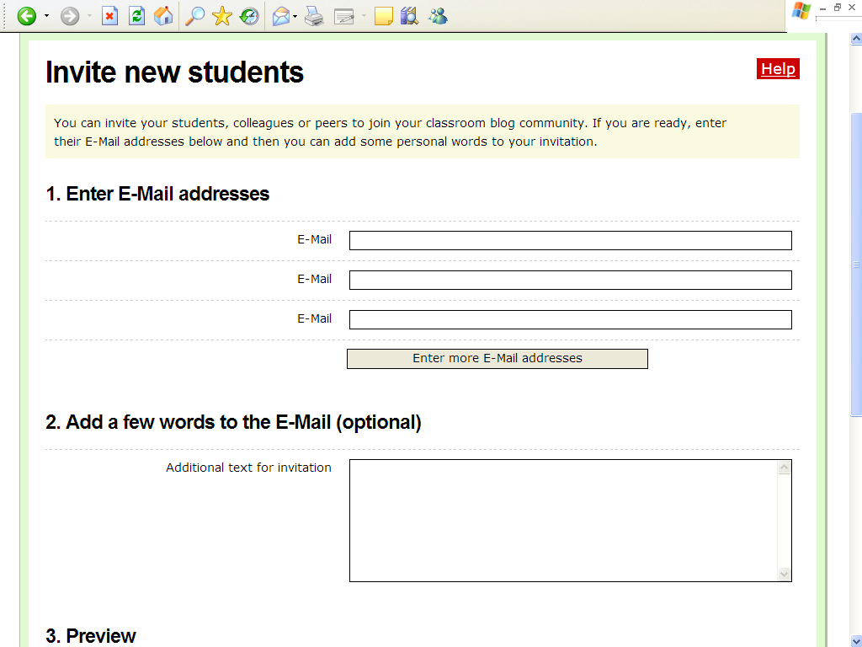
Step 3: Click Enter more E-Mail addresses as many times as necessary to show additional entry boxes.

Step 4: Add a message to your invitation.
- Preview the blog invitation and then click Send.

Allowing Member Registration from Your Blog Portal Home Page
You can allow users to go directly to your blog portal and create an account directly. To allow members to register from your blog portal home page:
- Point to Student accounts, and then click Manage and add student accounts.
- Click Allow member registration.
Click Allow member registration.
- Click the Provide link for members to register themselves checkbox.
- Under the confirmation settings, click the desired settings:
- Select Registration requires clicking a link in an E-Mail to eliminate malicious users from trying to access your blog portal. However, if you are in a training and trying to sign up users quickly, this will slow down the process, especially if users do not have access to their e-mail accounts.
- Select Registrations need to be confirmed through teacher to require your approval of all new users who request membership. Again, if you are in a training and trying to sign up users quickly, this will slow down the process, but it provides you with the most control if you allow users to sign up directly from the blog portal home page.
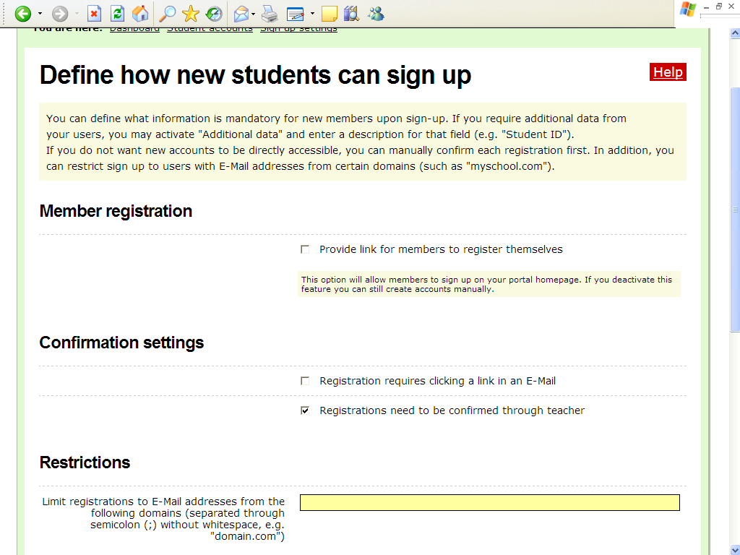
- Another way to retain control, which does not add extra confirmation steps, is to limit registration to users who have e-mail addresses from specific domains. This restriction should only be used if all users have e-mail addresses from the same domain (example, oakschool.k12.ca.us or oakschoolacademy.edu) or just a few domains.
- In the Mandatory fields section, click the desired checkboxes to select the fields that you want potential users to fill out so that you can either approve them or know who has signed up. You can choose among the following fields: First name, Last name, Address, City, State, Zip, Country, and Additional data.
- Click Save.
Setting Up Your User Account Settings for an Essentials Course
- Point to Student accounts, and then click Students’ blog settings.
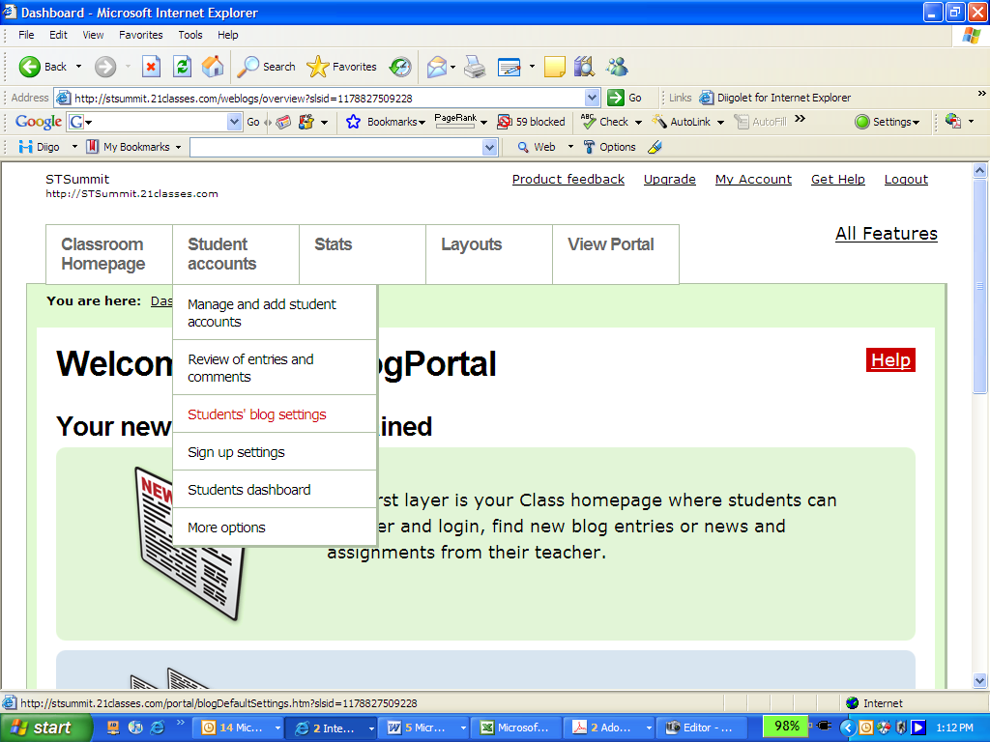
- For the Essentials Course, you will probably want to keep the default settings in the Student interaction section, but you may want to consider adding additional control for a classroom blog portal. The defaults are:
- Unchecked: New entries need to be reviewed by teacher before they are published
- Unchecked: New comments in all blogs need to be approved by teacher
- Checked: E-Mail functionality enabled
- For the Essentials Course, keep the default settings in the Default blog settings for new blogs section.
- Keep the default settings in the Default blog settings for new blogs section.
- In the Entry Visibility section, select either All Internet Users to allow anyone who goes to your blog portal to view the blogs (however, your users can also choose to keep blog entries private or only for blog portal members) or select the option to allow members only to view the blogs.
- In the Comments section, select either All Internet Users to allow anyone who goes to your blog portal to comment on the blogs (however, your users can also choose to keep their blog entries private or only for blog portal members) or select the option to allow members only to comment on the blogs.
- Click to place a checkmark at the Members may override visibility and comment settings for their entries setting to provide Participant Teachers full control over their visibility settings.
- Click Save.
- If you would like to include a welcome message that your Participant Teachers will see when they log on to their blogs, edit the default message as follows:
  - Point to Student accounts, and click Students dashboard.
  - Enter your own text or the following suggested text:
You are now logged on to your dashboard where you can manage your blog. You will use this blog site as a journal where you can reflect on the activities, skills, and approaches addressed in each module of the course. Feel free to look around and see all the features of your blog account.
  - Click Save.
Setting Up User Account Settings for a K–12 Classroom
Review the following instructions and make changes to the default settings according to your school or district’s Acceptable Use Policies (AUPs) and your students’ needs. Decide which options you will require in the categories of Student interaction, Define available features, Default blog settings, Entry Visibility, Comments, and User content rights. Carefully consider whether you want student blogs visible to anyone on the Internet or only to one’s own blogging community. Similarly, consider whether comments will be allowed for anyone who accesses the site or only for your blogging community. Suggested settings are listed in the following steps.
- Point to Student accounts, and then click Students’ blog settings.
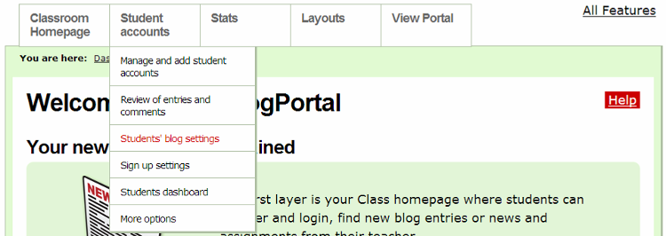
- Depending on the age of your students, the level of trust established in your classroom, and your students’ understanding of appropriate use, make your selections in the Student interaction section. For the highest level of control, make the following selections:
- Check: New entries need to be reviewed by teacher before they are published
- Check: New comments in all blogs need to be approved by teacher
- Uncheck: E-Mail functionality enabled
- Review the settings in the Define available features section. You may want to place a checkmark next to Activity report for all members to have a report sent to you that shows student activity.
- You will probably want to keep the default settings in the Default blog settings for new blogs section, depending on the age of your students, purpose of the blog, etc.
- In the Entry Visibility section, select the option to allow members only to view the blogs.
- In the Comments section, select the option to allow members only to comment on the blogs.
- Decide whether you want your students to keep their entries public or private. If you do not want them to have that option, make sure the Members may override visibility and comment settings for their entries option is unchecked.
- Click Save.
- Point to Student accounts, and then click Students dashboard.
- Edit the welcome message that students will see when they log on to their blogs. This is where you should include any specific instructions that they should follow or expectations they should meet.
- Click Save.

