Unit Plan Template
Click on any descriptive text, then type your own.

Unit Author
First and Last Name
School District
School Name
School City, State
Unit Overview
Unit Title
Unit Summary
Subject Area
Grade Level
Approximate Time Needed
Unit Foundation
Targeted Content Standards and Benchmarks
Student Objectives/Learning Outcomes
Curriculum-Framing Questions
 |  | Essential Question
 |  | Unit Questions
 |  | Content Questions
Assessment Plan
Assessment Timeline
Before project work begins |  | Students work on projects and complete tasks |  | After project work is completed
- 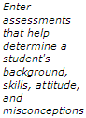 |  | - 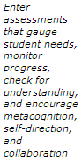 |  | - 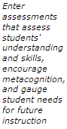

Assessment Summary
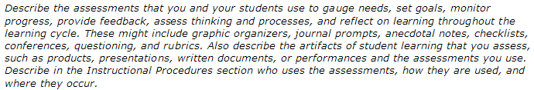
Unit Details
Prerequisite Skills
Instructional Procedures
Accommodations for Differentiated Instruction
 | Resource Student |  | 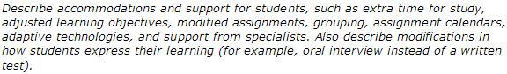
 | Nonnative English Speaker |  | 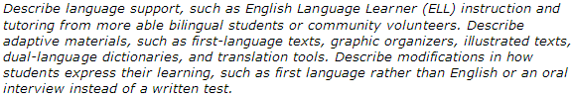
 | Gifted Student |  | 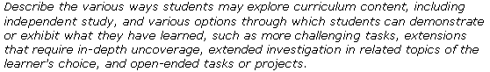
Materials and Resources Required For Unit

Technology – Hardware (Click boxes of all equipment needed)

Camera  Computer(s)  Digital Camera  DVD Player  Internet Connection | Laser Disk  Printer  Projection System  Scanner  Television | VCR  Video Camera  Video Conferencing Equip.  Other
Technology – Software (Click boxes of all software needed.)
Database/Spreadsheet  Desktop Publishing  E-mail Software  Encyclopedia on CD-ROM | Image Processing  Internet Web Browser  Multimedia | Web Page Development  Word Processing  Other

Printed Materials
Supplies
Internet Resources
Other Resources

Programs of the Intel® Education Initiative are funded by the Intel Foundation and Intel Corporation.
Copyright © 2007, Intel Corporation. All rights reserved. Intel, the Intel logo, Intel Education Initiative, and Intel Teach Program are trademarks of Intel Corporation in the U.S. and other countries. *Other names and brands may be claimed as the property of others.

