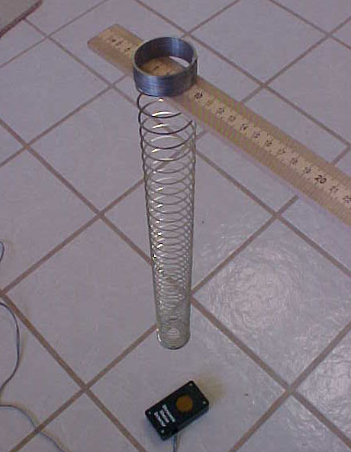
SPRING PROBLEM
Ideas for
Spring Problem

- Don’t let the spring get closer than 1.5 feet from the motion detector.
- Don’t let any objects or people get close to the spring when in motion.
- Use tape to keep the spring on the yardstick.
- Do several trials with different lengths of spring choosing the best curve.
- Make sure the CBL is on Ch1 sec.
- The motion detector must be ticking when working.
- Start the spring moving before hitting the trigger.
- The weight on the spring points downward.

CBL Directions

CBL must be connected to Motion Detector via Sonic Port.
- Turn on.
- Hit Mode.
- Hit CH View until “CH1 sec” appears
- (Goes through v→ a→ Ω → sec) .
- CBL readout will be
- “Ch 1 Sec”
- READY
- Multimeter ___ ___ ___
- Ti—83 Calculator — Connect to CBL with Link Cord
- If invalid reading occurs, check cords and seat well.
- Recall program such as “Hook” on GC. Hit enter.
- Slinky is released.
- Hit enter on the Ti—83. (Load Slinky Program.)
- Hit Trigger on the CBL.
- A scatter diagram should appear on the Ti — 83.
- Data will be in list 1 and list 2.
- Save lists. (e.g., L1 → T1 (Time 1); L2 → H1 (Height 1))
- Repeat steps 7 – 12 until you have 3 trials.

Using Lists in the TI- 83

Saving the Lists

- Get your in L1 and L2.
- Hit 2nd 1 (L1) and sto→ (just above the on button) and Alpha T1.
- Hit 2nd 2 (L2) and sto→ (just above the on button) and Alpha H1.
- Complete Steps 1 – 3 for all three trials changing the names to T2 and T3 for List 1 and H2 and H3 for List 2.

Retrieving your lists

- Go to 2nd Stat (list).
- Scroll down finding the name of your list and hit enter.
- Hit the sto→ button and 2nd L1. The stored list will now be in L1.
- Repeat steps 1 – 3 retrieving any of the stored lists into any of the preset lists in your calculator.

Using the Graph Link
- Get a floppy disk or your user I.D. name/password to log in.
- Log on to a computer with your user name and password.
- Choose the “bulldog folder” with your name. You will save to that folder.
- Go to the Start/Programs/TI graph link.
- Plug the cord into your calculator.
- Go to Link/Get screen. Your graph will appear. Save/print graph.
- Go to Link/Receive. Select your lists. Save.
- Go to File/Open. Select each list separately to view the list.
- Copy list1 and list2 to your folder/disk. Copy the graph to your folder.

Using Publisher
- Start Microsoft Publisher.
- Choose either newsletter, brochure, or Website.
- Then choose a layout of your choice.
- Insert/picture/from files – Go to your graph file and insert graph.
- Resize graph by pulling diagonally on the “handles’ in lower right corner.
- Load the lists in TI-graph link.
- Copy list1.
- Get a 2 by 100 table.
- Choose column one and paste.
- Copy list2.
- Choose column two and paste. (Both lists now appear in a table.)
- You can use the paint program to draw a picture of the setup or take digital pictures of your setup.
- Don’t forget the equation editor for math symbols.

