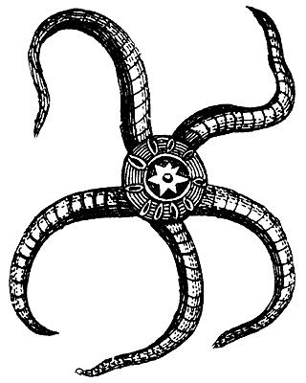
Date
Signature
Miss Jones presents
Katie Wilson with the
Invertebrate Award
For an outstanding presentation on an Invertebrate

