How to Use the Digital Camera

- Take the lens cap off gently.
- On the play or camera switch, set it to camera.
- To turn the camera on, push the green button while pushing down the switch about the green button.
- Insert a floppy in the slot on the right side of the camera, so the face of the floppy is towards you and the arrow points into the camera.
- On the camera top, push the button to take pictures.
- To eject the floppy:
  - Find the buttons on the bottom right hand corner of the camera – a “push” button and adjoining switch.
  - Using your left thumb, push and hold down on the “push” button.
  - Using your right thumb push the switch towards the center of the camera.

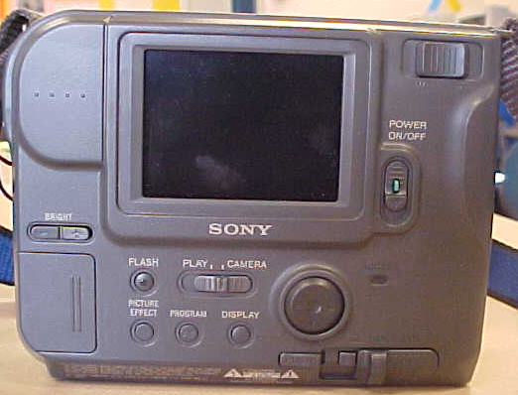
Play or Camera switch
On Off switch
To eject the disk
zoom
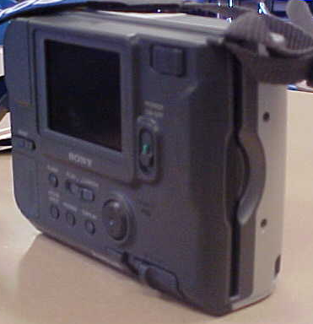
Slot for the disk

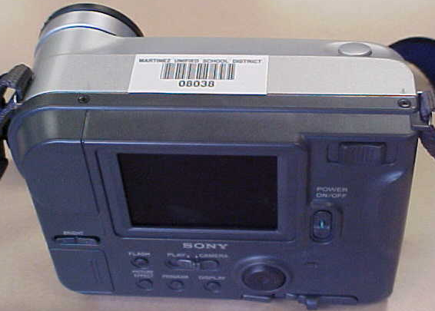
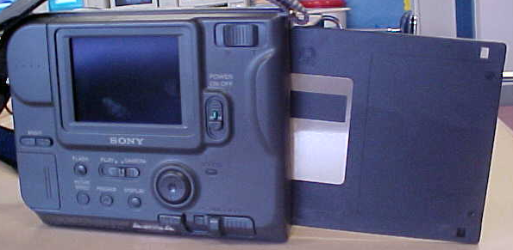
Button to take a picture
Carefully insert the disk in the slot.

