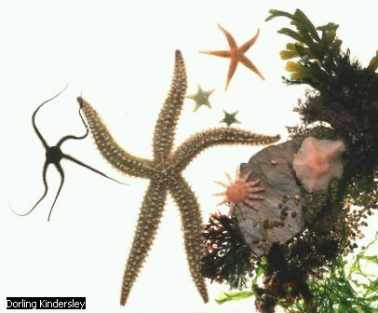
Invertebrate Unit Implementation Plan
What needs to be done before beginning the unit? | When does it need to be done?
- Sign up for checkout dates for digital camera. | December 1
- Reserve the computer lab in the library. | December 1
- Schedule class field trip to the Monterey Bay Aquarium. | December 1
- Schedule bus for field trip transportation. | December 1
- Check out hands-on science invertebrate materials. | February 1
- Save Web sites on invertebrates in Favorites. | February 1
- Sign up parents to chaperone field trip. | February 1
- Check out books from the school and public library on invertebrates. | February 1
- Send home a newsletter regarding the invertebrate unit. | February 1
- Collect field trip money from each student. | February 5
- Send out parent permission slips for field trip. | March 1

What needs to be done during the unit?
- Take pictures of students working. | Ongoing
- Pick up digital camera from media center. | February 1
- Assign project groups. | February 1
- Confirm parent chaperones. | March 14
- Schedule student oral presentations. | March 14
What needs to be done after the unit?
- Send thank-you notes to parent chaperones. | March 30
- Return equipment, books, and supplies. | March 30
- Clean up favorites and files. | April 15
- Grade projects. | April 15
- Present student award certificate(s). | April 15
- Send home parent newsletter showcasing the unit and student work. | April 15
- Follow-up student assessment or build-in questions in future student assessments to demonstrate continued understanding of the concepts. | April 30
- Think about the next unit that could effectively integrate technology. | Ongoing

