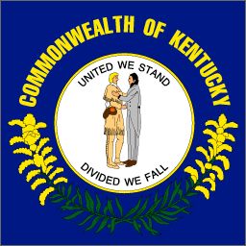 Web Sites for My State Report 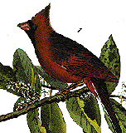

Information Gathered from:

Commonwealth of Kentucky: Paul E. Patton Governor
http://governor.ky.gov/contact.htm
I got the email address of Kentucky’s governor from this site.

50 States and Capitals
http://www.50states.com/kentucky.htm
I got information about Kentucky’s flag, state song, state bird, and other information from this site.

How far is it?
http://www.indo.com/distance/
I found out how far it is from my city to Kentucky.

Images Collected from:

The Kentucky Department of Travel
http://www.kytourism.com
I got photographs of Kentucky at this site.

50 States and Capitals
http://www.50states.com/kentucky.htm
I got a picture of the state of Kentucky, the state flag, and the state bird.

Kentucky Atlas and Gazetteer
http://www.uky.edu/KentuckyAtlas/kentucky.html
I got some great pictures of the state of Kentucky at this site.

Sounds Collected from and authorization received:

The Looney Tunes SoundSource
http://www.nonstick.com/sounds/
I got sound effects from this site.

50 States and Capitals
http://www.50states.com/songs/kentucky.htm
I downloaded Kentucky’s state song from this site.

