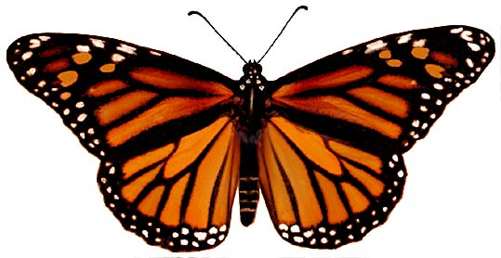
Web Sites for my Butterfly Project

Information from:

Encarta Online: Monarch Butterfly
http://encarta.msn.com/encyclopedia_761555723/Monarch_Butterfly.html

The Florida Monarch Butterfly Website
http://adver-net.com/FMonHome.html

Monarch Watch
http://monarchwatch.org/

Pictures from:

Monarch Watch Multimedia Gallery
http://monarchwatch.org/gallery/index.htm

Butterfly Gallery
http://www.smm.org/sln/monarchs/archive/gallery.html

