How to Give Acknowledgement for a Copyrighted Image
Under the image:
© Date Company/Person’s Name
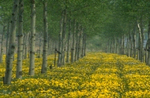

© 2002 John Doe

