Team Members __________________________________________ Date ____________________
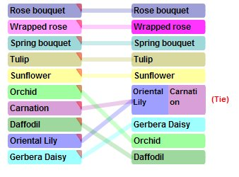
What We Learned

We learned that our team’s top five flower choices matched the class average exactly.
We learned that we ranked the orchid higher than most groups. We thought because we could make $13 on each orchid, we should sell it. Most groups said they ranked orchid low because it cost too much and most kids could not afford it. After we heard the other groups’ reasons for not picking orchids, we changed our minds, and we agree with them. We should have ranked it lower, too.
We see that almost every group thought that it was important to sell a flower that cost only $1 so that more students could buy them.

We found out there are a lot of different things to think about when deciding which flowers to sell. You need to think about profit, selling price, and popularity. Some groups ranked their flowers by popularity without thinking about price. Others put profit first. But you really need to consider all of these.
We learned that having a few choices is a good thing but too many makes it hard. Being able to see the class average made the decision easier on which flowers we should sell.

