Tool Guidelines

- Log in to project.
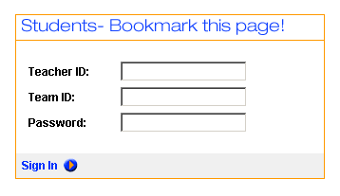
Teacher ID:

Team ID:

Password:

- Click the project name to enter the case.

- Working with your partner, determine which of your team’s pieces of evidence are the most credible.

- Input your team’s 10 most credible pieces of evidence.

Complete the following for each of the chosen pieces of evidence:
  - Input the summarizing sentence in the Summary section.
  - Input the quote in the Explanation section.
  - Input the URL address in the Source section.
  - Rate it.

Rating | 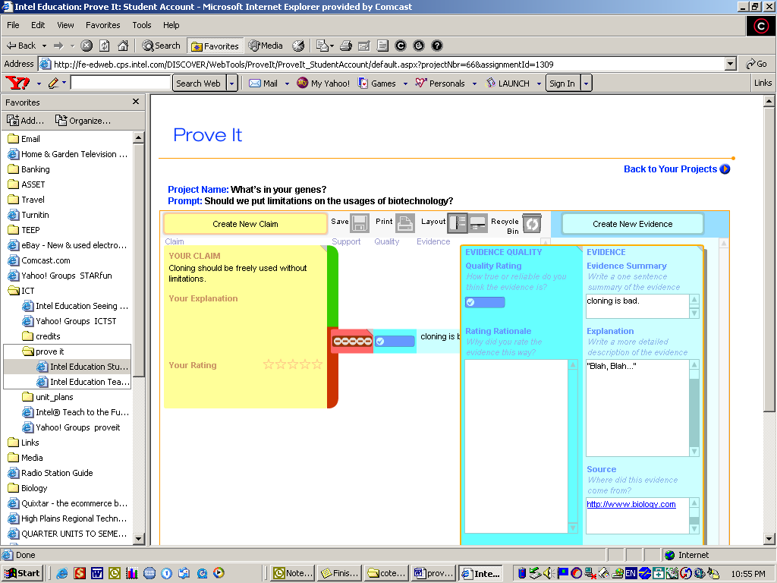 | 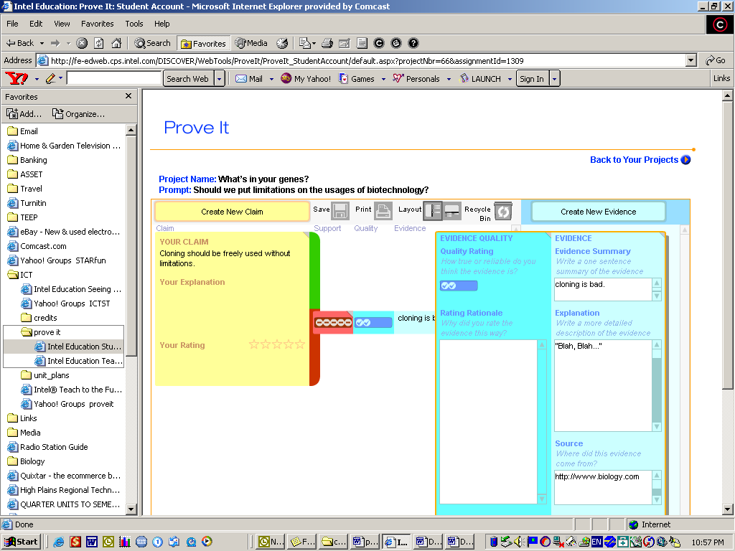 | 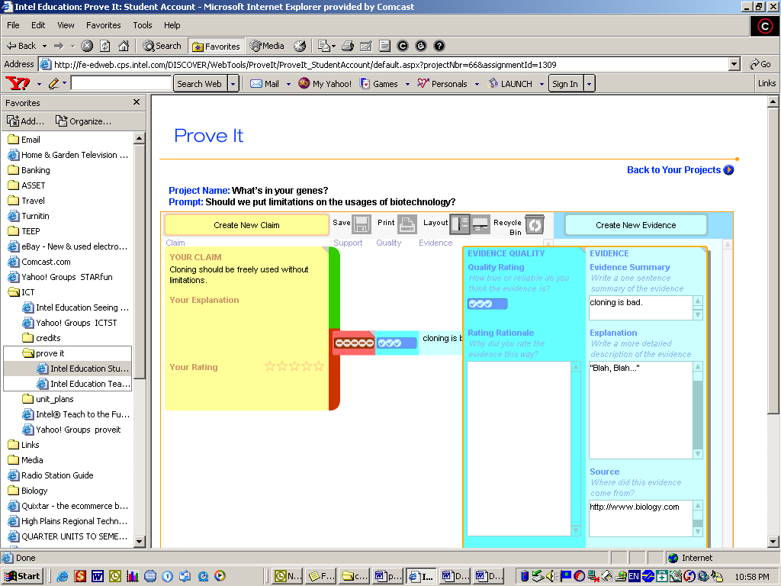 | 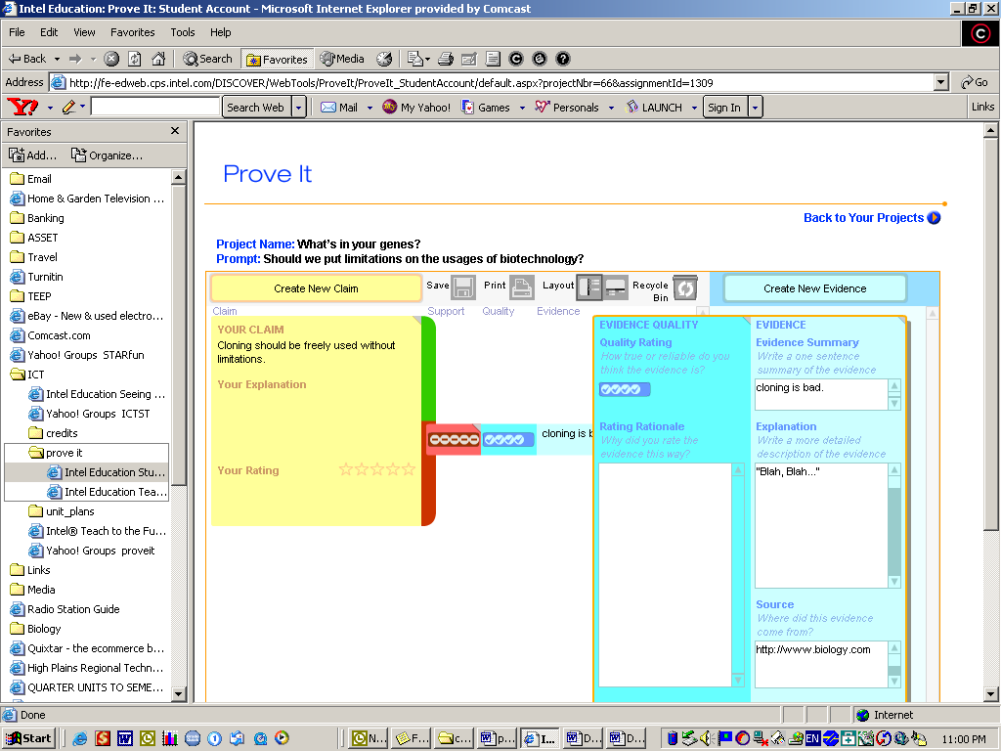 | 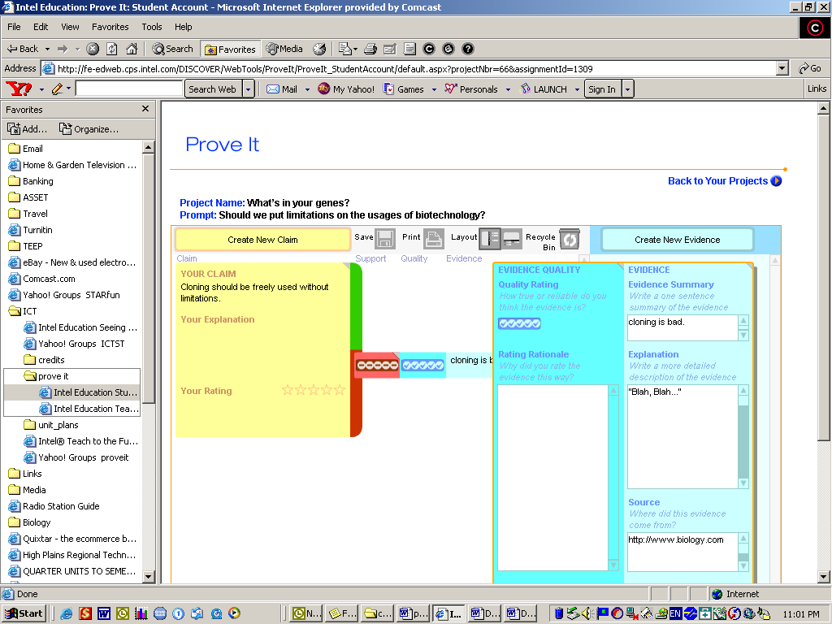
Author | Individual | Individual or Expert | Creditable Author | Expert in the field | Expert in the field
Sponsoring Organization | None | Biased Organization | Unbiased Organization | Credible  Organization | Credible  Organization
How strong is the quote? | Based on opinion | Opinion based slant | Gives both pros and cons of the usage | Factually based | Facts that are statistically supported

- Discuss with your partner and create a claim that is supported by your evidence not your opinion.

Choose one of the following statements for your claim and insert your issue in the blank:
___________ should be freely used without limitations.
___________ should be used with the following limitations …
___________ should be banned from use.

- Drag each piece of evidence one at a time over to the area supporting (green) or not supporting (red) the claim.
  - Discuss with your partner how well the piece of evidence supports or doesn’t support the claim.
  - Rate it.

Rating |  | 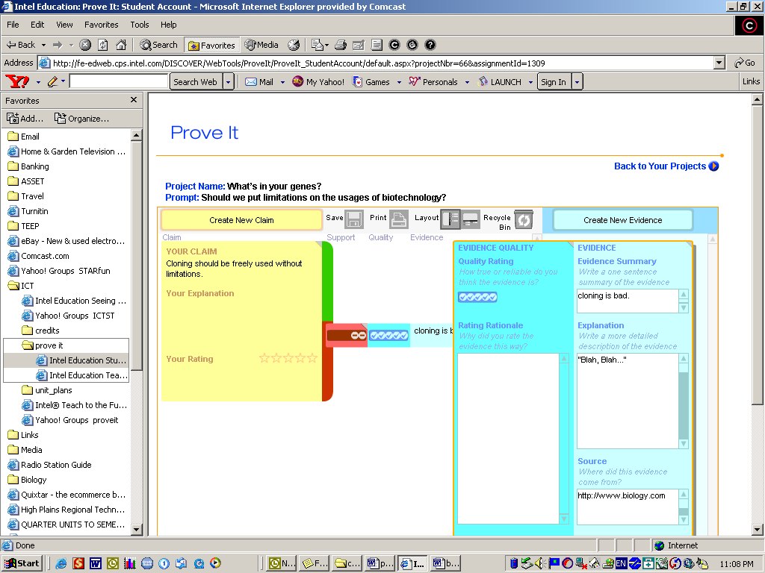  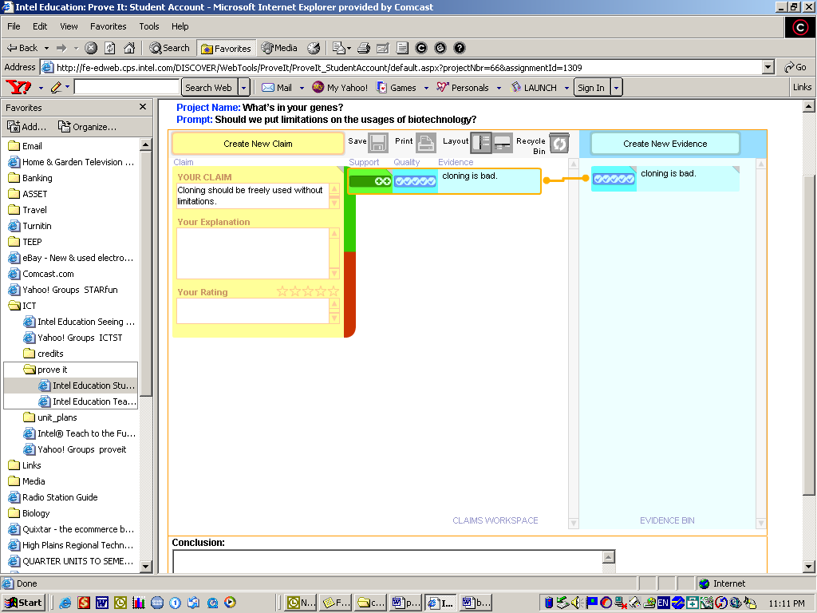 | 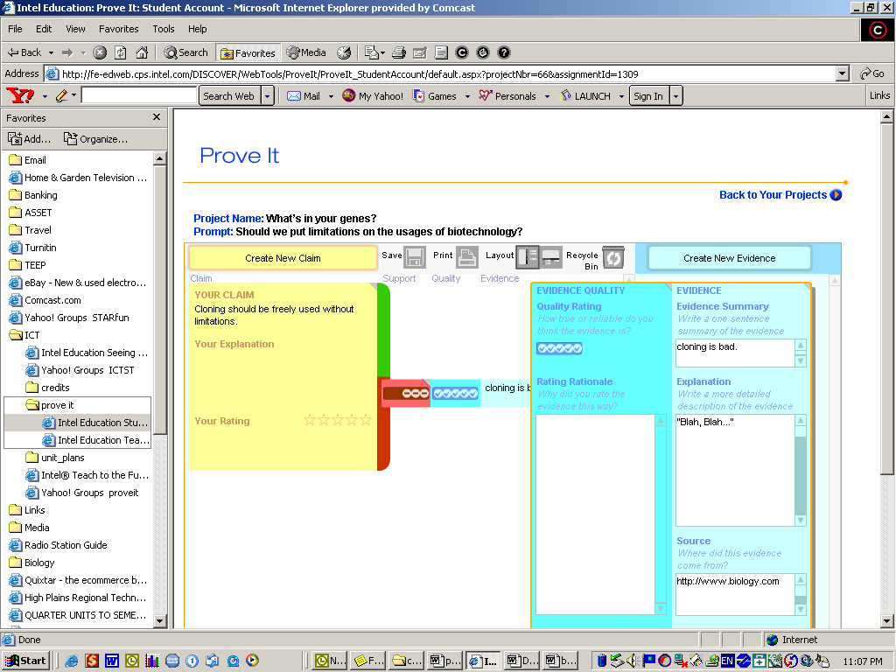  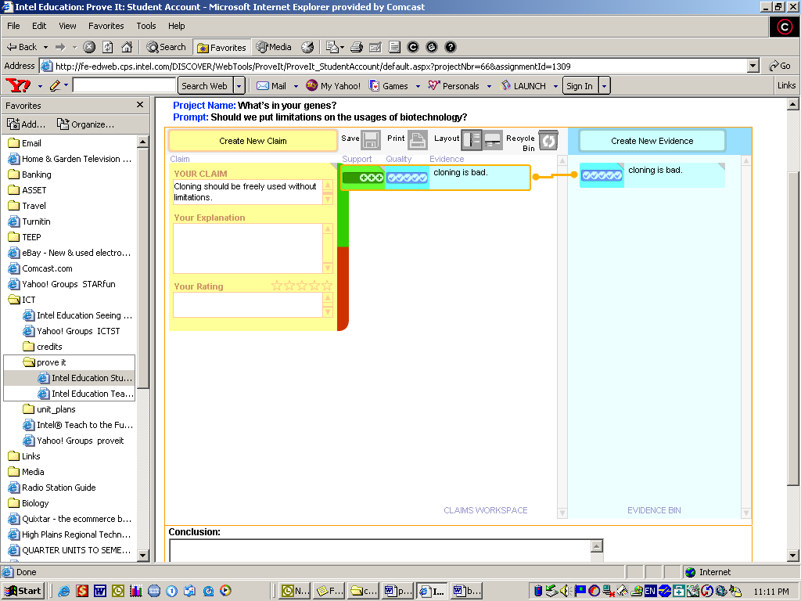  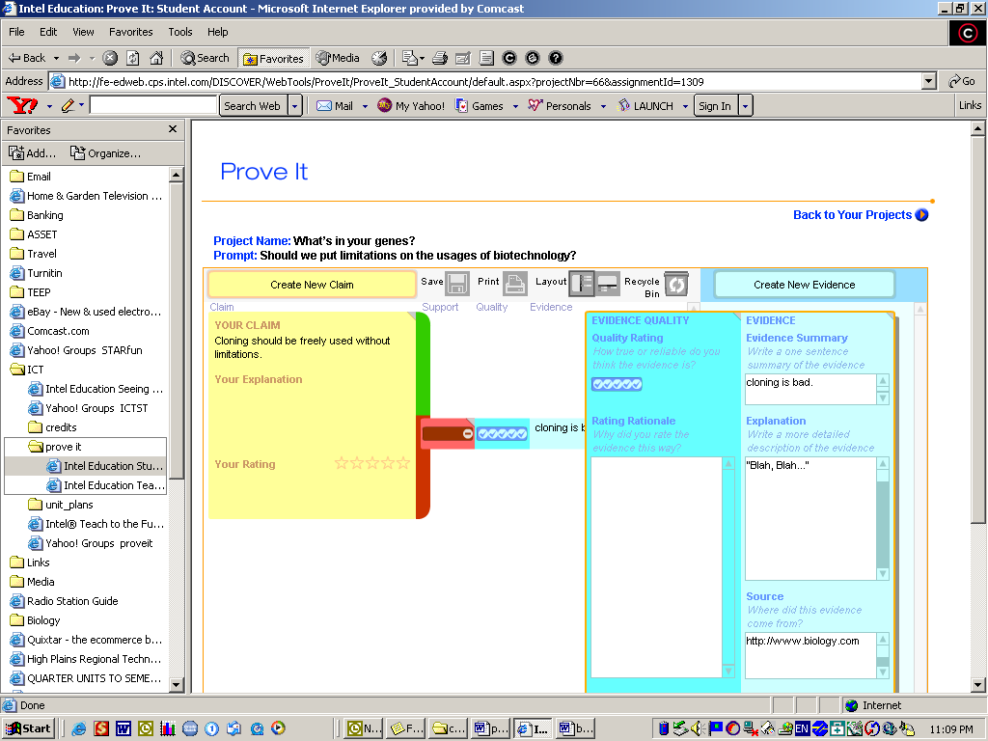  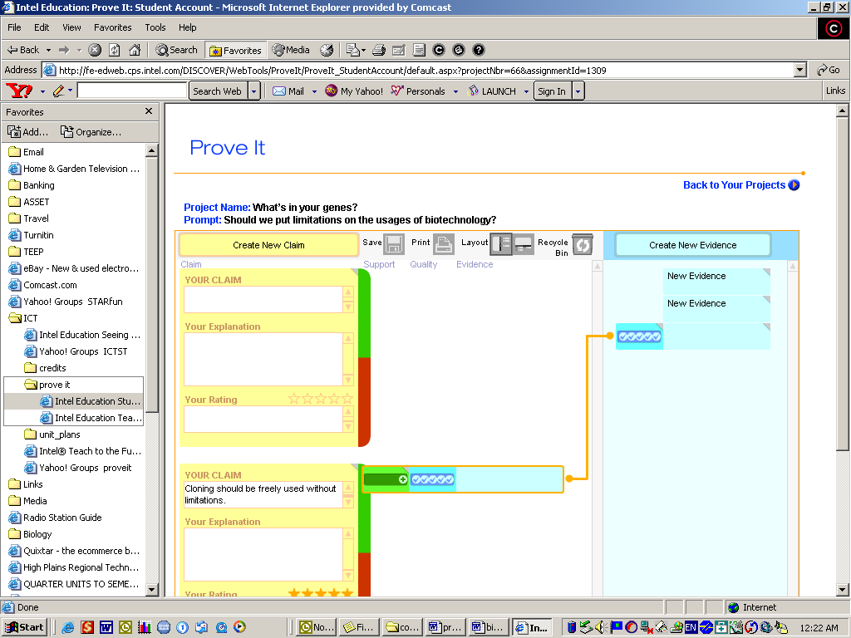 | 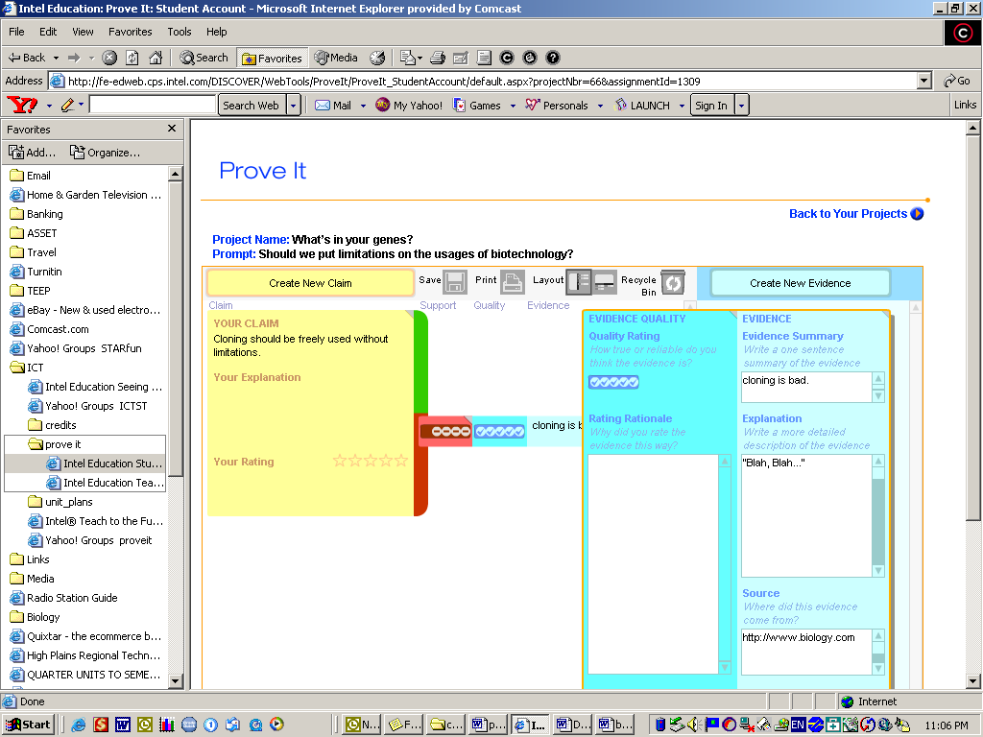  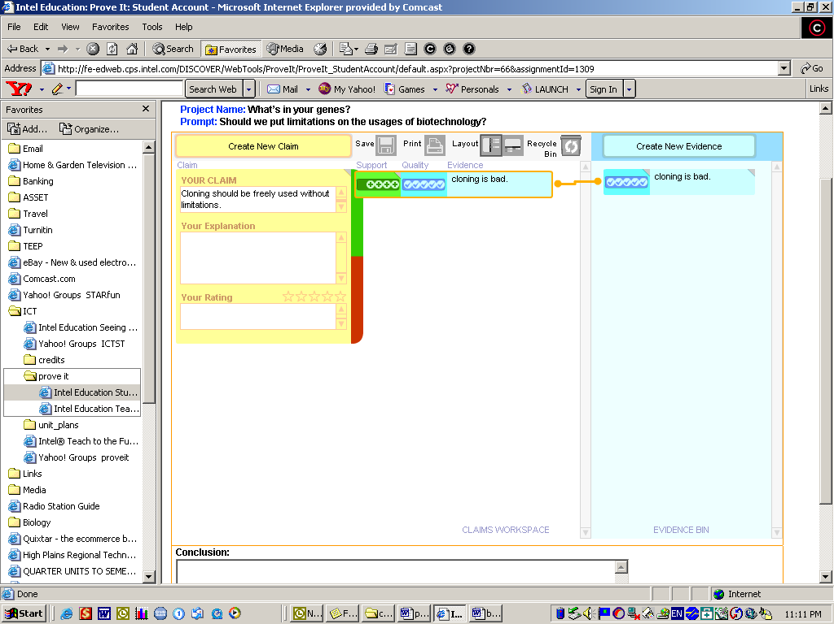 | 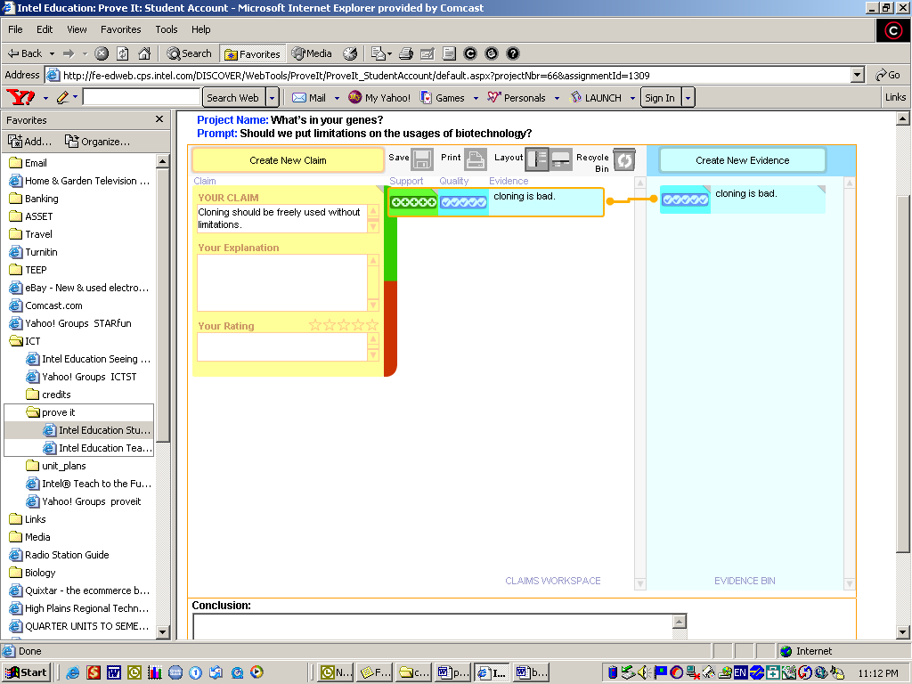
What was the evidence rated | 1-2 | 1-2 | 3 | 4 | 5
How does it support or not support the claim? | Weakly | Fairly | Strongly | Strongly | Strongly

  - Write a through explanation based on your discussion.

- Continue inputting the remaining nine pieces of evidence as you did in Step 6.

- Write a through explanation for why you chose your claim.
- Finish by ranking how strongly your claim is supported.

Ranking | 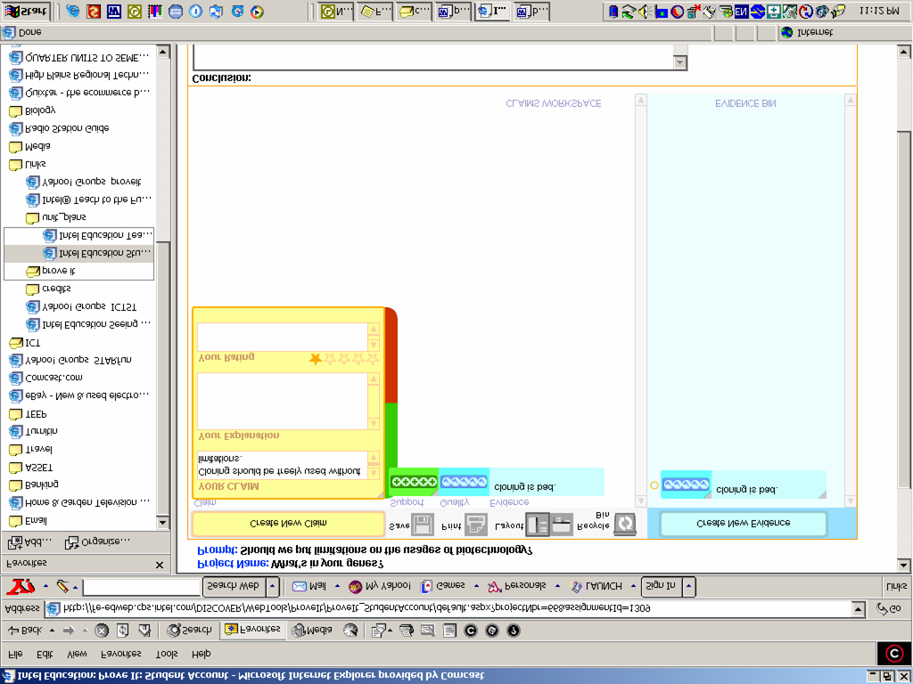 | 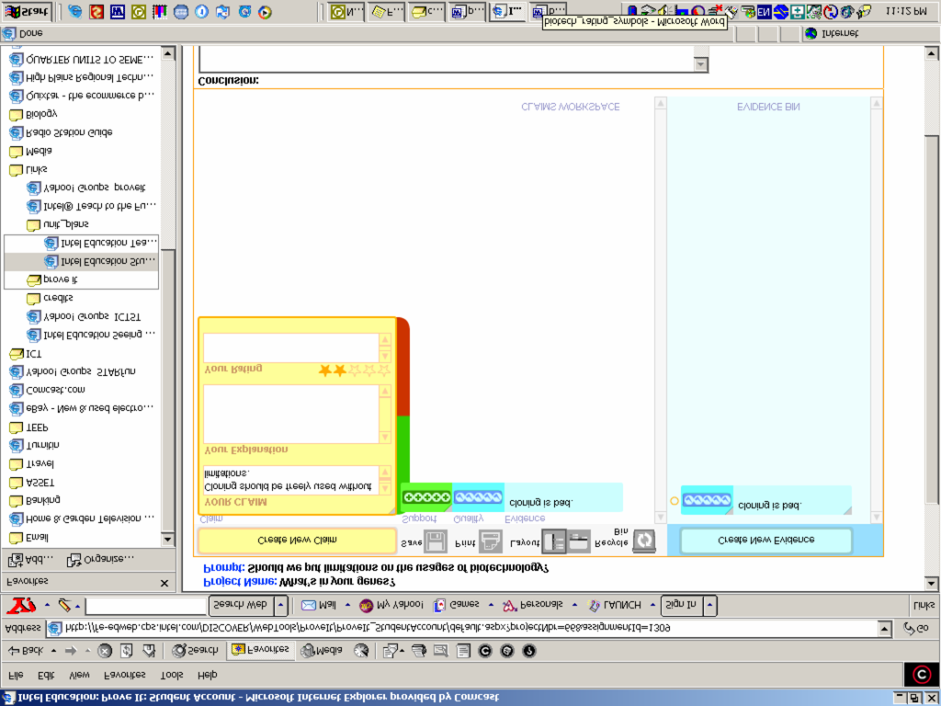 | 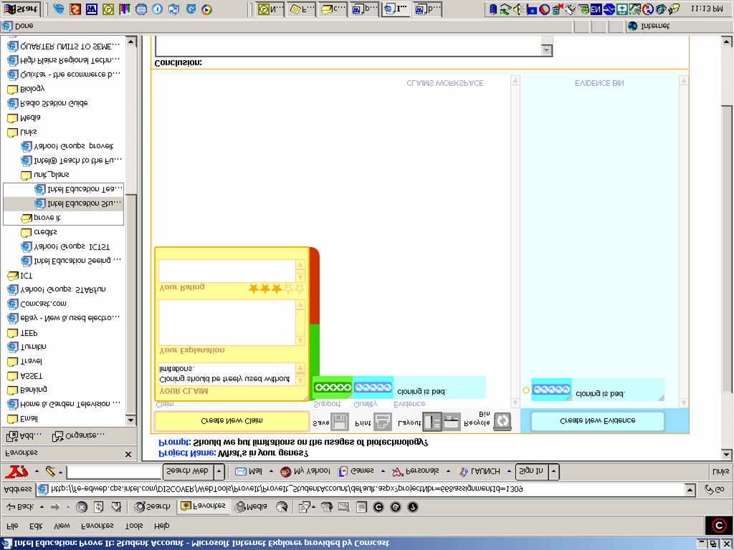 | 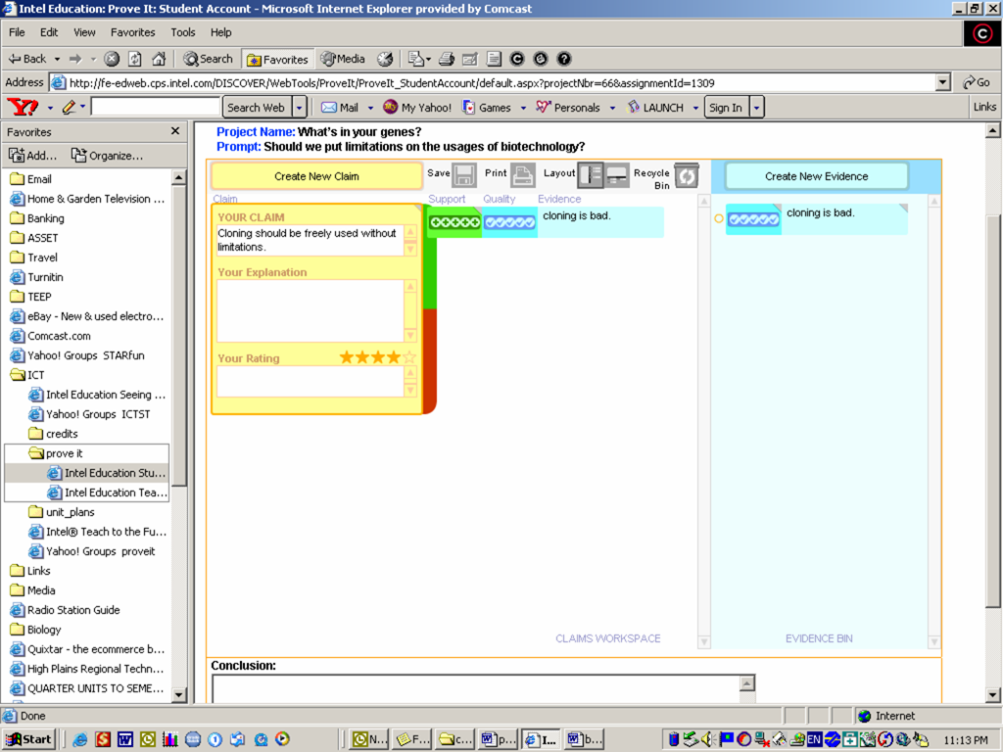  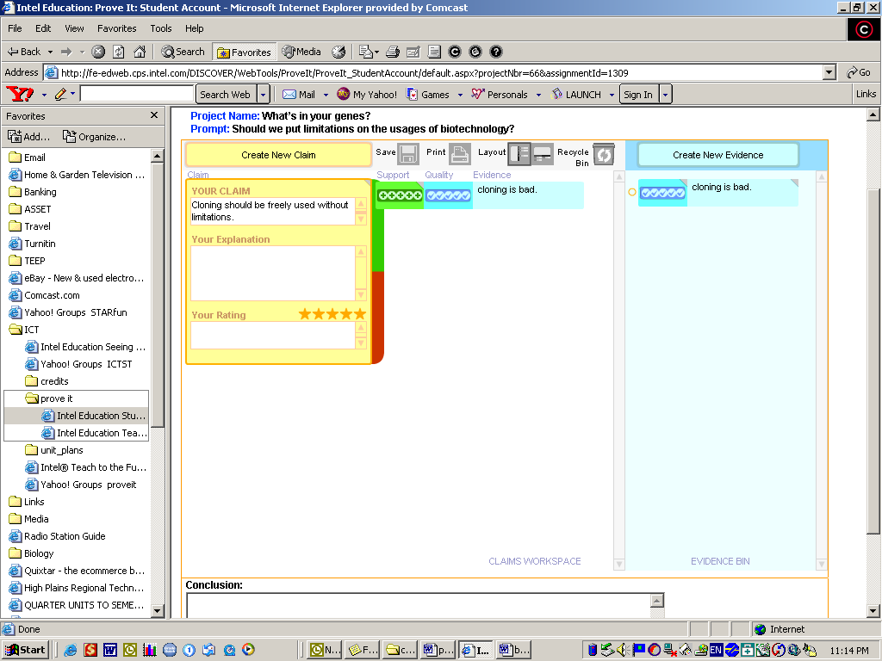
Number of pieces supporting evidence | 0-1 | 2-3 | 4-5 | 6-7 | 8-10
Number of pieces not supporting evidence | 8-10 | 6-7 | 4-5 | 2-3 | 0-1
How strong is the quality of supporting evidence | The supporting evidence has a quality rating of 3 or less. | The supporting evidences have a quality rating of 3 or less. | Three or more pieces of supporting evidences have a quality rating of 4 or higher. | Four or more pieces of supporting evidences have a quality rating of 4 or higher. | Six or more pieces of supporting evidences have a quality rating of 4 or higher.

