Adding Inline Styles to a Web Page
Other styles can be added to the inline styles. The span and div elements were designed to be used with the style element. You can use these two elements to apply styles to strings of text. The strings can be as short as a single letter or a large block of text. These elements are useful when you want to format only some of the text enclosed in an element, such as a heading or paragraph.

The span element has a start < span> tag and an end < /span> tag. The div element also has a start < div> and an end < /div> tag. You use the style element inside the start tags to format the text enclosed in span and div elements. Use the div element when you want line breaks before and after the string of text and the span element when you do not want line breaks.

You can consistently format an HTML document with the style, span, and div elements and a text editor. You add the style element to the start tag of any other HTML elements you want to format. After you add styles to your Web page, save your plain text file with an .htm or .html extension.

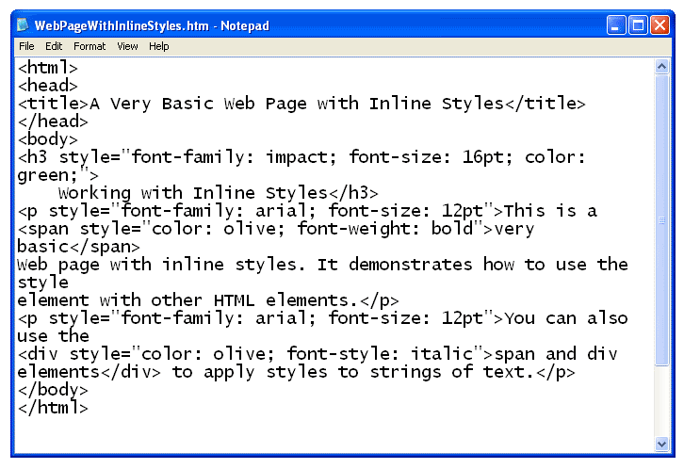

When you open the file with a web browser, the HTML document is formatted in the styles you specified. Notice that the < span>< /span> element does not cause a line break, but the div element causes line breaks before the start < div> tag and after the end < /div> tag. Also, notice that the div element ended the style defined for the paragraph. Starting another paragraph with the same style after the div element would continue the paragraph style.

