Adding an HTML Table to a Web Page
You can create a basic HTML table with the table element, its associated elements, and a text editor. You simply add the table element’s start < table> tag and end < /table> tag. Between the two table tags, you add a table row < tr> for each row you want to have in your table. After each table row you add a table header < th> tag or a table data < td> tag for each cell you want to have in that row. Then, you save the plain text file with an .htm or .html extension.

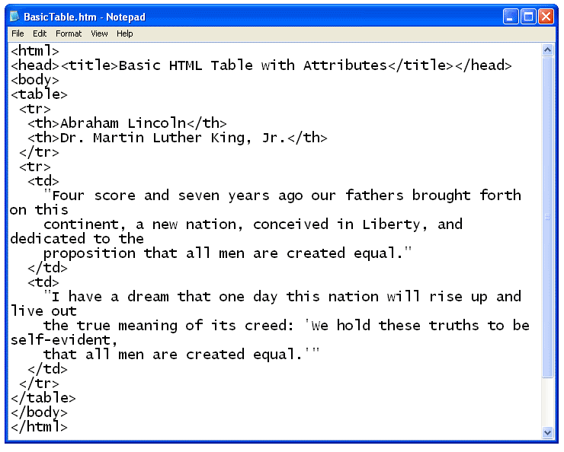

When you open the file with a Web browser, the plain text file is displayed as an HTML document with a table. The table, table rows, table headers, and table data cells are all displayed with the default values for each of their attributes.

