Formatting an HTML Table in a Web Page
You can change the appearance of the table by setting the values of its attributes. Open the file in a text editor, add the attributes you want to set, and save the plain text file with the .htm or .html extension.
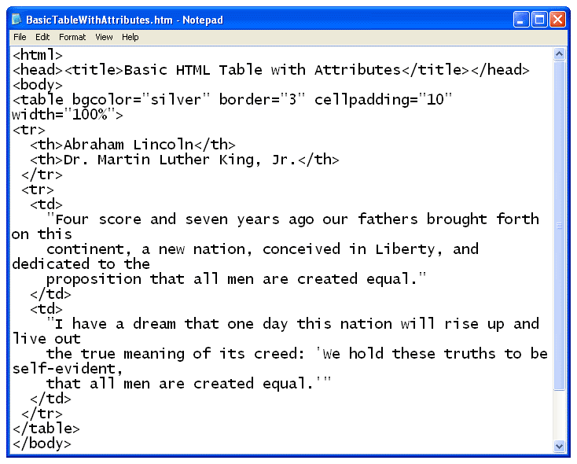

When you open the file with a web browser, the plain text file is displayed as an HTML document with a formatted table. The best way to learn how each table element’s attributes work is to change them to various settings, save the file, and view the file in a browser. You can leave both the text editor and browser windows open, and simply refresh the browser after you save the changes you make in the text file.

