Student Name
Date

Pictures and Video for United Nations Web Page

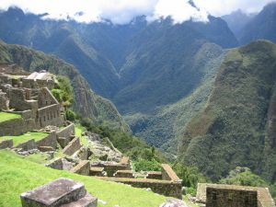
Machu Picchu

http://www.sxc.hu/photo/817984
This is a picture of the Inca site at Machu Picchu that is in danger of being destroyed. I think that seeing the archeological site will make a bigger impression than words alone.

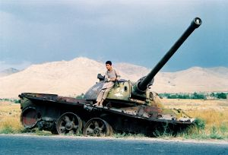
Middle East child

http://www.sxc.hu/photo/842886
This is a picture of a Middle Eastern child in a war torn country. A picture is worth a thousand words.

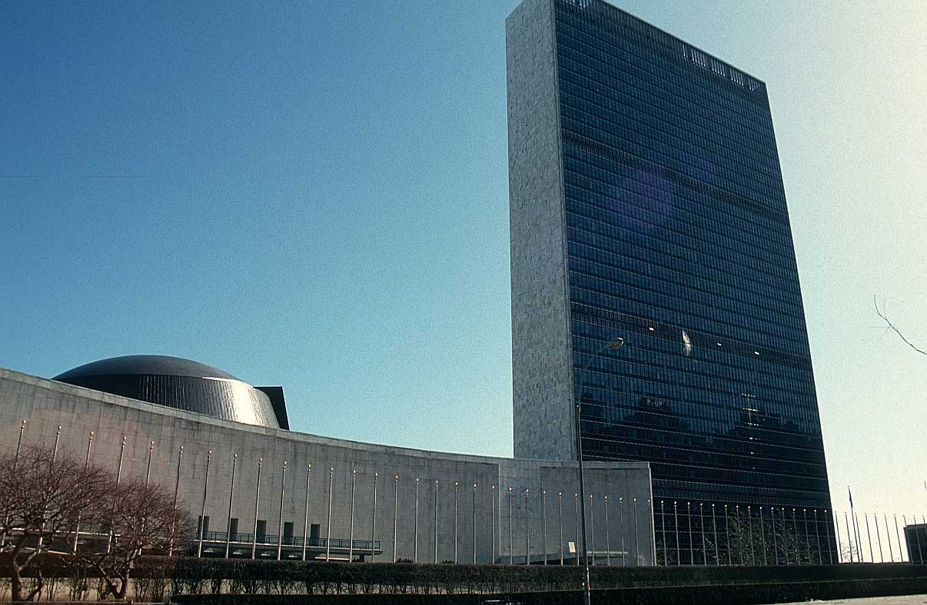
United Nations

http://www.bigfoto.com/sites/galery/newyork1/newyork13.jpg
This is the United Nations building. I think seeing the building will help make the United Nations seem more real to the reader.

Video | Darfur, Sudan
http://video.aol.com/video-search/id/1016755788
This is an excellent video that describes the very sad conditions in Darfur, Sudan. Seeing the pain and understanding the situation in Darfur can help bring the reality of the situation to the reader.
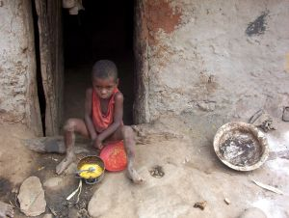
Malnourished child

http://www.sxc.hu/photo/79325
This image shows what can happen as a result of violence and malnutrition. The UN is helping to bring attention to the violence in Dar Fur.

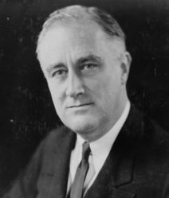

President Roosevelt

http://en.wikipedia.org/wiki/Franklin_D._Roosevelt
Since President Roosevelt was instrumental in founding the United Nations I felt it was important for the readers to see him.

