Adding Hyperlinks to a Web Page
You can add hyperlinks to a Web page with the anchor element and a text editor. You simply add the anchor tags with the location of the related document. Then, you save the plain text file with an .htm or .html extension.

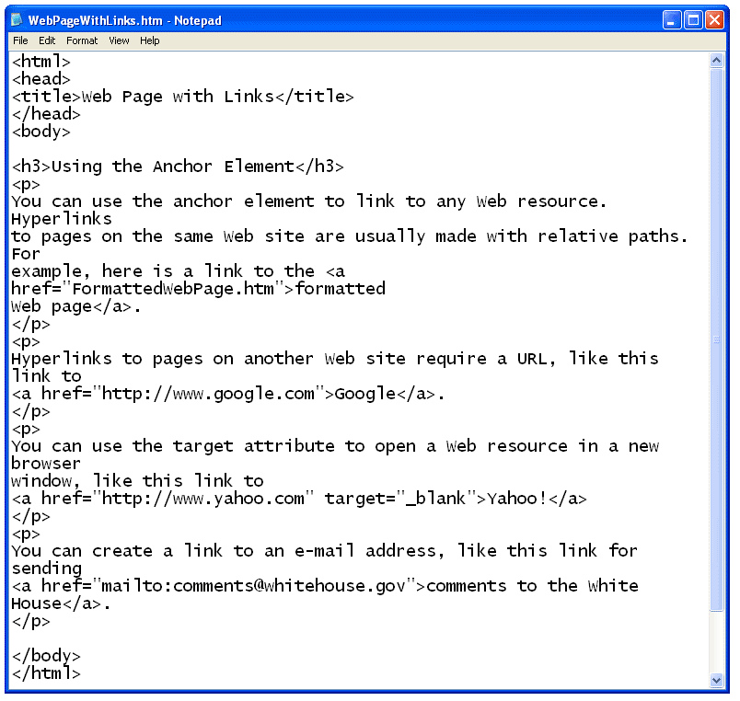

When you open the file with a web browser, the plain text file is displayed as an HTML document with hyperlinks. Notice that the anchor tags themselves are not displayed in the browser window.

