Creating a Basic Web Page
You can create a very basic Web page with the four HTML document elements and a text editor. When you have added a start <> tag and an end </> tag for each of the four elements, save the plain text file with an .htm or .html extension.

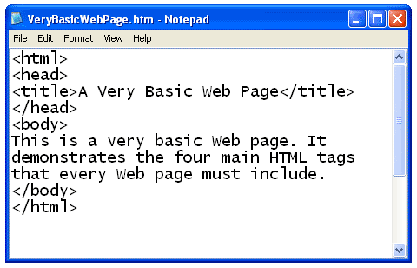

When you open the plain text file with a web browser, the text is displayed as an HTML document. Notice that the tags themselves are not displayed by the browser. The title is displayed in the blue title bar at the top of the browser window. The text that was entered in the body element of the file is displayed inside the browser window.

