Name
Date

Multimedia Management

This is the media that I will use in my presentation:

Media/Source
Reason Selected Copyright Status

http://www.sxc.hu/photo/240049
This graphic shows cooperation and what can be accomplished when everyone works together in a humorous way. This graphic will add the right touch for the conclusion of the presentation. | This picture does not need copyright permission.
bully_audio.mp3
http://www.stopbullyingnow.hrsa.gov
This short song will echo the overall theme of my presentation—that students need to “take a stand and lend a hand” to stop bullying. | This site is part of the US Department of Health and Human Services. Because government site are not copyrighted, the resources provided on this site can be used. The mp3 file should be sited in the presentation.

http://www.sxc.hu/photo/383193

This graphic shows one of the effects of bullying—isolation. It is important to remember the scars that the victims of bullying carry and this graphic shows the hurt well. | I wanted to use a different picture, but couldn’t get copyright permissions. This site picture has no copyright.
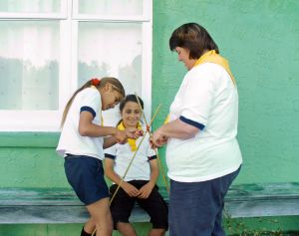

http://www.sxc.hu/photo/691745
This graphic shows girls teaming up against another girl and perhaps name-calling, a form of bullying listed in my survey data. | I wanted to use a different graphic http://pbskids.org/itsmylife/friends/bullies/index.html to show name calling, but I couldn’t get permission). This graphic is not copyrighted
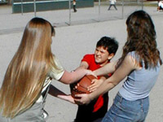

http://pbskids.org/itsmylife/friends/bullies/index.html
As the data from my survey showed, girls are likely to bully as boys are. This graphic depicts that fact. | This graphic is copyrighted. It may be used in a presentation delivered in a school and the source of the graphic must be cited in the presentation. Permission granted by request.
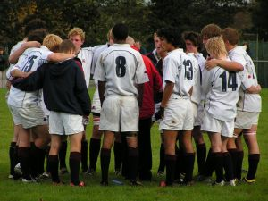
http://www.sxc.hu/photo/240049
This graphic illustrates one of the strategies to avoid being bullied. Most bullies prefer to pick on a single person and stay away from groups of people. | This graphic is not copyrighted.

