Reporting Percentages

Charts can display survey data. The chart below shows that 21 out of 25 students, or 84 percent of students, have taken personal action to reduce global warming. A pie chart is a good way to show percentages.

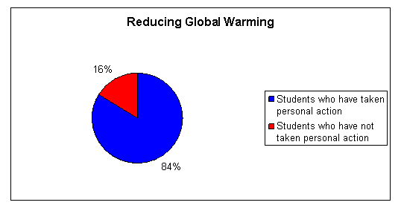

You could also report percentages for each of the five actions. The following bar graph shows how many students reported taking each action. You can use the numbers to compute percentages. A bar graph is a good way to report the number of items in selected categories.

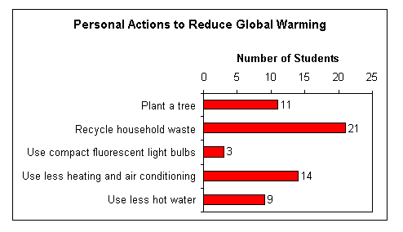

For example, 44 percent (=11/25*100) of the students reported planting a tree. In comparison, the action most frequently reported by students was recycling household waste. Overall, 84 percent (=21/25*100) of the students reported that they recycle. The least frequently reported action was using compact fluorescent light bulbs. Only 12 percent (3/21*100) of the students use compact fluorescent light bulbs.

Can you determine the percentage of students who reported using less heating and air conditioning? What percentage reported using less hot water?

