Working with Spreadsheet Applications
A spreadsheet is basically a table made up of rows and columns. The intersection of each row and column creates a cell that can hold data. Spreadsheet applications specialize in analyzing and representing data.

A single spreadsheet is sometimes called a worksheet. A spreadsheet file, sometimes called a workbook, can contain multiple worksheets. For example, you could have a worksheet for each month of the year, with all 12 worksheets saved in one workbook. Spreadsheet applications can perform calculations on data in any cell in the same worksheet, another worksheet in the same workbook, or even a worksheet in a different file.

Spreadsheet applications have a graphical user interface (GUI). A spreadsheet GUI is very similar to the GUIs in applications you have probably used more frequently, such as word processing applications. The interface provides menus that list the actions a user can take. The GUI also provides icons that represent commands on the menus. Icons are grouped together in toolbars.

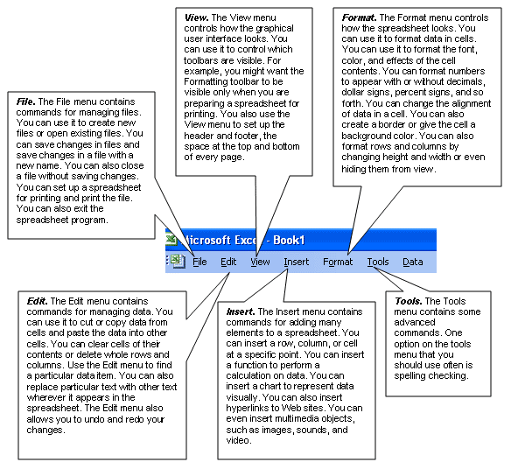

Using the Toolbar
The icons for commonly used options on different menus are gathered together on the Standard toolbar. The advantage of the toolbar is that you can select a menu option with one click. You do not have to open a menu first and then select an option.

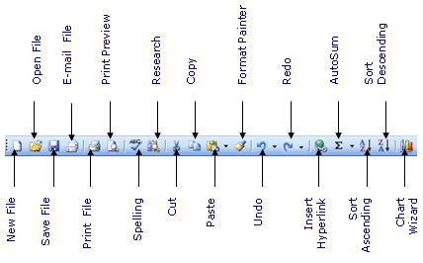

The Standard toolbar allows you to start a new file, open an existing file, save changes to a file, and print a file. You can cut, copy, and paste from the Standard toolbar. You can insert a hyperlink or a function to compute a sum or perform other calculations. You can also check spelling from the Standard toolbar.

