Working with Formulas and Functions
Spreadsheet applications use formulas and functions to calculate data. A formula is an equation you enter into a spreadsheet that can include cell references. A function is a standard formula that is built into a spreadsheet application. The difference is that you create formulas and the application includes functions.

Using a Formula
Suppose you want to add numbers in column A and column B in a spreadsheet, and you want to show the sum in column C. To set this up, you could select cell C2, click in the Formula Bar, and type =A2+B2. When you press the Enter key, the spreadsheet application will add the numbers in cells A2 and B2 and show the sum in C2.

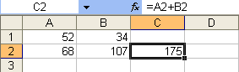

You can easily perform the same calculation on all of the remaining numbers in column A and column B of the spreadsheet. You would simply select the cell C2 and drag the lower right corner of the cell down the remaining cells in column C. This action repeats the formula in all of the remaining cells.

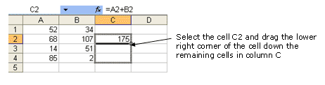

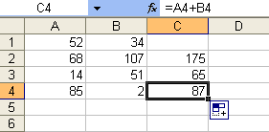

Using a Function
Functions, such as sums, are formulas built into spreadsheet applications. For example, another way to add cells A2 and B2 would be to select cell C2 and type the function =SUM(A2:B2) into the formula bar. The effect of using this function is the same as using the formula =A2+B2. You can also repeat the function for the remaining numbers in columns A and B.

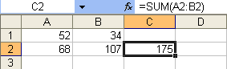

The advantage of functions becomes clear when a calculation has many variables. For example, suppose you want to add numbers in the first five columns of a spreadsheet. First, you would select cell F2 to contain the sum. Then, you then have two choices of what to type into the Formula Bar:

- The formula =A2+B2+C2+D2+E2
- The function =SUM(A2:E2)

Now, suppose you want to add numbers in the first 40 columns of a spreadsheet. Would you type a formula or use a function? Remember, the more you have to type, the more likely you are to make mistakes. Therefore, the main advantages of functions are saving time and reducing errors.

