Know Your Charts
Certain kinds of data require particular types of charts and graphs to represent them. The most common types of charts include:

- Bar Chart. Compares similarities and differences in a set of data. The items that you want to compare are represented by bars. The height or length of the bar represents the quantity of each item. For example, you could use a bar chart to compare the amount of carbon dioxide, one of the greenhouse gases that causes global warming, emitted by different countries.
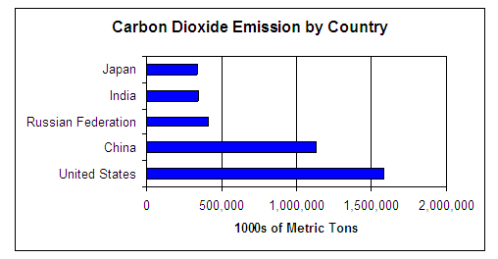

- Line Graph. Shows how a set of data changes over time. Time is usually represented on the x-axis. The items that you want to track over time are represented by points connected by lines. The location of the point on the y-axis represents the quantity of a data item at a particular time. For example, you could use a line graph to track global emissions of carbon dioxide, one of the greenhouse gases that causes global warming.

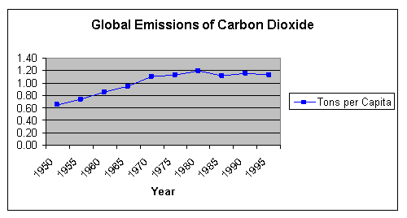

- Pie Chart. Compares parts of a set of data with each other and to the whole set. A pie chart gets its name from the fact that it looks like a pie—it is a circle representing a single set of data. Each part of the data set is represented by a slice of the pie. The size of the slice represents the quantity of that part. For example, the circle may represent all personal actions to reduce global warming taken by students in your class. Each slice would represent the number of students who took a particular action. A pie chart does not have an x-axis or a y-axis because it shows relationships within a single data set.

