Setting Up the Visual Ranking Tool Activity Using the Project Wizard

You will need to set up the Visual Ranking Tool activity before you begin Educational Leadership in the 21st Century. Participants complete this activity during Lesson 1, Activity 3.
- Go to the forum setup page: www.intel.com/education/forumsetup
- Click the Leadership Behaviors for Effective Technology Integration link.
- If you are not already logged on, you will be directed to a page that request that you log on. Click Log In.
- On the login page, enter your login ID and password, and click Login.
- The Teacher Workspace: Your Projects will open. A separate window will open as well, indicating that the project has been set up. Click OK.
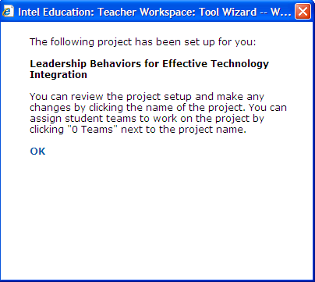
- In the Visual Ranking Projects section, click the 0 Teams link in the Student Teams column next to the project name, Leadership Behaviors for Effective Technology Integration.
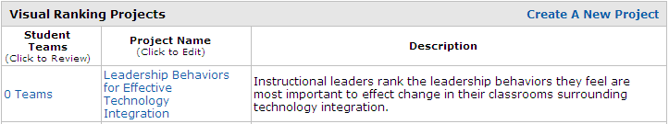
- Click Add New Student Teams.
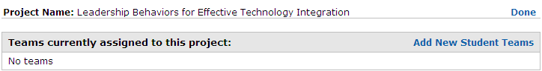
- In the Add New Student Teams section, click Create a set of new teams. If you get a warning screen, click Yes.
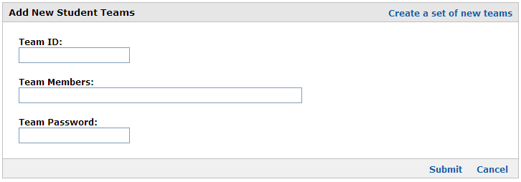
- Enter the number of teams you need for your forum, plus two more in case you have some last-minute sign-ups. Type User as the base word for the team IDs.
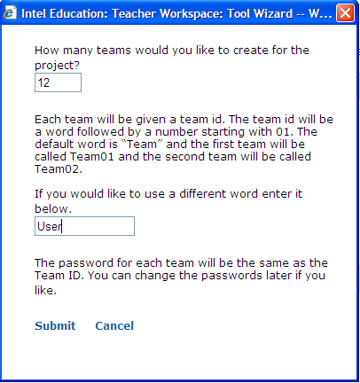
- Click Submit.
- Click Done at the top of the page. If you get a warning screen, click Yes.
- The project is now set up and ready to be used. The default password for each user is the same as the login name. Leaders will need your login ID (Teacher ID) and their login ID (Team ID) and password (which is the same as the Team ID) to log in to their project at https://educate.intel.com/workspace/student/loginpage.aspx?&LID=en.
Note: If you have difficulties using the wizard, use the instructions on the next page to create a new project without the wizard.

Setting Up the Visual Ranking Tool Activity without the Wizard

If you have difficulty with the project wizard when you set up the Visual Ranking Tool activity, copy and paste the Project Name, Project Description, and List to Sort into a new project using the content below.
- Go to: http://educate.intel.com/en/ThinkingTools/VisualRanking
- Click Teacher Workspace to log in to your thinking tool account.
- Set up a new Visual Ranking Tool project.
- Copy and paste the information below into a new Visual Ranking Tool project.

Project Name: Leadership Behaviors for Effective Technology Integration

Project Description: Instructional leaders rank the leadership behaviors they feel are most important to effect change in their classrooms surrounding technology integration.

Prompt for Students: Rank the following leadership behaviors in order of importance to facilitate integration of technology for student learning in your classrooms.

List to Sort:
Inspire and facilitate among all stakeholders a shared vision (Ia)
Advocate for policies, programs, funding to support implementation (Ic)
Model and promote the use of technology for learning (IIb)
Provide learner-centered environments equipped with technology (IIc)
Promote and participate in learning communities (IIe)
Allocate time, resources, access to ensure ongoing prof. growth (IIIa)
Lead change to maximize the achievement of learning goals (IVa)
Recruit and retain highly competent personnel (IVc)
Ensure equitable access to appropriate digital tools and resources (Va)
Promote, model and establish policies for safe, legal, and ethical use (Vb)

