Tutorial for a Wiki Site: wik.is

This document includes the steps and suggestions for setting up a wiki site for the Intel® Teach Essentials Course or your own personal classroom. These instructions apply to the wiki site, wik.is. Set up will be similar at other wiki sites, but features and specific instructions will vary.
Registering for a Wiki
Changing Your Password
Editing the Home Page of Your Wiki
Creating Sub-pages
Creating Hyperlinks to a Web Site
Creating Hyperlinks to a Page within Your Wiki
Attaching a File or Image
Inserting an Image
Adding Users to the Wiki

For other questions, visit the FAQ at wik.is: http://help.wik.is/FAQ

Registering for a Wiki

- Obtain e-mail addresses for your students or course participants.
- Go to: www.wik.is
- Click the button to start your wik.is.
- Enter the site name you want for your course or class.
Note: Make the site name unique to you, your school, or your class since it becomes a part of the URL.
- Enter your e-mail address.

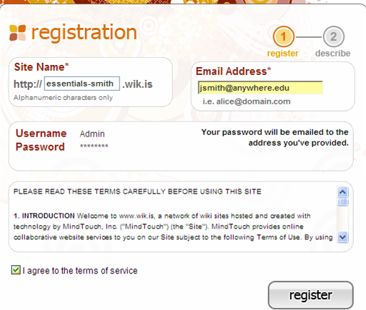
Enter a name for your wiki (a sample is provided).
Enter your e-mail address.
Note your Username as the administrator of this wiki. Your password will be e-mailed to you.

Click the checkbox.
Click the register button.
- Click the checkbox to agree to the terms of service.
- Click register.
- Check your e-mail for the login information.
- Click the link within the e-mail to activate your wiki.
- Click go to my wiki.
- Log in to your wiki using the password provided in the e-mail.
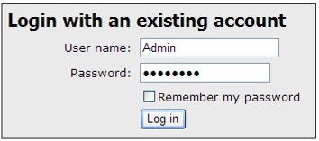
Changing Your Password
- If you would like to change your password, on the Tools menu, click My Preferences.
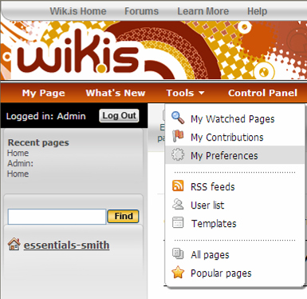
Click My Preferences.
- Click My Password and enter the old password and your new password twice.
- Click Apply preferences.

Editing the Home Page of Your Wiki
It is very important that you edit the home page of your wiki and replace the existing text with your own text in order to reassure users that they are in the right place, as well as to give them some introduction as to how they will use the wiki.
- Click the link for the home page of your wiki in the left navigation pane.
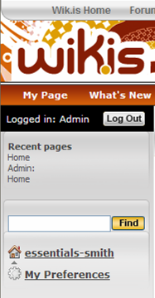
Click the name of your wiki to go to your home page.
Note: The name of your wiki will be different from the one listed here.
- Click Edit page.
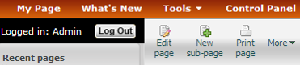
Click Edit page.
- Click anywhere on the placeholder text box to select it.
- Press the delete button on your keyboard to delete the text.
- Type a welcoming text for your course or class. If this is for your Essentials Course, copy and paste the text available from the “Setting Up a Wiki Site for Your Course” document located in the Training Community Resources > Prepare for Course.
Note: The title on the home page cannot be edited since it is tied to the URL of the wiki.
- You can change the style of the text quickly through the styles drop-down menu. Select the text so it is highlighted and then select a style from the drop-down menu.
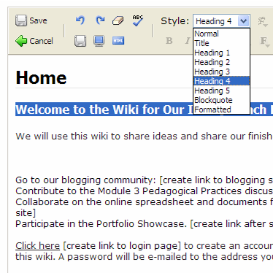
Click the Save and Exit button the first time you save.
Click the drop-down box to edit the font style.
Note the Save without exiting button.
- Click the top left Save and Exit button. This save button will take you out of edit mode, but must be used the first time you save a page.
Note: You can click the Save without exiting button on the second row for any subsequent saves where you want to save your work but continue working on your page.
- Click the Edit page button to go back into edit mode and continue working on your welcome message.
- Use the Save without exiting button frequently as you work so that you will not lose work in case your connection to the Internet fails.
- Click the top left Save and Exit button to save and exit when you are done.

Creating Sub-pages
- Click New sub-page.
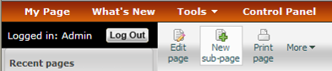
- Select to highlight the Page Title text and then type your own.
Note: The page title will become a part of the wiki URL for this page, so keep the title short.
- Click the top left Save and Exit button to save and exit.
- Click the Edit page button to go back into edit mode. Delete the placeholder text and create the text for the body of the sub-page. If this wiki is for your Essentials Course, copy and paste the text available from the “Setting Up a Wiki Site for Your Course” document located in the Training Community Resources > Prepare for Course for the appropriate sub-pages, such as Module 2 Pedagogical Practices.
- Format the text as desired—adding, for example, bold, bullets, or color.
- If the format of pasted text is not what you want, use the Clear formatting button to eliminate formatting code that is creating undesired results.
- Use the Save without exiting button frequently as you work so that you will not lose work in case your connection to the Internet fails.
- Click the top left Save and Exit button to save and exit when you are done.

Creating Hyperlinks to a Web Site
- To create a link to another web site, select the text that you want to hyperlink so that it is highlighted.
- Click the blue underlined L on the menu.
Click the Insert/modify link button.

Type or paste the URL.

Click Make link.
- Paste or type the URL into the Link box.
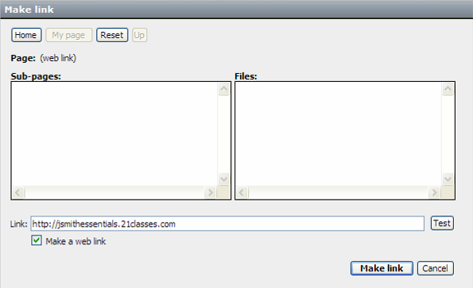
Creating Hyperlinks to a Page within Your Wiki
Although the left-hand navigation is almost always present, it may be helpful to provide links to internal wiki pages within the body of your home page so that you can provide context. Use the instructions below to create a link to a page within your own wiki.
- Select the text that you want to hyperlink so that it is highlighted.
- Click the blue underlined L on the menu.
- Select the desired sub-page listed in the box. The link will automatically be created.
- Click Make link.
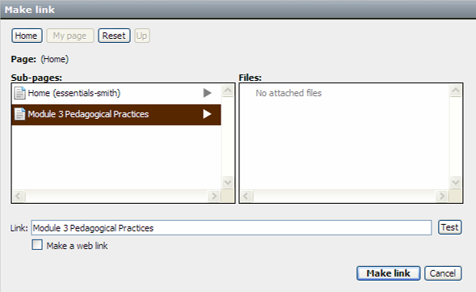

Select the desired sub-page.

Click Make link.
- On the home page of your wiki, you may want to put a link to the login page where your participants or students can either log in or register to use the site.
  - Click logout and you will be brought to the login page.
  - Copy the URL of the login page. It will be unique to your wiki.
  - Log back in as the admin.
  - Edit the home page and create a link to the login page.

Attaching a File or Image
Before you can link to a file or insert an image into the body of your text, you have to attach—or upload—the file. All files uploaded to a particular page will appear at the bottom of the page; therefore, it may not be necessary to provide an internal link to the file as well, unless you want to provide context or additional instructions.
- Go to the wiki page where you want the file or image to appear.
Note: You cannot be in edit mode when attaching a file.
- There are two ways to attach a file:
  - On the More menu, select Attach file or image, OR
  - Click the Attach file or image link at the bottom of any of your wiki pages.
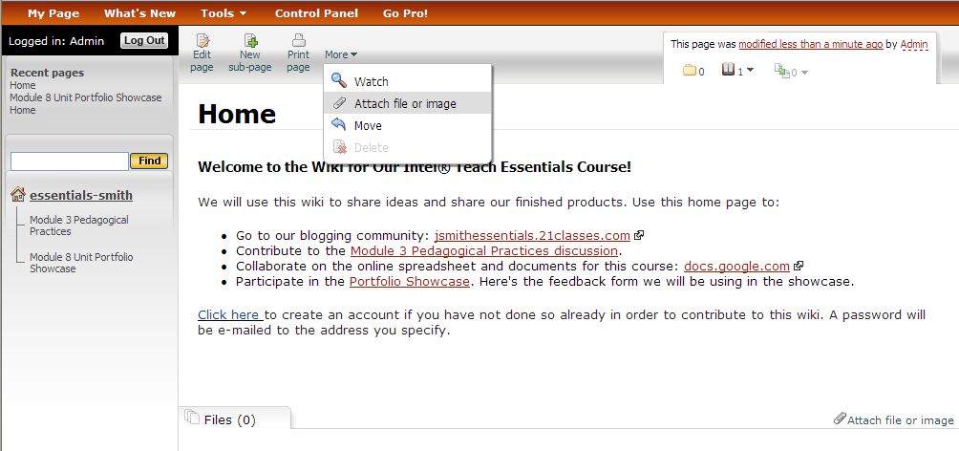
Select either method to upload a file.
- Click Browse and locate the file on your computer. Click Open.
- Type a description of the file, if needed.
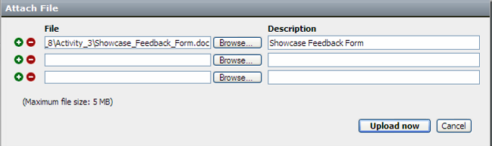
- Click Upload now.
- Once the file is uploaded, it will be listed at the bottom of the wiki page.
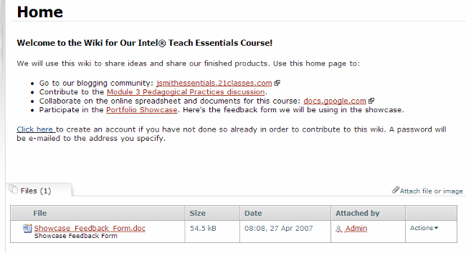
Uploaded files appear at the bottom of the page.
- If desired, you can create a link to the uploaded file.
  - Click the Edit page button.
  - Select the text that you want to hyperlink so that it is highlighted.
  - Click the blue underlined L on the menu.
  - Select the file from the right-hand side. The link will automatically be created.
  - Click Make link.
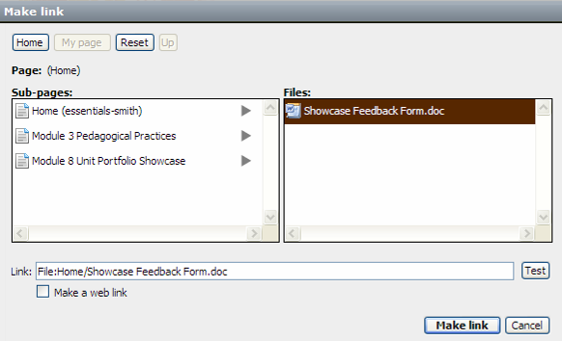
Inserting an Image
Before you can insert an image onto your wiki, you must upload—or attach it—to your wiki. (See previous instructions.) Once that is accomplished, you can insert the image onto the wiki page.
- Click the Edit page button for the page where you want to insert the image.
- Place your cursor at the location in the page where you want the image to appear.
- Click the Insert image button.
- Select the desired image located in the middle panel. (All uploaded images will be listed.) Once you click on an image, a preview will appear on the right.
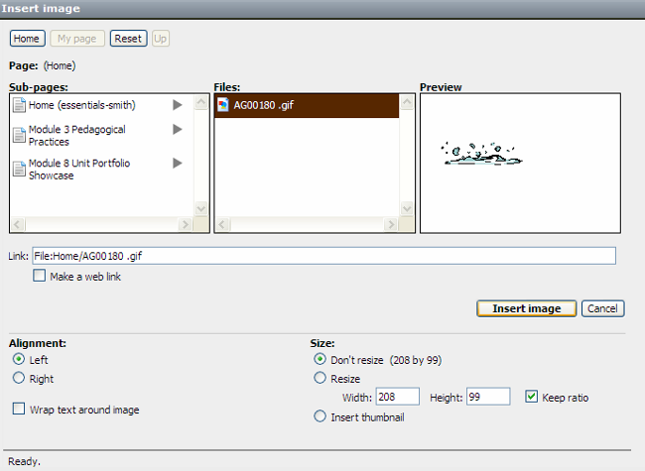
- Make any additional modifications for how the image will appear on the page.
  - If desired, you can resize the image or automatically size the image down to create a thumbnail size (a postage stamp size—or about the size of your thumb).
  - You can change the alignment or how text will interact—or wrap—with your image.
Change how the image Re-size the image.
will appear on the page.
- Click Insert image.

Adding Users to the Wiki
It may be easier for your users if you create a login account for them. You can create a standardized user name, such as one generated by first initial and last name. When you add a user, the system at wik.is automatically generates a randomly-created password and e-mails it to the user. If the e-mail address either does not exist or e-mail server rejects the e-mail sent by wik.is (sometimes it is seen as spam), you will be notified, along with a copy of the e-mail that was sent out—which includes the login name and password. It may be necessary to provide the login information directly to the user. In the case of adding students as users, you may want to intentionally create e-mail addresses that do not exist in order to receive the passwords directly.
- Click Control Panel.
- Click User Management.
- If this wiki is for a K-12 classroom, you may want to uncheck the box under Account creation settings, which will not allow people to create accounts for themselves via the Log In page. If this wiki is for the Essentials Course, it may be helpful to keep that default setting.
- To quickly add new users, click the Click here link several times to add another row to the form. This will provide multiple entry boxes so you will be able to submit the new users in batches.
- Add User names using a standardized login, such as first initial and last name.
- Add corresponding e-mail addresses.
- It may be helpful to add the users’ full name or first name in the Real name box to help identify them. This field is optional.
Click Control Panel, then User Management.
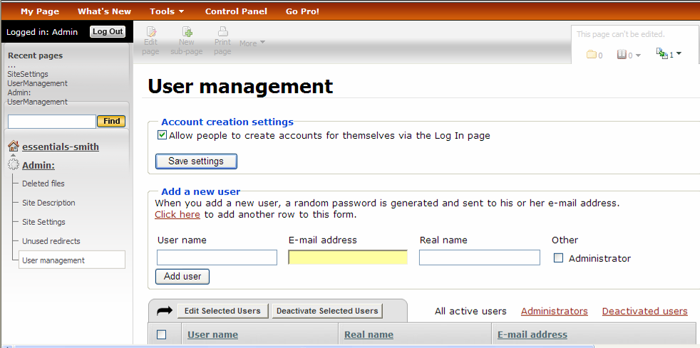
Click Click here to add multiple rows to the form.
When user information has been entered, click Add user.
- If you have a co-facilitator or team teacher(s) who will be helping to administer this wiki, you may want to click the Administrator box when adding them to the site in order to allow all management rights.
- Click Add user.

