

Intel® Teach Program
Facilitation Guide

May, 2008
Version 1
[Page Name: Facilitation Guide]
[Page Name to Show in Course Menu: Facilitation Guide]
[Previous & Next Link: No Links]

[Block: Content, no Border]
[Supertitle:]
[Title:] Facilitation Guide
[Subtitle:] Overview
This guide offers guidance on the preparation and delivery of the online course. For offline viewing, click the link below to download a PDF of the guide.

The Facilitation Guide [insert link to http://download.intel.com/education/common/en/resources/EO/facilitation_resources/Facilitation_Guide.pdf] is divided into seven sections:

Section 1: Recruiting Participant Teachers [insert link] reviews expectations for Participant Teacher recruitment and presents facilitators with necessary tools and strategies to support the recruitment process.

Section 2: Preparing for the Course [insert link] provides detailed instructions for setting up the Web 2.0 sites, planning co-facilitation, and making the necessary onsite preparations for the training.

Section 3: Using the Online Manage Features [insert link] includes instructions for accessing and using the following online features: Manage Training, Post Announcements, Invite/Unenroll Participants, Set Up Schedule, Set Up Chat, Create a Discussion, Review Surveys, and Certify Participants.

Section 4: Conducting the Orientation [insert link] prepares facilitators for the initial portion of the training.

Section 5: Conducting the Face-to-Face Training [insert link] provides a step-by-step outline of the facilitator’s duties and responsibilities during the face-to-face portion of the training. This part also includes information on using and integrating the required resources.

Section 6: Conducting the Online Training [insert link] provides a step-by-step outline of the facilitator’s duties and responsibilities during the online portion of the training. This part also includes information on how to best use and integrate the required resources.

Section 7: Accessing Facilitation Resources [insert link] provides an alphabetical list of the facilitation resources referenced in this guide.

All documents linked in the online Facilitation Guide are also compiled for easy downloading in Section 7: Accessing Facilitation Resources. [insert link] In addition, online task lists are provided to help you organize tasks for each component of the training. These task lists are located under the Facilitation tab > Manage Training link [insert link]. For your convenience, the task lists are also available as downloadable files in Section 7: Accessing Facilitation Resources. [insert link]
[Page Name: S1: Recruiting Participant Teachers]
[Page Name to Show in Course Menu: S1: Recruiting Participant Teachers]
[Previous & Next Link: Next Page Only]

[Block: Content, no Border]
[Supertitle:] Facilitation Guide
[Title:] Section 1: Recruiting Participant Teachers
[Subtitle:] Overview

[Block: Facilitator Corner]
[Block Title: leave blank]
[Minutes: leave blank]
[Display Picture: NO]

As a Master Teacher for the Essentials Online Course, you are required to:

- Participate fully in MT training and be prepared to present the Essentials Online Course to Participant Teachers.
- Review the MT Milestones [link to doc - http://download.intel.com/education/common/en/resources/EO/ facilitation_resources/MT_Milestones.doc] (DOC; 1 page) to track your progress
- Recruit Participant Teachers, according to the guidelines
- Train at least 10 Participant Teachers
- Deliver all eight modules in no fewer than 7 weeks from the starting date and within 12 months of completing your Master Teacher training

Because you are certified to deliver Essentials in either format—fully face-to-face or hybrid online—you may want to review the differences between the two delivery formats and confirm which is best for your situation. Both courses deliver the same outcomes; only the delivery methods are different. Review the Decision Guide [link to - http://download.intel.com/education/common/en/resources/EO/facilitation_resources/decision_guide.pdf - open in new window] (PDF; 3 pages) to help guide you in your decision. Also review the Face-to-Face vs. Online Course [link to xls - http://download.intel.com/education/common/en/resources/EO/facilitation_resources/F2F_vs_Online_Course.xls - open in new window] (xls; 1 page) spreadsheet to understand the specific differences between Essentials Online and Essentials v.10 (face-to-face).

- If you choose the face-to-face format, e-mail teacher.training@intel.com and request a single Master Teacher guide, print materials, and extranet account instructions to set up your training.
- If you choose the hybrid online, continue below.

This section provides practical strategies and resources you can use to successfully recruit Participant Teachers and fulfill the course requirements:

Part 1: Reviewing Recruitment Guidelines provides Participant Teacher recruitment guidelines.

Part 2: Considering Recruitment Strategies outlines a Participant Teacher recruitment process and several supporting strategies.

[Page Name: S1; P1: Recruitment Guidelines]
[Page Name to Show in Course Menu: P1: Recruitment Guidelines]
[Previous & Next Link: Both Previous and Next]

[Block: Content, no Border]
[Supertitle:] Facilitation Guide
[Title:] Section 1: Recruiting Participant Teachers
[Subtitle:] Part 1: Reviewing Recruitment Guidelines

[Block: Facilitator Corner]
[Block Title: leave blank]
[Minutes: leave blank]
[Display Picture: NO]

Recruiting people with the appropriate technology skills for your training will avoid “show-stopping” obstacles. This is not a course for new users of technology. Please review the guidelines below for recruiting participant teachers.

[Block: Content, no Border]

Participant Teachers must:

- Be current K–12 classroom teachers in a participating district or consortium
- Possess intermediate-level computer skills. Teachers should be able to:
  - Format and edit text
  - Copy, cut, and paste text and graphics
  - Save documents
  - Use e-mail
  - Navigate and perform a search on the Internet
  - Be familiar with a word processing program

Note: Teachers who do not possess these skills prior to Intel® Teach Essentials Online Course should successfully complete pretraining workshops or classes. Pretraining workshops are not provided by the Intel Teach Program.
- Commit to completing 60 hours of training (12 hours face-to-face and 48 hours online).
Participant Teacher benefits include:

- Free, practical, standards-based, hands-on training on integrating technology into the classroom curriculum
- Creation of a Unit Portfolio that integrates technology into the teacher's existing curriculum
- Opportunity to purchase university/continuing education credits, based on availability (to be established by the LEA)

back to top

[Page Name: S1: P2: Considering Strategies]
[Page Name to Show in Course Menu: P2: Considering Strategies]
[Previous & Next Link: Both Previous and Next]

[Block: Content, no Border]
[Supertitle:] Facilitation Guide
[Title:] Section 1: Recruiting Participant Teachers
[Subtitle:] Part 2: Considering Recruitment Strategies

[Block: Facilitator Corner]
[Block Title: leave blank]
[Minutes: leave blank]
[Display Picture: NO]

Teachers have very busy schedules and often have access to a variety of professional development opportunities. To convince teachers to take your course, you need to show them that it will be a worthwhile experience that will enhance their instruction and improve their students’ learning. You may also need to convince administrators of the course’s value. In this activity, you review strategies to help recruit Participant Teachers.

[Block: Content, no Border]

Review and select strategies from the following list to support your recruitment process:

- Look at the school calendar and request opportunities to address teachers during faculty meetings and in-service sessions. In your presentations and discussions, include teacher testimonials and research about technology integration and sustained teacher professional development.
  - Review the Intel Teach Essentials Online Course Overview [link to file - http://download.intel.com/education/common/en/resources/eo/resources/about_this_course/EO_P2_Course_Overview.doc - new browser window] (DOC; 3 pages) Consider printing and distributing it as a handout in your presentations.
  - Review the Course Overview presentation [link to doc - http://download.intel.com/education/common/en/resources/EO/facilitation_resources/Course_Overview.ppt] (PPT; 12 slides).
  - Identify information you may want to add to these course overview resources.
- Talk to colleagues, friends, and neighbors about your experiences in the course and share your insights.
  - See if you can get permission to conduct part or all of your training during designated professional development times or events.
  - Create posters and/or brochures with the necessary course details and distribute them to school personnel. Post flyers in prominent locations, including teachers’ lounges, school and district offices, teachers’ school mailboxes, computer labs, classrooms, hallways, break rooms, and local community centers.
  - Determine any existing local school-wide technology or curriculum initiatives and show connections between those initiatives and the Essentials Online Course. Illustrate how the Essentials Online Course may extend or support the existing initiatives.
  - Consider other ways to sustain your efforts as well as promote the Essentials Online Course goals and objectives, such as mentoring (pairing teachers to support each other), e-mail groups, mini-workshops, lunch meetings during the school year to discuss challenges and successes, a sharing night to present accomplishment to parents and other teachers, and so forth.

- Consider what schedule would best serve the teachers you are trying to recruit. Review the embedded spreadsheets in the Sample Course Schedules [link to doc - http://download.intel.com/education/common/en/resources/EO/facilitation_resources/sample_course_schedules.doc - open in a new window (DOC; 1 page with 3 embedded XLS files) document to help you decide the best schedule for your training.

Determine available teacher incentives.

Work with your school or district to identify possible teacher incentives:

- Tangible incentives:
  - Course credit
  - New software or equipment
  - Stipends
- Intangible incentives:
  - Greater professional status
  - Personal interest or gain
  - The chance to network and build professional resources

back to top

[Page Name: S2: Preparing for the Course]
[Page Name to Show in Course Menu: S2: Preparing for the Course]
[Previous & Next Link: Next Page Only]

[Block: Content, no Border]
[Supertitle:] Facilitation Guide
[Title:] Section 2: Preparing for the Course
[Subtitle:] Overview

[Block: Facilitator Corner]
[Block Title: leave blank]
[Minutes: leave blank]
[Display Picture: NO]

Advanced preparations are necessary to ensure a smooth start to your training. This section provides detailed instructions for preparing both the physical environment and the online environment. You must also begin preparing your participants so they can take full advantage of the face-to-face portion of the training.

Part 1: Preparing the Environment specifies the tasks for establishing an adequate computer lab for the face-to-face training, ordering materials, registering participants, and designating dates and times for your training. You also modify and send two existing introductory e-mails—an introductory letter and course registration information.

Part 2: Setting Up the Web 2.0 Tools details the instructions for setting up the Course Wiki, blog, tagging/bookmarking, and online collaborative Web sites.

[Page Name: S2: P1: Prepare for Participants]
[Page Name to Show in Course Menu: P1: Prepare the Environment]
[Previous & Next Link: Both Previous and Next]

[Block: Content, no Border]
[Supertitle:] Facilitation Guide
[Title:] Section 2: Preparing for the Course
[Subtitle:] Part 1: Preparing the Environment

[Block: Facilitator Corner]
[Block Title: leave blank]
[Minutes: leave blank]
[Display Picture: NO]

In this activity, you devote some time to preparing for the Orientation and face-to-face portions of your training. Communicating the necessary information sets expectations and builds a community atmosphere.

[Block: Content, no Border]
Review the Prepare for the Course task list [insert link to task list]. This list contains tasks to help you prepare for your training. For your convenience, all course Task Lists (xls; 11 worksheets) [insert link to task lists - http://download.intel.com/education/common/en/resources/EO/facilitation_resources/task_list.xls] are downloadable from the Facilitation Guide > Section 7: Accessing Facilitation Resources [anchor link].

Two important e-mails are sent prior to the training:

- Facilitator Introduction for Intel® Teach Program Essentials Online Course Two weeks before the training, you prepare an initial e-mail for Participant Teachers to welcome and introduce them to the course. This sets the tone and expectations for collaborative professional development.

- Accessing the Intel® Teach Program Essentials Online Course and Completing the Orientation One week prior to the face-to-face training, send an e-mail with login information for the course so participants can complete the Orientation.

- (Optional) Accessing the Intel® Teach Program Essentials Online Course and Completing the Orientation—Reminder Two days before the face-to-face training (or whatever timeline you designate), send an e-mail to remind and encourage participants to complete the Orientation.

Review the sample Introductory E-Mails [link to document - http://download.intel.com/education/common/en/resources/EO/facilitation_resources/Introductory_E-mails.doc] open in a new window (DOC; 4 pages). All sample e-mails can be downloaded from the Facilitation Guide > Section 7: Accessing Facilitation Resources [anchor link].

Modify the introductions for your own use. Consider whether you want to include any of the following:

- An introduction to you, including your background, your motivation for facilitating this course, and a testimonial or personal story to help bond with participants.

- Details on how to select an appropriate unit idea to use in the training. Explain that developing a new unit for this training is more labor intensive than bringing a unit that has already been implemented but does not include the integration of technology. Seeing the role technology plays in a unit is clearer when there is a basis for comparison. The unit should also address critical learning standards and objectives.

back to top
[Page Name: S2: P2: Revisit Initial Setup]
[Page Name to Show in Course Menu: P2: Set Up Web 2.0 Tools]
[Previous & Next Link: Both Previous and Next]

[Block: Content, no Border]
[Supertitle:] Facilitation Guide
[Title:] Section 2: Preparing for the Course
[Subtitle:] Part 2: Setting Up the Web 2.0 Tools

[Block: Facilitator Corner]
[Block Title: Facilitator Corner]
[Minutes: leave blank]
[Display Picture: No]

In this section, you review the Web 2.0 tools used in your course and directions for setting up your tag/bookmarking, blog, and online collaborative Web sites. Read the instructions for setting up your Web 2.0 sites and then create them for your training:

- Create a Blog [insert link to S2: P2: Create a Blog]
- Review the Course Wiki [insert link to S2: P2: Using the Course Wiki]
- Create an Online Spreadsheet [insert link to S2: P2: Create an Online Spreadsheet]
- Select a Tag/Bookmark Site [insert link to S2: P2: Select a Ta/Bookmark Site]

Note: You will need participants’ e-mail addresses to register the participants for the sites mentioned above (except for the Course Wiki, which is internal). When possible, use participants’ personal e-mail addresses, since many business e-mail systems may block the invitation e-mails from the Web sites.

[Page Name: S2: P2: Create a Blog]
[Page Name to Show in Course Menu: Create a Blog]
[Previous & Next Link: Both Previous and Next]

[Block: Content, no Border]
[Supertitle:] Facilitation Guide
[Title:] Section2: Preparing for the Course
[Subtitle:] How to Create a Blog

You may want to identify and become familiar with one or two blogging sites before conducting the course with your participants. Participants will need to register for the chosen blogging site during the Orientation module.

  - Review and choose a Web site for your participants' use. www.21classes.com* [insert link] is the site recommended for trainings due to its inherent arrangement as a community. You may choose another site from the Blogging Sites list [link to http://download.intel.com/education/common/en/resources/eo/resources/resources.htm#Blog] in the Resources tab > Collaboration link or, if a district has its own blogging site, you should use it, if possible.
  - Register and practice doing the following tasks on the blogging site so you can demonstrate the procedures when conducting Module 1: Teaching with Projects:
        - Register for an account.
        - Create a blog space titled Course Blog.
        - Design home page content and features (use the sample text from the Blog Prompts [insert link - http://download.intel.com/education/common/en/resources/EO/facilitation_resources/blog_prompts.doc - open new window] (DOC: 4 pages) document).
        - Review administrative settings (designate your blog as private and for invited members only).
        - Create a new entry.
        - Modify text.
        - Insert a picture.
        - Change the theme of the page (if applicable).
        - Post comments to an entry.
Note: Refer to the Facilitator Blogging Tutorial [insert link to download server document – open in new window http://download.intel.com/education/common/en/resources/EO/facilitation_resources/facilitator_blogging_tutorial.doc] (Doc; 11 pages) for information on setting up a blog for your course. These instructions apply to the blog site www.21classes.com* but can serve as a reference for other blogging sites.
  - Record the URL, login, and password of the blog site in a new Login Information [insert link to doc - http://download.intel.com/education/Common/en/Resources/EO/Resources/About_This_Course/Login_Information.doc] document (DOC: 2 pages) and add the link to the My Links section on your Home tab.
back to top

[Page Name: S2: P2: Review Wiki]
[Page Name to Show in Course Menu: Review the Course Wiki]
[Previous & Next Link: Both Previous and Next]

[Block: Content, no Border]
[Supertitle:] Facilitation Guide
[Title:] Section2: Preparing for the Course
[Subtitle:] Reviewing the Course Wiki
The Essentials Online Course uses an internal wiki for the Pedagogical Practices discussions.
The Course Wiki is preloaded with information and instructions for completing each of the activities. Each Pedagogical Practices wiki page includes a table with several rows for participant responses. Before each activity, create additional rows in each table to accommodate the number of participants in your course.

Review the Wiki Help page within the Course Wiki tab for more information on using the internal wiki. In addition, view the animated demonstration on Using the Wiki Administrative Features. [insert link - http://download.intel.com/education/common/en/resources/EO/facilitation_resources/Course_Wiki/Wiki_Admin_Features.htm]

[insert image: wikiadmin.gif]

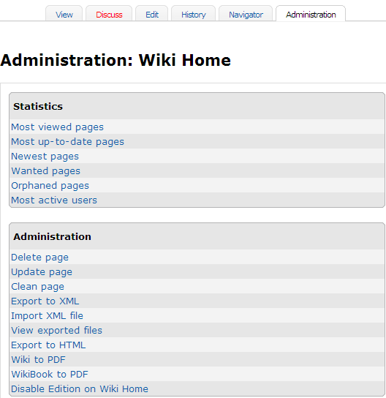

To understand more about public wikis and how they can be used in the classroom, investigate the following resources:

- Wiki Wisdom: Lessons for Educators, Education Week's Digital Directions*
- Wikiwhileyouwork.wikispaces.com* shares a presentation on wikis and how to use them.
- WikiMatrix* provides a very detailed matrix to compare features of wikis.

Edutopia highlights a blog* by Chris O'Neal in which wiki use in the classroom is addressed. Similarly, you might want to read another blog entry*, Blocking and Filtering and Lockdowns, Oh, My!: The Internet-Security Overreaction.

back to top
[Page Name: S2: P2: Create an Online Spreadsheet]
[Page Name to Show in Course Menu: Create Online Spreadsheet]
[Previous & Next Link: Both Previous and Next]

[Block: Content, no Border]
[Supertitle:] Facilitation Guide
[Title:] Section 2: Preparing for the Course
[Subtitle:] How to Create an Online Collaborative Spreadsheet

In Modules 2 and 3, participants edit an online spreadsheet to gain experience in working with an online collaborative Web site. You will need to have this online collaborative spreadsheet set up and participants identified before conducting the activities. Use the following instructions:

- Review Web-based Collaborative Learning [insert link: http://download.intel.com/education/Common/en/Resources/EO/Resources/resources.htm#Collab_Web] in the Resources tab > Collaboration link.

- Register for a site.
- Record the URL, login, and password of the online collaborative Web site on the new Login Information document and add the link to the My Links section on your Home tab.
- Create a separate spreadsheet for each module activity—either directly in the online environment or by using the sample spreadsheets below and uploading them to the online collaborative Web site. Note: On some collaborative Web sites, you access or insert special elements, such as tables, from a separate tab or link on the main editing window.
- Module 2, Activity 2, Step 1: CFQ Practice
Use the CFQ Practice Template [link to spreadsheet— http://download.intel.com/education/common/en/resources/EO/facilitation_resources/CFQ_Practice_Template.xls - open in new window] (XLS: 1 page) as a guide.
- Module 3, Activity 6, Step 2: Using Web 2.0 Tools
Use the Using Web 2.0 Spreadsheet [link to spreadsheet— http://download.intel.com/education/common/en/resources/EO/facilitation_resources/Using_The_Web_2.0_Spreadsheet.xls] (XLS: 2 pages) as a guide. Resize columns as needed.
- If you want to group participants by their grade levels, create three spreadsheets:

  - Rename the first spreadsheet Elementary.
  - Create a second spreadsheet and name it Middle School.
  - Create a third spreadsheet and name it High School.
  - Copy the tables from each sample worksheet and paste them into the Elementary worksheet. Repeat for the Middle and High School worksheets.
  - Resize columns as needed.
  - At the beginning of the activity, have participants identify their grade levels. Assign a specific spreadsheet and row to each participant. This will reduce the possibility of participants overwriting content when they edit the spreadsheet simultaneously.
- If you are not planning to create spreadsheets for grade levels, you may want to enter the names of all your participants on the spreadsheet to identify the row for their information. The alternative is to assign a specific row to each participant.
Note: If you choose to enter the names of all your participants, you will need to return to the spreadsheet after you have identified your participants.

back to top
[Page Name: S2: P2: Tag/Bookmark Site]
[Page Name to Show in Course Menu: Tag/Bookmark Site]
[Previous & Next Link: Previous Page Only]

[Block: Content, no Border]
[Supertitle:] Facilitation Guide
[Title:] Section2: Preparing for the Course
[Subtitle:] How to Select a Tag/Bookmark Site

You will need to have a tagging/bookmarking site identified before conducting Module 1: Teaching with Projects with your participants. Use the following instructions to identify the tagging/bookmarking site your participants will use:

- Review and choose a Web site for your participants' use from the Online Tagging and Bookmarking Sites [Link to - http://download.intel.com/education/common/en/resources/eo/resources/resources.htm#TagandBook] in the Resources tab > Collaboration link.

Note: Diigo* [link to site www.diigo.com– open in new browser window] is a recommended site due to its set of features; however, you can choose any of the sites provided on the list or one of your own choosing.
- Check the lab where your training will be held to be sure you can access the site and use the bookmarking features.
- If you choose the same tagging/bookmarking site that you are using in your MT candidate course, skip to step 5 unless you would like additional practice in creating and using bookmarks/tags.
- If you choose a new site, register and practice using the site so you can demonstrate how to bookmark and tag Web sites during Module 1: Teaching with Projects.
        - Register for an account.
Note: Notice whether you have to activate the account by responding to an e-mail. If you do, be prepared to help participants register for an account during the activity.
        - Review any how-to resources of the bookmarking/tagging Web site.
        - Bookmark or tag the Designing Effective Projects Web site on project-based learning. [insert link to http://educate.intel.com/en/ProjectDesign/Design/]
        - Use any additional features, such as highlighting, sticky notes, sorting by clouds, and so on.
        - Access and sort your favorites in various ways.
        - Share your favorites with someone else.
  - Record the URL, login, and password of the tagging site on the new Login Information document and add the link to the My Links section on your Home tab.

back to top

[Page Name: S3: Online Manage Features]
[Page Name to Show in Course Menu: S3: Online Manage Features]
[Previous & Next Link: Next Page Only]

[Block: Content, no Border]
[Supertitle:] Facilitation Guide
[Title:] Section 3: Using the Online Manage Features
[Subtitle:] Overview

This section is your technical help guide for the online management features found under the Facilitation tab, including directions for:

- Using the communication tools to post announcements, send messages, and hold office hour chats
- Reviewing surveys, inviting/unenrolling participants, setting up your schedule, preparing modules, and certifying participants
- Helping participants set up and use the Sharing tab for discussions during the Pair and Share and Portfolio Showcase activities
- Conducting informal discussions in the Teacher’s Lounge

Note: The Pedagogical Practices discussions conducted in the Course Wiki have the prompts and instructions preloaded. Other assigned discussions are conducted in the course blog (see Create a Blog [insert link] section of this guide).

This section includes information for the following features under the Facilitation tab:

- Manage Training [insert link to S3: p1]
- Post Announcements [insert link to S3:P2]
- Invite/Unenroll Participants [insert link to S3:P3]
- Set Up Schedule [insert link to S3:P4]
- Set Up Chat [insert link to S3:P5]
- Show/Hide Modules [insert link to S3:P6]
- Create a Discussion [insert link to S3: P7]
- Review Surveys [insert link to S3:P8]
- Certify Participants [insert link to S3:P9]

back to top
[Page Name: S3: P1: Manage Training]
[Page Name to Show in Course Menu: P1: Manage Training]
[Previous & Next Link: Both Previous and Next]

[Block: Content, no Border]
[Supertitle:] Facilitation Guide
[Title:] Section 3: Online Manage Features
[Subtitle:] Part 1: Manage Training

Each module in the course has a Task List that will help you prepare for and facilitate the module. You have already reviewed the Prepare for Course task list. Now take some time to review the task lists for each of the modules.

- Click the Facilitation tab.

- Click Facilitation tab > Manage Training [insert link – to manage training]. Notice all the Task Lists for your training are listed in the left navigation pane (see below).

[insert image: manage_managemodules.gif]

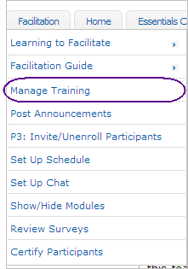

- Click the Task List of the section you want to manage. [insert image: manage_tasklist.gif]

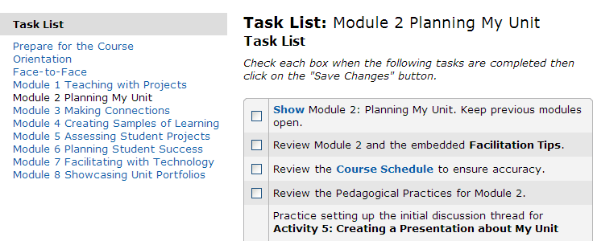

- Review the tasks listed for each section. Check each box when a task is completed.

- If a task name is shown as a hyperlink, click the link to access the management feature (such as Post an Announcement) or document directly.

Note: Not all tasks have hyperlinks.

- Click Save.

- All Task Lists [link to spreadsheet— http://download.intel.com/education/common/en/resources/EO/facilitation_resources/task_list.xls] (XlS: 11 worksheets) can also be downloaded from the Facilitation Guide > Section 7: Accessing Facilitation Resources.

back to top
[Page Name: S3: P2: Post Announcements]
[Page Name to Show in Course Menu: P2: Post Announcements]
[Previous & Next Link: Both Previous and Next]

[Block: Content, no Border]
[Supertitle:] Facilitation Guide
[Title:] Section 3: Online Manage Features
[Subtitle:] Part 2: How to Post Announcements

Announcements appear on the Home tab. They serve as an efficient way to regularly communicate with course participants as a group. Sample Announcements are embedded in the Task Lists and can be modified as needed. You should always first compose announcements in a word processing application that has a spell check feature to ensure that your announcements are error free. This method also allows you to save announcements for reference and future use. Announcements are primarily used to welcome participants to new modules, provide course schedule reminders, and help keep participants on track.

Click Previous announcements to view a record of past announcements. The most recent announcement appears on your Home tab.

[insert image: manage_announcementpage.gif]

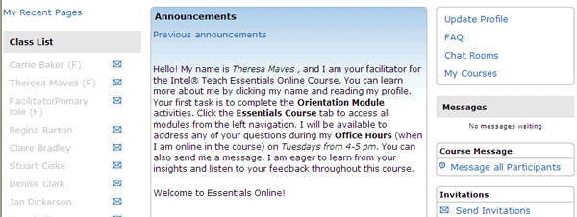

- To create an announcement, click the Facilitation tab then choose Post Announcements. [insert link – new window]

[insert image: manage_postannouncements.gif]

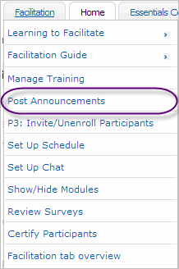

- Click Add new announcement.

[insert image: manage_addnewannouncement.gif]


- Give your announcement a title in the Subject field.

- Type your announcement in the Message field.

Note: For optimal results, format all text in course communication using Verdana font, size 10.

[insert image: manage_newdiscussiontopic.gif]
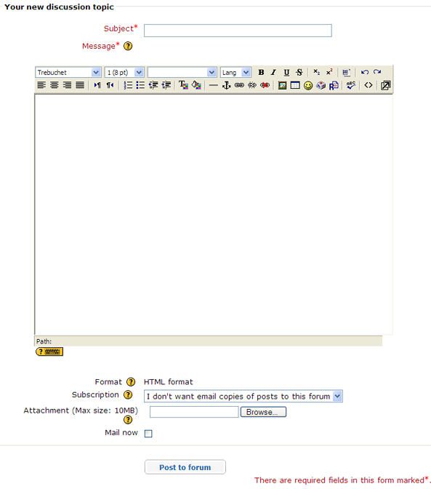

- To attach a document, click Browse, locate the file you want to upload, and then click OK.

Note: You may only upload one file per announcement. If multiple files are needed, compress the files into a single ZIP file before uploading. Directions for compressing files can be found in the Intel® Education Help Guide.
##Operating Environment 2.6#OE_2.6##: To compress a file or folder

- Select Mail now, if you want to e-mail the new announcement immediately to all course participants. If you do not select Mail now, the announcement will automatically be e-mailed to all participants within 36 hours if they have not entered their course.

Note: You have one hour to modify an announcement after you post it. After one hour, it cannot be edited. To change it, you must delete the announcement and create a new one.

- When you are finished, click Post to Forum.

back to top
[Page Name: S3: P3: Invite/Unenroll Participants]
[Page Name to Show in Course Menu: P3: Invite/Unenroll Participants]
[Previous & Next Link: Both Previous and Next]

[Block: Content, no Border]
[Supertitle:] Facilitation Guide
[Title:] Section 3: Online Manage Features
[Subtitle:] Part 3: How to Invite and Unenroll Participants

Review the two sets of directions below to learn how to Invite Participants [insert link] or Unenroll Participants [insert link].

Invite Participants
Use this feature to invite participants who were not enrolled in the course during the course set up. You can invite new participants to the course from the Home tab. Click the Send Invitations link to access this feature.

[insert image: manage_inviteusers.gif]
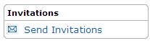
You can enter users one at a time, or you can upload a CSV file.

To enter new users one at a time:

- Obtain e-mail addresses from your participants.
- Click Send Invitations from the course Home tab.
- Enter one e-mail address per line.
- When you finish entering new participants’ e-mail addresses, click Send Invitations.

[insert image: manage_sendinvitation.gif]

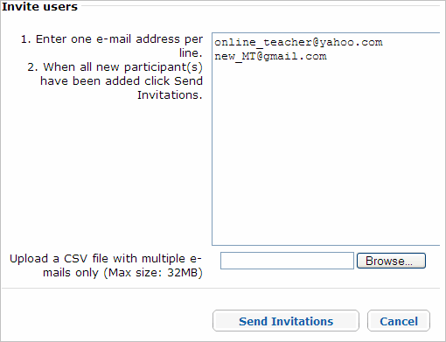

To enter multiple new users at one time:

- Obtain e-mail addresses from your participants.
- Enter one e-mail address per cell in a spreadsheet.
- Save as a CSV file.
  - To save as a CSV file, select File, and then click Save As.
  - In the File Type drop-down menu, select CSV.
- Click Send Invitations on the course Home tab.
- Click the Browse button and locate your CSV file.
- Select your CSV file.
- Click Send Invitations.

After you send your invitations, a confirmation window states that your invitations were sent. Click Continue or Back to Home to return to the course Home tab.

[insert image: manage_invitationresult.gif]

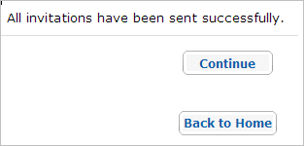

Participants will receive the following invitation. They need to follow the directions prompted in the e-mail to register for the course.

[insert image sample_invitation.gif]
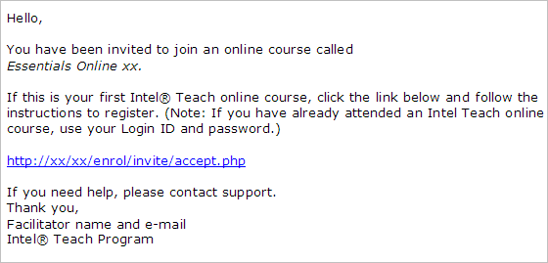

The participant goes to the site and registers for the course.

[insert image: manage_register.gif]

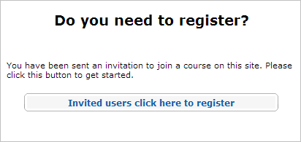

The participant fills out all of the fields to create an account.

[insert image: manage_createaccount.gif]

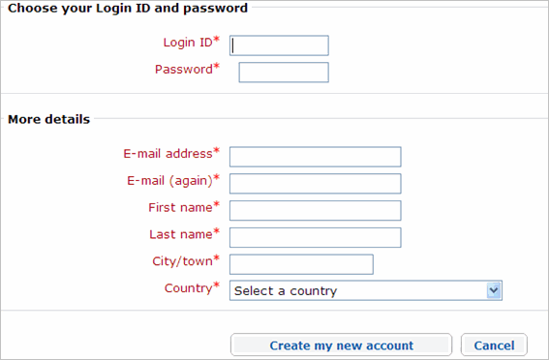

The participant receives a message to confirm registration.

[insert image: manage_confirmregistration.gif]

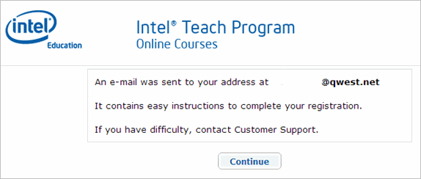

The participant must click the verification links in the e-mail message before logging on. Once verified, the participant can then enroll in the course.

[insert image: manage_enrollincourse.gif]

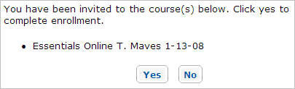

insert image: manage_enrollincourse2.gif]
After clicking Yes to enroll in the course, a confirmation window appears.

Note: As the facilitator, you receive an e-mail when a participant accepts the invitation.

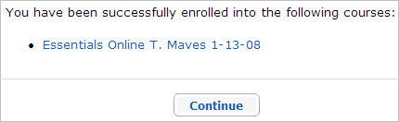
Participants can enter the course in two ways after receiving the confirmation message. They can click the course name to go to the course, or they can click Continue to go to the Home tab, which lists all registered courses. Once a participant enters a course, the participant’s name appears in the Class List.

The participant is assigned the default role for the course. This can be verified by clicking the participant’s name and checking the role assigned in the profile.

[insert image: manage_role.gif]

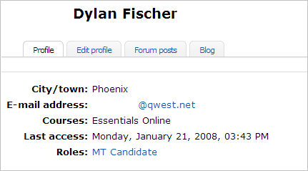

back to top

Unenroll Participants [insert target]
To unenroll a participant, click the participant’s name in the Class List on the Home tab.

[insert image: manage_unenrollusers.gif]


Click the Unenroll… link at the bottom of the page.
[insert image: manage_unenrolllink.gif]

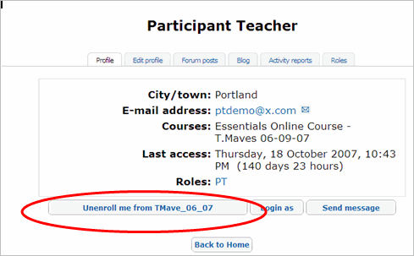

A new window appears and asks you to verify that you want to unenroll the participant. Once a participant is unenrolled, all data associated with the participant is deleted and can not be restored. Confirm the request to unenroll a participant only if you are sure of this action.

back to top
[Page Name: S3: P4: Set Up Schedule]
[Page Name to Show in Course Menu: P4: Set Up Schedule]
[Previous & Next Link: Both Previous and Next]

[Block: Content, no Border]
[Supertitle:] Facilitation Guide
[Title:] Section 3: Online Manage Features
[Subtitle:] Part 4: How to Use the Set Up Schedule

The course schedule informs participants when key events and activities occur in the course as well as when specific assignments or postings are due. The course schedule appears on the Home tab, under Announcements. If a participant enters the course environment on a day when an activity is due, the activity is emphasized in bold.

[insert image: manage_activitylist.gif]

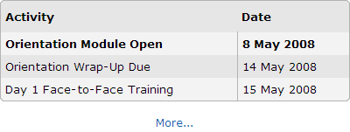

Prior to setting up the course schedule, review the embedded spreadsheets found in the Sample Course Schedules [insert link to http://download.intel.com/education/common/en/resources/EO/facilitation_resources/Sample_Course_Schedules.doc– open in new window] (doc; 1 page with 3 embedded XLS files). Choose a schedule and then determine any potential changes you need to make to the schedule, such as noting holidays or school closures.

The Set Up Schedule feature pre-populates all the required course activities and allows you to customize dates and activities for your course. View Set Up Schedule [link to demo - http://download.intel.com/education/common/en/resources/eo/facilitation_resources/Set_Up_Schedule /Set_Up_Schedule.htm] demonstration.

To set up the course schedule:

- Click the Facilitation tab and select Set Up Schedule.[insert link]
[insert image: manage_setupschedule.gif]
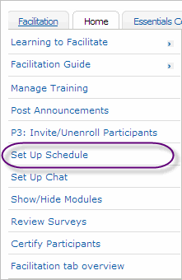

- Time Zone: On the drop-down menu, select the time zone for your training. Use the table below to find your time zone. The default time is GMT -5 or Eastern Standard Time.
Zone | City or Area Zone Crosses
GMT-12 | Eniwetok
GMT-11 | Samoa
GMT-10 | Hawaii
GMT-9 | Alaska
GMT-8 | PST, Pacific US
GMT-7 | MST, Mountain US
GMT-6 | CST, Central US
GMT-5 | EST, Eastern US
GMT-4 | Atlantic, Canada
GMT-3 | Brazil, Buenos Aries
GMT-2 | Mid-Atlantic
GMT-1 | Cape Verdes
GMT | Greenwich Mean Time, Dublin
GMT+1 | Berlin, Rome
GMT+2 | Israel, Cairo
GMT+3 | Moscow, Kuwait
GMT+4 | Abu Dhabi, Muscat
GMT+5 | Islamabad, Karachi
GMT+6 | Almaty, Dhaka
GMT+7 | Bangkok, Jakarta
GMT+8 | Hong Kong, Beijing
GMT+9 | Tokyo, Osaka
GMT+10 | Sydney, Melbourne, Guam
GMT+11 | Magadan, Soloman Is.
GMT+12 | Fiji, Wellington, Auckland

Note: The time zones above do not take into account daylight savings.

Click Set Time Zone to update the schedule to your time zone.
[insert image: manage_timezone.gif]

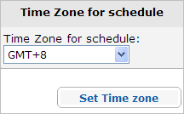
The time zone you choose appears on the Home tab of your course.

- Change Activity: To change an activity name or delete an activity, click the Edit Button.

[insert image: manage_editicon.gif]
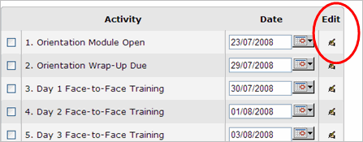
- Click the Edit Icon to modify the name of an activity or to delete the activity.
- When done modifying the activity name or deleting an activity, click Submit at the bottom of the page to save the changes.

- Use Suggest Dates to automatically assign dates for each activity based on the start date you choose for the course.

- Use the calendar on the right to select a start date for the beginning of your course. Start with Day 1 of the Orientation.
- Click Suggest Dates. The dates for each activity on the left will be automatically populated based on the timing of the Recommended Course Schedule CSV spreadsheet found in Sample Course Schedules [insert link to download server document – open in new window http://download.intel.com/education/common/en/resources/EO/facilitation_resources/Sample_Course_Schedules.doc] (DOC; 1 page with 3 embedded XLS files; 3 pages).

[insert image: manage_suggest_dates.gif]
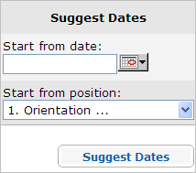
- After dates are submitted, verify that the dates appear for the correct activities and in the correct order.
- Determine any potential schedule changes. If you need to change the date of a specific activity (such as adjusting for an upcoming holiday), click the calendar and choose the new date on which you would like the activity to start. Choose the activity name from the drop-down menu and then select suggest dates. All other dates following the activity will be adjusted to maintain the proper timing of the recommended schedule.

Note: You can also change the date of just one activity by clicking the calendar in the schedule next to the activity.

- When you are ready and the dates have been verified, click Submit, and the course schedule will be updated.

- Use the Add button below the schedule to add a new activity, such as office hours, or to upload a new schedule. To add a new activity:
- Click Add at the bottom of the Set Up Schedule page.
- Provide a title for the activity.
- Determine a start date. Use the calendar feature for assistance in selecting dates.
- Click Submit to add the activity. The new date will appear on the course schedule.
[insert image: manage_add_activities.gif]
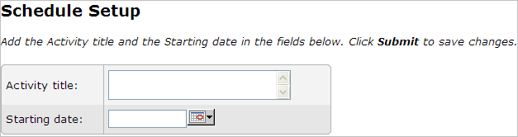
6. To specify customized dates and timing for all activities, delete all default activities and then upload your customized CSV file:

- Click Select all at the bottom of the Set Up Schedule page.
- Click Delete selected.
[insert image: manage_delete_activities.gif]

- Click Add at the bottom of the page.
- Use the Browse button to search for a previously created CSV file.
    - You can find a CSV file for the Recommended Course Schedule in the Sample Course Schedules [insert link to download server document – open in new window http://download.intel.com/education/common/en/resources/EO/facilitation_resources/sample_course_schedules] (doc; 1 page with 3 embedded XLS files). Use the sample CSV to modify multiple dates or create your own CSV from scratch.

Note: You must use the same column headings found in the sample CSV if you create your own CSV file.

- Select the file.
- Click Submit at the bottom of the page to save changes. The new dates will appear on the course schedule.

Practice implementing a few dates on the pre-loaded Course Schedule.

back to top
[Page Name: S3: P5: Set Up Chat]
[Page Name to Show in Course Menu: P5: Set Up Chat]
[Previous & Next Link: Both Previous and Next]

[Block: Content, no Border]
[Supertitle:] Facilitation Guide
[Title:] Section 3: Online Manage Features
[Subtitle:] Part 5: How to Set Up Chat

The Chat feature is for facilitators to hold office hours where multiple participants can engage in a synchronized discussion. As the facilitator, you need to publish the chat office hours, including the date and time, and inform participants through course announcements or messages.

The chat feature is always available. To access it, click on the course Home tab and select Chat Rooms.[insert link – to Chat Rooms Page] Five chat rooms are available. The first one is dedicated to the facilitator’s office hours, and the remaining four rooms are for participant use. Add the topic and select the Enter button.

A participant can join a chat by simply entering a chat session.

[insert image: manage_chatrooms.gif]
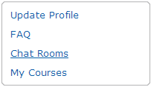

Once announced, the facilitator must keep the chat open as published to participants, even if no participants are in the chat. Some participants may join later.

back to top

[Page Name: S3: P6: Show/hide Modules]
[Page Name to Show in Course Menu: P6: Show/Hide Modules]
[Previous & Next Link: Both Previous and Next]
[Block: Content, no Border]

[Supertitle:] Facilitation Guide
[Title:] Section 3: Online Manage Features
[Subtitle:] Part 6: How to Show and Hide Modules

To keep participants together through the course, only the current and completed modules should be open at a time. The discussions and activities are centered on the fact that participants will collaborate and that they process the information from each module together.

During the Orientation, the facilitator opens all modules so participants can glimpse what the course is about. After the Orientation, the facilitator should close all the modules except the one that is currently the focus. In addition, the facilitator should keep previous modules open so participants can refer to them if needed.

Note: When a module is closed, it is also unavailable to the facilitator. You will have to temporarily open a module in order to prepare and then close it when finished.

[insert image show-hide_module.gif]

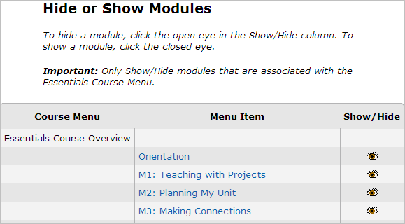

[Page Name: S3: P7: Create Discussions]
[Page Name to Show in Course Menu: P7: Create Discussions]
[Previous & Next Link: Both Previous and Next]

[Block: Content, no Border]
[Supertitle:] Facilitation Guide
[[Title:] Section 3: Online Manage Features
[Subtitle:] Part 7: How to Create a Discussion

Discussions are activities in the course where participants exchange ideas and give feedback. Each discussion topic is initiated by a specific activity, prompt, or question. A discussion consists of individual posts, or written replies, and can include attachments.

Online interactions in this course take place in several different places:
- Pedagogical Practices discussions in the Course Wiki
- Individual and group reflections in the Course Blog
- Pair and Share and Portfolio Showcase feedback in the Sharing Tab
- Additional discussion topics in the Lounge Tab

This section provides instructions for setting up discussions in the Sharing tab and the Lounge tab. You can find information for setting up the Course Blog [insert link] and Course Wiki [insert link] discussions in Section 2: Preparing for the Course.

Using the Lounge Tab
You, as a facilitator, and participants may add discussions to the Teachers’ Lounge in the Lounge tab or reply to a discussion already posted. To add a new discussion topic, follow the instructions below.

- To begin, click the Lounge tab to access the Teachers’ Lounge.
[insert image: manage_add_discussion.gif]

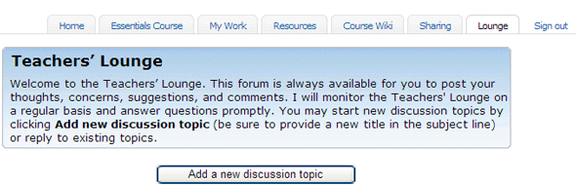
- Click Add a new discussion topic

- Designate a subject and write a prompt to engage others in a discussion.

- Use the editing toolbar to upload pictures or files and link to Web sites.
[insert image: manage_newdiscussiontopic.gif]

- To attach a document, click Browse, locate the file you want to upload, and then click OK.

Note: You may only upload one file per discussion post. If multiple files are needed, compress the files into a single ZIP file before uploading. Directions for compressing files can be found in the Intel® Education Help Guide.
##Operating Environment 2.6#OE_2.6##: To compress a file or folder

- Click Post to forum.

To respond to a post:

- Click the Discussion title.
- Click Reply on the post you want to respond to (the post must be open before you can respond).
- Type your message, and click Post to forum.

Note: After posting, you have one hour to edit your post before it becomes permanent.

back to top

Using the Sharing Tab
The Sharing tab is used during the Pair and Share and Portfolio Showcase activities. Participants post Unit Portfolios, share ideas, and give and receive feedback using the discussion feature. You need to be familiar with how to set up the initial sharing thread to help guide participants through the process.

- Practice setting up the initial discussion thread using the directions provided in the Module 2 Sharing document [insert link - http://download.intel.com/education/common/en/resources/EO/resources/About_this_course/Module_2_Sharing.doc] (DOC; 3 pages). After you finish practicing, delete your practice discussion thread from your training course.

Note: After posting, you have one hour to delete your post before it becomes permanent.

- Review the detailed Directions for Sharing [insert link to Sharing tab] provided for each Pair and Share activity.

[insert image: Sharing_tab.gif]
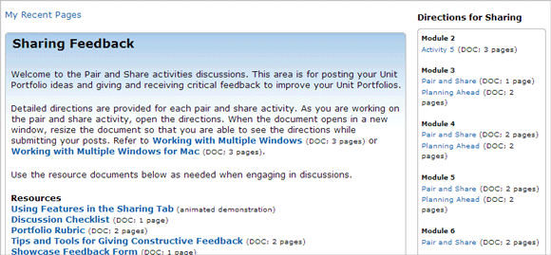

- As participants work on the activity, they are directed to open the directions and resize the document so they are able to see the directions while submitting posts. Review the Working with Multiple Windows [insert link to http://download.intel.com/education/common/en/resources/eo/resources/about_this_course/Working_with_Multiple_Windows.doc] (DOC; 3 pages) or Working with Multiple Windows for Mac [insert link to http://download.intel.com/education/common/en/resources/eo/resources/about_this_course/Working_with_Multiple_Windows_Mac.doc] (DOC; 3 pages) so that you can guide participants through this skill.

back to top
[Page Name: S3: P8: Review Surveys]
[Page Name to Show in Course Menu: P8: Review Surveys]
[Previous & Next Link: Both Previous and Next]

[Block: Content, no Border]
[Supertitle:] Facilitation Guide
[Title:] Section 3: Online Manage Features
[Subtitle:] Part 8: How to Review Surveys

The Review Surveys feature shows summaries of the Course Orientation Survey, End of Module Surveys, and End of Training Survey:

- For the Orientation Survey and End of Module Surveys, a summary lists the Average Score per question, Number of responses per question, and Open text responses with individual participant comments. The facilitator is able to view individual responses.
- The summary for the End of Training Survey provides aggregate responses representing class results. The facilitator is not able to view individual responses.

To review survey results:

- Click the Facilitation tab.
- Click Review Surveys [insert link – to review surveys page] to show class results.
- To review results by module, select the desired module from the drop-down menu. The resulting table represents the average data for all participants.
[insert image: review_surveys2.gif]

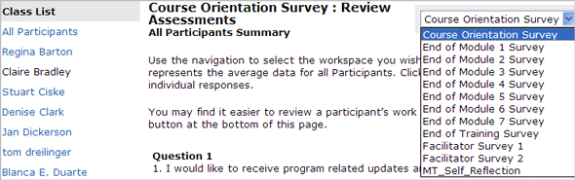

- Click a participant’s name to view individual responses.
- Download results by clicking Download CSV. To view downloaded results, open Microsoft Excel*, open the downloaded CSV file, adjust formatting if necessary, and then save the spreadsheet.
- The last survey contains an evaluation on you as a facilitator. You are able to see the aggregated results for this survey but not the individual responses. Be sure to inform you participants of this fact so they can feel free to deliver honest and candid feedback.
[Page Name: S3: P9: Certify Participants]
[Page Name to Show in Course Menu: P9: Certify Participants]
[Previous & Next Link: Previous Page Only]

[Block: Content, no Border]
[Supertitle:] Facilitation Guide
[Title:] Section 3: Online Manage Features
[Subtitle:] Part 9: How to Certify Participants

Participant certification is dependent on meeting all course requirements. After participants successfully complete the Intel® Teach Essentials Online Course and achieve certification, you need to contact them via e-mail to notify them of their certifications and dates certified. Complete a Certificate of Completion for each participant teacher and attach it to the message. You also need to e-mail any participant who will not be certified and, when possible, suggest alternative training dates. Additionally, you need to report certification to your Lea/ITA.

To certify participants who have met all course requirements:

- Go to the Facilitation tab > Certify Participants [insert link: to Certify Participants].
- Check the box next to the name of the participant(s) to be certified.
- When completed, click Submit. The table will populate with the Date Certified information.
- Click Notify Participants, to open a message window with the following pre-populated message:
Congratulations. You have completed the course successfully. You will receive your certification from your facilitator.
- You can customize the message if desired. Click Send message when finished.
- The table will populate with the Date Notified information.

[insert image: certify_participants.gif]

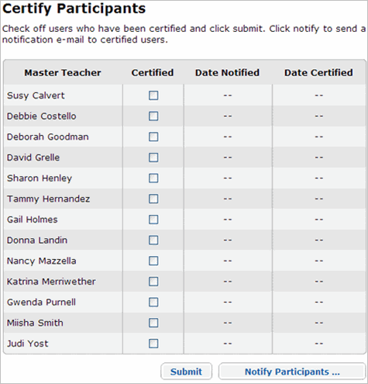

- Add the date certified and the name of each certified participant to a Certificate of Completion [insert link to http://download.intel.com/education/common/en/resources/EO/facilitation_resources/PT_Certificate_of_Completion.PDF - open in new window] (PDF; 1 page) found in the Facilitation Guide > Section 7: Accessing Facilitation Resources. Attach the certificates to participants in individual e-mails.

[Page Name: S4: Conducting the Online Orientation]
[Page Name to Show in Course Menu: S4: Conducting the Orientation]
[Previous & Next Link: Next Page Only]

[Block: Content, no Border]
[Supertitle:] Facilitation Guide
[Title:] Section 4: Conducting the Online Orientation
[Subtitle:] Overview

[Block: Facilitator Corner]
[Block Title: leave blank]
[Minutes: leave blank]
[Display Picture: NO]

A successful start to any training sets a tone and creates an atmosphere in which participants feel they can grow professionally and take risks. This is especially true in an online environment. The Orientation involves approximately two hours of online prework that is completed one week before the face-to-face training. The Orientation prepares participants to get the most from the course.

Note: You may choose to conduct the Orientation during the first day of the face-to-face training. However, you need to add two to three hours to the agenda.

[Block: Content, no Border]
Conducting the Online Orientation consists of two parts:

Part 1: Managing Orientation guides facilitators in managing the prework that participants are required to complete before the face-to-face training.

Part 2: Reviewing My Work describes the My Work tab from a facilitator’s perspective.

[Page Name: S4: P1: Managing Orientation]
[Page Name to Show in Course Menu: P1: Manage Orientation]
[Previous & Next Link: Previous Page Only]

[Block: Content, no Border]
[Supertitle:] Facilitation Guide
[Title:] Section 4: Conducting the Online Orientation
[Subtitle:] Part 1: Managing Orientation

[Block: Facilitator Corner]
[Block Title: leave blank]
[Minutes: leave blank]
[Display Picture: NO]

Many participants approach an online course with a certain amount of trepidation and anxiety. Some will need frequent support and reassurance as they progress through the Orientation. As the facilitator, you must provide leadership by communicating and being prepared to build a community of learners.

[Block: Content, no Border]
The following is a high-level overview of items to consider as you manage the Orientation:
  - Complete all tasks on the Orientation Task List [link to Facilitation Tab >Manage Training] in the Facilitation tab > Manage Training section. This task list is also available for download in the Facilitation Guide > Section 7: Accessing Facilitation Resources. [insert anchor]
  - If desired, use a tracking document to help visualize the progress of your participants. Review the Tracking Progress [link to spreadsheet - http://download.intel.com/education/common/en/resources/EO/facilitation_resources/tracking_progress.xls] (xls; 2 pages) spreadsheet and adapt it for your own needs.
  - Visit the Teachers’ Lounge often and respond to new ideas or suggestions.
  - Post an announcement or send a message encouraging participants to use the FAQs on the Home tab.
  - Ask participants to review the unit ideas posted on the course blog to see if there are any colleagues they might wish to collaborate with when creating the Unit Portfolio for the course.
Note: As an option, you could create an online collaborative document or spreadsheet to share this information with participants during the face-to-face.

[Page Name: S4: P2: Investigating the My Work Tab]
[Page Name to Show in Course Menu: P2: Investigate the My Work Tab]
[Previous & Next Link: Previous Page Only]

[Block: Content, no Border]
[Supertitle:] Facilitation Guide
[Title:] Section 4: Conducting the Online Orientation
[Subtitle:] Part 2: Investigating the My Work Tab

[Block: Content, no Border]
In this step, you investigate how the My Work tab helps you monitor your Participant Teachers as they progress through the course.

The My Work tab allows the facilitator to review work and progress submitted by participants. For this activity, first review the available features and then follow your facilitator’s demonstration for how each of these features works once participant work has been submitted.
If you try to view the My Work tab before your participants have submitted work, the page will display No submissions found instead of letting you view the relevant content on the page. If this happens, you can find a link to a document that displays the relevant content in a Facilitation Tip on the My Work landing page.

Review the following features of the My Work tab:

Note: Instead of reading about the features, view the following animated demonstrations if you prefer:

Reviewing Participants’ Course Progress [link to demo - http://download.intel.com/education/common/en/resources/EO/facilitation_resources/Course_Progress/ Course_Progress.htm - open in new window]

Reviewing Participants’ Work [link to demo - http://download.intel.com/education/common/en/resources/EO/facilitation_resources/Participants_Work/Participants_Work.htm- open in a new window

- Course Progress Participants are asked to complete a course progress checklist for each module indicating the specific activities they have completed. The facilitator can view the whole group’s progress or each participant’s progress individually to see how the participants are progressing through the course.

[image: review_course_progress.gif]
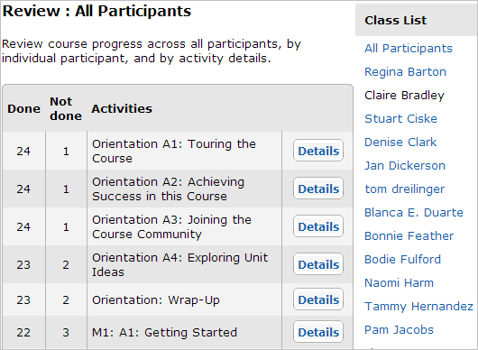

The facilitator can send congratulation messages to participants who have finished or gentle reminder messages to participants who are still working. (See Sample Progress Messages [insert link http://download.intel.com/education/common/en/resources/EO/facilitation_resources/sample_Progress_Messages.doc - open in new window] (DOC; 6 pages) for ideas)

[image: contact_participants.gif]

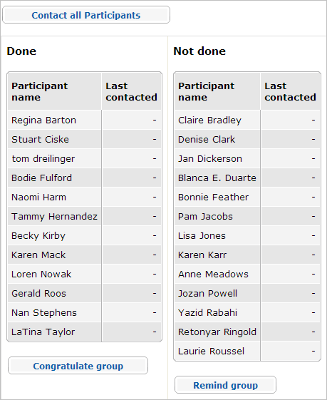

Facilitators can also choose the Unit Plan Checklist from the My Work > Course Progress section to see what participants have finished. Facilitators may send congratulation and reminder messages to ensure participants are using the checklist to monitor the progress of their Unit Plans.

- Self-Assessments: Participants are asked to reflect on their practices periodically throughout the course. The two main self-assessments are:

- Current Assessment Practices
- Facilitation Self-Assessment

The facilitator can view participants’ self-assessments and provide feedback to further instruct or encourage participants. The facilitator can also view each self-assessment as a whole group to gain a big picture of where the whole group may need help.

- Portfolio Rubric: Each participant uses a rubric to help guide Unit Portfolio development and to ensure that the course objectives are attained. The facilitator can view either group or individual responses to the rubric to gain an understanding of how participants are thinking about their work.

- Notebook: An online notebook is provided for each participant to document notes throughout the course. If desired, the facilitator can view each participant’s notebook. The notebooks can give the facilitator a fairly accurate view of a participant’s higher-order thinking throughout the course. Delivering feedback on notebook entries is not an option, but reviewing the notebooks can be very insightful and provide valuable anecdotal evidence on the impact of the course.

If desired, review your participant’s first notebook entry in the Orientation: Reviewing Unit Plans activity before beginning the face-to-face portion of the course.
[Page Name: S5: Conducting the Face-to-Face Training]
[Page Name to Show in Course Menu: S5: Conducting the Face-to-Face Training]
[Previous & Next Link: Next Page Only]

[Block: Content, no Border]
[Supertitle:] Facilitation Guide
[Title:] Section 5: Conducting the Face-to-Face Training
[Subtitle:] Overview

[Block: Facilitator Corner]
[Block Title: leave blank]
[Minutes: leave blank]
[Display Picture: NO]

The key outcome of the face-to-face training is a confident and excited group of teachers who feel prepared and comfortable with their colleagues to continue their learning online together. For many participants, this will be their first online course and the unknown often creates insecurities among participants. Your job is to help everyone feel confident and excited for the online portion and to make sure all participants have acquired the skills necessary to complete the rest of the course online.

Section 5: Conducting the Face-to-Face Training contains two parts:

Part 1: Preparing for the Face-to-Face Training outlines the necessary preparations for the beginning of the training.

Part 2: Delivering the Face-to-Face Training offers tips and reminders to consider as you progress through the face-to-face portion of the training.

[Page Name: S5: P1: Prepare for F2F]
[Page Name to Show in Course Menu: P1: Prepare for F2F]
[Previous & Next Link: Both Previous and Next]

[Block: Content, no Border]
[Supertitle:] Facilitation Guide
[Title:] Section 5: Conducting the Face-to-Face Training
[Subtitle:] Part 1: Preparing for the Face-to-Face Training

[Block: Facilitator Corner]
[Block Title: leave blank]
[Minutes: leave blank]
[Display Picture: NO]

Nothing is more important than careful preparation for the course—with every detail in place, you can relax and enjoy learning together with your PTs. Several logistical details need to be completed to ensure a well-organized face-to-face training and smooth transition to the online portion of your course.

[Block: Content, no Border]

Review the Manage Training > Face to Face Task list [link] also located in the Facilitation Guide > Section 7: Accessing Facilitation Resources.

The following tips can help ensure a more successful face-to-face training:

- If possible, schedule the blog reflection just before a break. Some participants may take longer to navigate to the blog and create a personal space than others.
- Review the Working with Multiple Windows documents - one for Windows[link http://download.intel.com/education/common/en/resources/eo/resources/about_this_course/Using_Multiple_Windows.doc] (DOC; 3 pages) and one for Mac[link http://download.intel.com/education/common/en/resources/eo/resources/about_this_course/Using_Multiple_Windows_Mac.doc] (DOC; 3 pages)
- Practice working with multiple windows open, including the course presentation. Use the Alt+Tab key combination to toggle between the windows. Practice talking through your navigation steps out loud (for example, “I click Module 1, and the navigation opens the entire module.”) so that you will be able to model the steps for Participant Teachers.
- Review the Intel® Education Help Guide [link to – Help Guide - open in new window] on Creating a Portfolio Folder.
##Intel Teach Courses Skill 2.1#EC_2.1##: To create the course folder and subfolders
- Practice setting up the initial discussion thread in the Sharing tab.
- Complete the Task Lists for Modules 1 through 3 in the online environment in the Facilitation tab> Manage Training [link to Manage Training]
- Adapt the PT Presentation [link to http://download.intel.com/education/common/en/resources/EO/facilitation_resources/PT_Presentation.ppt] (PPT; 34 slides) and PT Agenda [link to http://download.intel.com/education/common/en/resources/EO/facilitation_resources/PT_agenda.xls - open in a new window] (XLS; 3 worksheets) to fit your training.

back to top
[Page Name: S5: P2: Deliver F2F]
[Page Name to Show in Course Menu: P2: Deliver F2F]
[Previous & Next Link: Previous Page only]

[Block: Content, no Border]
[Supertitle:] Facilitation Guide
[Title:] Section 5: Conducting the Face-to-Face Training
[Subtitle:] Part 2: Delivering the Face-to-Face Training

[Block: Facilitator Corner]
[Block Title: leave blank]
[Minutes: leave blank]
[Display Picture: NO]

As you prepare for the face-to-face portion of the course, keep in mind what you have learned about your students from their participation in the Orientation. You may have to address some participants’ anxieties about online learning. You may also need to set expectations for the kind of critical and creative thinking that will help participants have a productive learning experience, both face-to-face and online.

[Block: Content, no Border]

Use the following reminders as you complete the components of the face-to-face training:

  - Provide feedback to participants on all discussions and work shared during the face-to-face training.
  - Demonstrate to participants the kind of information in the profiles such as, message history and course statistics. Review the Profile Animated Demonstration [link to demo - http://download.intel.com/education/common/en/resources/EO/facilitation_resources/Profile_Information/Profile_Information.dhtm] for ideas.
  - Review the Teachers’ Lounge, Sharing tab, and participant’s personal blogs to identify and respond to participant concerns, suggestions, and comments.
  - Create a blog entry in the course blog with a summary of each module completed during the face-to-face training.
  - Check with your participants to make sure that they received the system-generated e-mail from the online collaborative Web site prior to Module 2. Most sites require users to register before they can collaborate on a document.
  - When you complete each module, post an announcement in the online course environment. Sample announcements are embedded on the Task Lists under the Facilitation tab > Manage Training [insert link to manage training].
  - Have a contingency plan in case access to the Internet is disrupted. Print the Alternative Offline Activities [link to doc - http://download.intel.com/education/common/en/resources/EO/facilitation_resources/alternative_offline_activities.doc] (DOC; 3 pages) document.
  - Before the face-to-face ends:
    - Review with participants Tips for Success [link to file - http://download.intel.com/education/common/en/resources/eo/resources/about_this_course/EO_P2_Tips_for_success.doc - new browser window open in a new window] (DOC; 4 pages) for information that will help them succeed in this course. For future reference, this document can be found in the Resources tab > About This Course link.
    - Make sure all participants can log on to the Assessing Projects application.
    - Emphasize to participants that they must self-manage their time in Essentials Online within the recommended facilitated time frame.
  - Encourage participants to complete the modules over several sessions in a week rather than in one sitting. This allows for more reflection on the activities. Remind participants that this also allows for richer discussions.
  - Remind participants to use the Course Progress Checklist in the My Work tab to manage their work during each module.

back to top
[Page Name: S6: Conducting the Online Training]
[Page Name to Show in Course Menu: S6: Conducting the Online Training]
[Previous & Next Link: Next Page Only]

[Block: Content, no Border]
[Supertitle:] Facilitation Guide
[Title:] Section 6: Conducting the Online Training
[Subtitle:] Overview

[Block: Facilitator Corner]
[Block Title: leave blank]
[Minutes: leave blank]
[Display Picture: NO]

After the first activity in Module 3, the course is delivered only through the online environment. You will not meet again face-to-face with your Participant Teachers. After participants leave the face-to-face training, they still need to feel that they are part of a learning community. Effective facilitation of the online modules will inspire participants to continue through each activity in the online course. As an option, you may plan a face-to-face debriefing session at the end of the course.

Conducting the Online Training consists of three parts:

Part 1: Managing Modules 3 through 8 provides a high level overview of managing the online portion of the course.

Part 2: Facilitating Module Communication provides guidance on managing online communication.

Part 3: Closing the Course provides instructions for certifying participants.

[Page Name: S6: P1: Prepare Online]
[Page Name to Show in Course Menu: P1: Manage Modules 3 though 8]
[Previous & Next Link: Both Previous and Next]

[Block: Content, no Border]
[Supertitle:] Facilitation Guide
[Title:] Section 6: Conducting the Online Training
[Subtitle:] Part 1: Managing Modules 3 through 8

[Block: Facilitator Corner]
[Block Title: leave blank]
[Minutes: leave blank]
[Display Picture: NO]

A smooth transition to the online portion of the course builds participants’ confidence and prepares them for a positive experience. Review all online course features to ensure that everything is ready for participants to work successfully in the online environment.

[Block: Content, no Border]

Managing the Online Modules
Review the following list and note key areas to address when managing modules:

  - Complete all Task Lists [insert link] for each module under the Facilitation tab > Manage Training link.
  - Review Survey [insert link] results at the conclusion of module activities and prior to the start of the next module, as outlined in the course schedule and agenda.
  - The survey results are a great indicator of Participant Teacher progress and success. From the results, you might find that a Participant Teacher is struggling or may need additional support and encouragement. You also might find that a Participant Teacher must drop the course or complete it at a later date.
Note: Contact the ITA if you find that a Participant Teacher is in danger of not completing the course.
- Create a blog entry summarizing any interesting comments, suggestions, discussion topics, or key learnings and enter them on the course blog at the end of each module.
back to top
[Page Name: S6: P2: Facilitate Communication]
[Page Name to Show in Course Menu: P2: Facilitate Communication]
[Previous & Next Link: Both Previous and Next]

[Block: Content, no Border]
[Supertitle:] Facilitation Guide
[Title:] Section 6: Conducting the Online Training
[Subtitle:] Part 2: Facilitating Module Communication

[Block: Facilitator Corner]
[Block Title: leave blank]
[Minutes: leave blank]
[Display Picture: NO]

Facilitating communication throughout the course is one the most important jobs you have as a facilitator in an online environment. Participants must rely on your regular support and know that you are reviewing their work. They need to know that you will be available to answer questions and to assist with unit planning.

[Block: Content, no Border]
Follow the facilitator expectations regarding module communications:

- Check e-mail and course messages often and respond appropriately
- Convey a friendly, positive tone in your responses
- Clarify misconceptions
- Post announcements in a timely manner
- Engage often in the course discussions
- Check the Teachers’ Lounge periodically
- Hold regular office hours in the chat rooms
- Create entries with comments, observations, and summaries to the course blog
- Provide feedback on participant work in the Sharing tab

The facilitator needs to guide discussions to keep them focused and relevant to the prompt. Encourage participants to review the Guidelines for Online Interactions [link to file - http://download.intel.com/education/common/en/resources/eo/resources/about_this_course/Guidelines_for_Online_Interactions.doc - new browser window] (DOC; 2 pages)

You may need to manage reluctant or absent Participant Teachers. Modify and send a message with the sample text provided in Sample Progress Messages [link to doc - http://download.intel.com/education/common/en/resources/EO/facilitation_resources/Sample_Progress_Messages.doc open in a new window] (DOC; 6 pages).

During your course, you participated in several activities addressing the concept of what makes a good facilitator. Periodically throughout your participant training, refer to your notes from the Learning to Facilitate [link to page] activities and apply what you learned to your participant training.

[Page Name: S6: P3: Close Course]
[Page Name to Show in Course Menu: P3: Close Course]
[Previous & Next Link: Previous Page Only]

[Block: Content, no Border]
[Supertitle:] Facilitation Guide
[Title:] Section 6: Conducting the Online Training
[Subtitle:] Part 3: Closing the Course

[Block: Facilitator Corner]
[Block Title: leave blank]
[Minutes: leave blank]
[Display Picture: NO]

Congratulations! You have completed your facilitation training. You should feel great satisfaction in helping your colleagues develop new skills and deeper appreciation for student learning with technology. In this activity, you complete some final steps — certifying PT course completion and closing your course.

Thank you for your dedication to teacher professional development in technology integration.

[Block: Content, no Border]
Guidelines for closing the course are as follows:

  - Send a Closing the Course message located in the Manage Training > Module 8 Task List.[insert link]
  - Certify Participant Teachers who have completed the course and met all the required criteria using the Certify Participants [link] function under the Facilitation tab.
- Complete a Certificate of Completion [link to pdf - http://download.intel.com/education/common/en/resources/EO/facilitation_resources/PT_Certificate_of_completion.pdf] (PDF; 1 page) found in the Facilitation Guide > Section 7: Accessing Facilitation Resources for each certified Participant Teacher. Download the certificate, add their name, the date, save, and attach in an email to each participant.
- Notify participants who did not complete requirements.
  - Submit a class roster with the Participant Teachers’ completion status to the LEA/ITA.
- Close the course and view a summary of the course evaluations. Take note of key learnings you can apply to your next training.

[Page Name: S7: Facilitation Resources]
[Page Name to Show in Course Menu: S7: Facilitation Resources]
[Previous & Next Link: No Links]

Block: Content, no Border]
[Supertitle:] Facilitation Guide
[Title:] Section 7: Accessing Facilitation Resources
[Subtitle:] Overview

[Block: Facilitator Corner]
[Block Title: leave blank]
[Minutes: leave blank]
[Display Picture: NO]

The files in the following table are resources you need to successfully facilitate this training. These resources are referenced and linked throughout the Facilitation Guide. Download these files so that you will be prepared to facilitate the course. Each file can be downloaded separately or all files may be downloaded as a group using the ZIP file.

[Block: Content, no Border]
Type- insert image | Resource
Facilitation Guide (A PDF of the Facilitation Guide with all resources listed in the Facilitation Guide section of this chart)
http://download.intel.com/education/common/en/resources/EO/facilitation_resources/Facilitation.zip
 | Facilitation Guide only (A PDF of the Facilitation Guide without the resources) http://download.intel.com/education/common/en/resources/EO/facilitation_resources/Facilitation_Guide.pdf
Learning to Facilitate (A PDF of the Learning to Facilitate activities with all resources listed in the Learning to Facilitate section of this chart)
http://download.intel.com/education/common/en/resources/EO/facilitation_resources/Learning_to_Facilitate.zip
 | Individual Resource Files for Facilitation Guide
Alternative_Offline_Activities
http://download.intel.com/education/common/en/resources/EO/facilitation_resources/Alternative_Offline_Activities.doc
Animated_Demonstrations
http://download.intel.com/education/common/en/resources/EO/facilitation_resources/animated_demonstrations.doc
Blog_Prompts
http://download.intel.com/education/common/en/resources/EO/facilitation_resources/Blog_Prompts.doc
CFQ_Practice_Template
http://download.intel.com/education/common/en/resources/EO/facilitation_resources/CFQ_Practice_Template.xls
Co-facilitation_Strategies
http://download.intel.com/education/common/en/resources/EO/facilitation_resources/Co-facilitation_Strategies.doc
Computer Lab Checklist
http://download.intel.com/education/common/en/resources/EO/facilitation_resources/Computer_Lab_Checklist.doc
Course Overview
http://download.intel.com/education/common/en/resources/EO/facilitation_resources/Course_Overview.ppt
Decision_Guide
http://download.intel.com/education/common/en/resources/EO/facilitation_resources/decision_guide.pdf
Face-to-Face vs. Online Course
http://download.intel.com/education/common/en/resources/EO/facilitation_resources/F2F_vs_Online_Course.xls
Face-to-Face Checklist
http://download.intel.com/education/common/en/resources/EO/facilitation_resources/Face-to-Face_Checklist.doc
Facilitator_Blogging_Tutorial
http://download.intel.com/education/common/en/resources/EO/facilitation_resources/ facilitator_blogging_tutorial.doc
Guidelines for Online Interactions
http://download.intel.com/education/common/en/resources/eo/resources/about_this_course/Guidelines_for_Online_Interactions.doc
Intel Teach Essentials Online Course Overview
http://download.intel.com/education/common/en/resources/eo/resources/about_this_course/EO_P2_Course_Overview.doc
Introductory_E-Mails
http://download.intel.com/education/common/en/resources/EO/facilitation_resources/Introductory_E-mails
MT_Milestones
http://download.intel.com/education/common/en/resources/EO/facilitation_resources/MT_Milestones.doc
Name Tent
http://download.intel.com/education/common/en/resources/EO/facilitation_resources/Name_Tent.doc
Orientation_Messages
http://download.intel.com/education/common/en/resources/EO/facilitation_resources/Orientation_Messages.doc
Participant Teacher Registration
http://download.intel.com/education/common/en/resources/EO/facilitation_resources/ Participant_Teacher_Registration.doc
PT_Agenda
http://download.intel.com/education/common/en/resources/EO/facilitation_resources/PT_Agenda.xls
PT_Certificate_of_Completion
http://download.intel.com/education/common/en/resources/EO/facilitation_resources/PT_Certificate_of_Completion.PDF
PT_Presentation
http://download.intel.com/education/common/en/resources/EO/facilitation_resources/PT_Presentation.ppt
Sample_Course_Schedules (contains 3 embedded XLS files)
http://download.intel.com/education/common/en/resources/EO/facilitation_resources/Sample_Course_Schedules.xls
Sample_Progress_Messages
http://download.intel.com/education/common/en/resources/EO/facilitation_resources/sample_Progress_Messages.doc
Task_Lists
http://download.intel.com/education/common/en/resources/EO/facilitation_resources/task_List.xls
Tracking_Progress
http://download.intel.com/education/common/en/resources/EO/facilitation_resources/Tracking_Progress.xls
Using_the_Web_2.0_spreadsheet
http://download.intel.com/education/common/en/resources/EO/facilitation_resources/Using_the_Web_2.0_Spreadsheet.xls
 | Learning to Facilitate Resources
Constructive_Feedback
http://download.intel.com/education/common/en/resources/EO/facilitation_resources/Constructive_Feedback.doc
Learning_to_Facilitate_Notebook in Microsoft Word*
http://download.intel.com/education/common/en/resources/EO/facilitation_resources/LearningtoFacilitate.doc
Learning_to_Facilitate_Notebook in PDF
http://download.intel.com/education/common/en/resources/EO/facilitation_resources/LearningtoFacilitate.pdf
Sample_Student_support_posts
http://download.intel.com/education/common/en/resources/EO/facilitation_resources/Sample_Student_support_posts.doc
Student_support_career_choices
http://download.intel.com/education/common/en/resources/EO/facilitation_resources/Student_support_career_choices.doc
Student_support_country_plans
http://download.intel.com/education/common/en/resources/EO/facilitation_resources/Student_support_country_plans.doc
Student_support_rubric
http://download.intel.com/education/common/en/resources/EO/facilitation_resources/Student_support_rubric.doc
 | ST Resources
Checklist_MT_Training
http://download.intel.com/education/common/en/resources/EO/facilitation_resources/Checklist_MT_Training.doc
Master_Teacher_Registration
http://download.intel.com/education/common/en/resources/EO/facilitation_resources/Master_Teacher_Registration.xls
MT_Agenda
http://download.intel.com/education/common/en/resources/EO/facilitation_resources/MT_Agenda.xls
MT_Certificate_of_Completion
http://download.intel.com/education/common/en/resources/EO/facilitation_resources/MT_Certificate_of_Completion.PDF
MT_Presentation
http://download.intel.com/education/common/en/resources/EO/facilitation_resources/MT_Presentation.ppt
ST_Intro_Letter
http://download.intel.com/education/common/en/resources/EO/facilitation_resources/ST_Intro_Letter.doc
ST_LEA_Email
http://download.intel.com/education/common/en/resources/EO/facilitation_resources/ST_LEA_Email.doc
ST_Master_Teacher_Attendance
http://download.intel.com/education/common/en/resources/EO/Facilitation_resources/ST_Master_Teacher_Attendance.doc

