Intel® Teach Elements
CD Instructions

Once you approve your course and have a final Gold version, creating a CD is easy!
- Create a CD master Folder. To track versions, consider Including the date in the folder name.
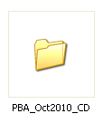

- Decide what you want on your CD.
  - Option 1: only the course
  - Option 2: course with a CD interface to launch the course or open other related files
  - Other (“bonus”) resources, such as the Intel® Education Help Guide
  - Flash player
- Create a DVD case, CD Faceplate, and Terms of Use to insert in the case
- Find templates to leverage in the File Sharing Site (Marketing Materials Tab) or the CAG Marketing Toolkit (Education tab > General > Toolkits)
- Burn the CD using any Burn software

Option 1: CD with only the course
- Copy your approved course into the Master folder. Your files should look like this.
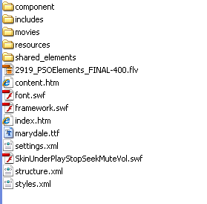

Option 2: CD with user interface
The US creates 1 CD for each Element course. On the CD we provide an offline Web page as an interface for users to launch to the course, review the syllabus, overview, FAQ, or view a Help Guide. The zip file includes the offline Web pages for each individual course. You may choose to adapt the Offline Web page for a multiple course CD.
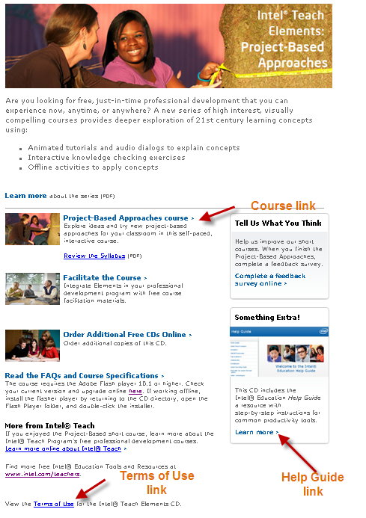
- Localize the Offline Web page in the course you are creating. We name our page StartHere.htm or another good name is Launch_Elements.htm
  - Note: you will need the CSS, content_images, and includes folder)
- Copy your local syllabus and overview pdf into the master folder
- Localize the FAQ if needed
- Create a course folder with course name (such as PBA) within the master folder and copy your approved course to this folder. Your files should look like this.
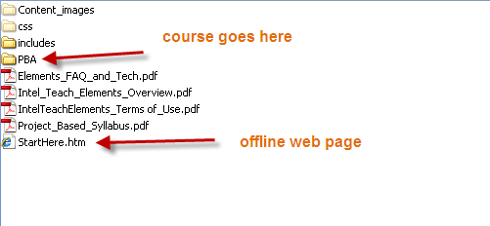
- Optional: You may also include Help Guides on your CD. To include Help Guides:
  - Localize the HelpGuide.htm and Strategies.htm
  - Copy local versions of your Help Guide in the Help Guide folder
  - We recommend also including a copy of the Terms of Use for the Help Guide. You may adapt the Corporate Terms of Use but should review with your local legal team.
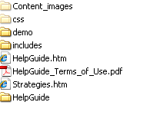

Flash Player
The course requires the Adobe Flash player 10.1 or higher. The US CD includes the flash player so users can install or upgrade if needed while working offline. To offer this you will need to apply for a license with Adobe. http://www.adobe.com/products/players/fpsh_distribution1.html

DVD Case, CD faceplate, and Terms of Use:
We recommmend also including a copy of the Terms of Use for the CD. You can place this in the master folder. You may adapt the Corporate Terms of Use but should review with your local legal team.
Download the DVD case, CD Faceplate, and Terms of Use to insert in the case from File Sharing Site under the Marketing Materials tab.

Burn CD
- You can use any CD burning software. The US uses Toast Titanium.
- If available, we recommend selecting an auto opening option. This makes the CD window open once it has been loaded into the CD player.
