Intel® Teach Program Getting Started Course
Test Script for Master Teacher Curriculum CD
v.2.0

Test Script Overview

Testing the Master Teacher (MT) Curriculum CD is a six-part process. The components to test include:
- Part 1: Testing the CD_Start page (Pages 1-2)
- Part 2: Testing the CD Index HTML page (Pages 2-3)
- Part 3: Testing the Navigation Panes (Pages 3-12)
- Part 4: Testing the PDF Documents (Pages 12-19)
- Part 5: Testing the Web Resources (Pages 20-21)
- Part 6: Testing the Using this CD page (Pages 21-22)

This document is designed to walk you through each of the items that will require testing. To help make revising and fixing the CD easier, please document your findings in the form fields in this document.

Part 1: Testing the CD_Start Page

When you insert the CD and open it, you should see a folder named: Getting_Started_CD. When you open this folder, you will see two items:
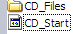

- Double-click the CD_Start.html file to open it. This is the CD homepage.

- Test the following components of this file:
- Does it open? Yes No
If no, provide details:
- Does it resemble the screenshot below? Yes No
If no, provide details:
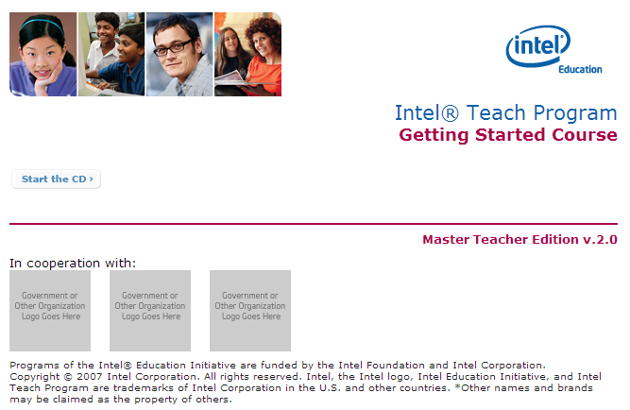

- Does it automatically resize when you click the Restore Down button of your browser window? Yes No
If no, provide details:
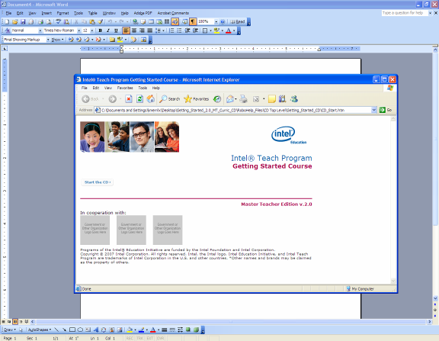

Note: After completing this test step, click the Maximize button on your browser to restore it to the full window.

Part 2: Testing the CD Index HTML Page

From the CD homepage, click the Start the CD button. Does the CD Index HTML page open in the right pane as shown on the next page?
Yes No If no, provide details:

Note: If you are testing using Internet Explorer 6.0* as your browser, you may receive a warning regarding active content. Click Yes to proceed. If the Information Bar opens near the top of the browser window, right click on it and select Allow Blocked Content. This will close the Information Bar and allow you to proceed using the CD.

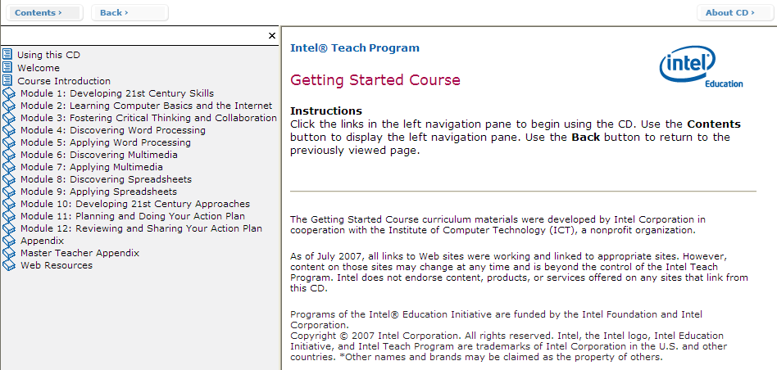

Please review the text on this page and note any edits needed.

Part 3: Testing the Navigation Panes

The left navigation pane of the CD is essentially a table of contents to the book sections. It appears on every page. The table of contents expands and contracts when the “book links” are clicked. The table of contents displays a page in the right pane when the “page links” are clicked.

The top navigation pane, which is always displayed, contains 3 buttons: Contents, Back, and About CD.

Before testing all of the left navigation pane links, first test some of the features of both the left and top navigation panes.

- To hide the left navigation pane, click the “X” located above the left navigation pane. (Note: The purpose of hiding the left navigation pane is to allow users to view contents in the right navigation pane in full screen, if needed.) Does clicking this link this hide the left navigation pane?
Yes No If no, provide details:

- To show the left navigation pane, click the Contents button located on the top navigation pane. Does clicking the Contents button display the left navigation pane?
Yes No If no, provide details:

- The Back button (located on the top navigation pane) will return you to a page you were previously viewing in the right pane. To test this, follow the steps below.
  - In the left navigation pane, click Module 1: Developing 21st Century Skills  Exercise 1 – Identifying Essential Skills.
  - The page for Module 1, Exercise 1 should now be displayed in the right pane.
  - In the top navigation pane, click the Back button.
  - Did clicking the Back button return you to the CD Index page you were previously at?
Yes No If no, provide details:

- The About CD button (located on the top navigation pane) provides general information about the CD version and copyright. Click the About CD button. Does a pop-up window display?
Yes No If no, provide details:
Click the “X” in the top right corner of the pop-up window to close it.

- To change the width of the left navigation pane, place your cursor over the bar that divides the left and right panes. Your cursor will turn to a horizontal double arrow. Click and drag the dividing bar left or right to increase or decrease the width of the left navigation pane.

- To test the left navigation pane, click each link listed in the table below. Verify that the Intended Action is correct for that link.

Link Name | Intended Action | Functioning? | Description of issue
Click Using this CD | Displays the corresponding HTML page in the right pane | Yes  No
Click Welcome | Displays the corresponding PDF in the right pane | Yes  No
Click Course Introduction | Displays the corresponding HTML page in the right pane | Yes  No
Click Module 1: Developing 21st Century Skills | Expands to show links for the module sections | Yes  No
Click Exercise 1 – Identifying Essential Skills | Displays the corresponding PDF in the right pane | Yes  No
Click Exercise 2 – Comparing Classrooms of Today with Classrooms of Tomorrow | Displays the corresponding PDF in the right pane | Yes  No
Click Exercise 3 – Introducing Yourself | Displays the corresponding PDF in the right pane | Yes  No
Click Take-Home Exercise – Reflecting on Module 1 | Displays the corresponding PDF in the right pane | Yes  No
Click Module 1 Summary | Displays the corresponding PDF in the right pane | Yes  No
Click Module 1: Developing 21st Century Skills again | Collapses all links within module | Yes  No
Click Module 2: Learning Computer Basics and the Internet | Expands to show links for the module sections | Yes  No
Click Pair and Share – Reflecting on Module 1 | Displays the corresponding PDF in the right pane | Yes  No
Click Exercise 1 – Naming the Parts and Moving the Mouse | Displays the corresponding PDF in the right pane | Yes  No
Click Exercise 2 – Working with the Operating System | Displays the corresponding PDF in the right pane | Yes  No
Click Exercise 3 – Searching the Internet | Displays the corresponding PDF in the right pane | Yes  No
Click Take-Home Exercise – Reflecting on Module 2 | Displays the corresponding PDF in the right pane | Yes  No
Click Module 2 Summary | Displays the corresponding PDF in the right pane | Yes  No
Click Module 2: Learning Computer Basics and the Internet again | Collapses all links within module | Yes  No
Click Module 3: Fostering Critical Thinking and Collaboration | Expands to show links for the module sections | Yes  No
Click Pair and Share – Reflecting on Module 2 | Displays the corresponding PDF in the right pane | Yes  No
Click Exercise 1 – Engaging in Higher-Order Thinking | Displays the corresponding PDF in the right pane | Yes  No
Click Exercise 2 – Promoting Collaboration | Displays the corresponding PDF in the right pane | Yes  No
Click Exercise 3 – Planning, Doing, Reviewing, and Sharing | Displays the corresponding PDF in the right pane | Yes  No
Click Take-Home Exercise – Reflecting on Module 3 | Displays the corresponding PDF in the right pane | Yes  No
Click Module 3 Summary | Displays the corresponding PDF in the right pane | Yes  No
Click Module 3: Fostering Critical Thinking and Collaboration again | Collapses all links within module | Yes  No
Click Module 4: Discovering Word Processing | Expands to show links for the module sections | Yes  No
Click Pair and Share – Reflecting on Module 3 | Displays the corresponding PDF in the right pane | Yes  No
Click Exercise 1 – Exploring Word Processing Software | Displays the corresponding PDF in the right pane | Yes  No
Click Exercise 2 – Discussing Word Processing Skills | Displays the corresponding PDF in the right pane | Yes  No
Click Exercise 3 – Using the Help Guide | Displays the corresponding PDF in the right pane | Yes  No
Click Exercise 4 – Identifying Word Processing Resources | Displays the corresponding PDF in the right pane | Yes  No
Click Exercise 5 – Using Word Processing Skills | Displays the corresponding PDF in the right pane | Yes  No
Click Assessment Handout | Displays the corresponding PDF in the right pane | Yes  No
Click Take-Home Exercise – Reflecting on Module 4 | Displays the corresponding PDF in the right pane | Yes  No
Click Module 4 Summary | Displays the corresponding PDF in the right pane | Yes  No
Click Module 4: Discovering Word Processing again | Collapses all links within module | Yes  No
Click Module 5: Applying Word Processing | Expands to show links for the module sections | Yes  No
Click Pair and Share – Reflecting on Module 4 | Displays the corresponding PDF in the right pane | Yes  No
Click Exercise 1 – Creating Word Processing Productivity Tools | Displays the corresponding PDF in the right pane | Yes  No
Click Weekly Lesson Planner | Displays the corresponding PDF in the right pane | Yes  No
Click Newsletter | Displays the corresponding PDF in the right pane | Yes  No
Click Diagram | Displays the corresponding PDF in the right pane | Yes  No
Click Certificate | Displays the corresponding PDF in the right pane | Yes  No
Click Exercise 2 – Being a Critical Friend | Displays the corresponding PDF in the right pane | Yes  No
Click Exercise 3 – Showcasing Word Processing Productivity Tools | Displays the corresponding PDF in the right pane | Yes  No
Click Take-Home Exercise – Reflecting on Module 5 | Displays the corresponding PDF in the right pane | Yes  No
Click Module 5 Summary | Displays the corresponding PDF in the right pane | Yes  No
Click Module 5: Applying Word Processing again | Collapses all links within module | Yes  No
Click Module 6: Discovering Multimedia | Expands to show links for the module sections | Yes  No
Click Pair and Share – Reflecting on Module 5 | Displays the corresponding PDF in the right pane | Yes  No
Click Exercise 1 – Exploring Multimedia Software | Displays the corresponding PDF in the right pane | Yes  No
Click Exercise 2 – Discussing Multimedia Skills | Displays the corresponding PDF in the right pane | Yes  No
Click Exercise 3 – Identifying Multimedia Resource | Displays the corresponding PDF in the right pane | Yes  No
Click Exercise 4 – Using Multimedia Skills | Displays the corresponding PDF in the right pane | Yes  No
Click Curriculum Preview | Displays the corresponding PDF in the right pane | Yes  No
Click Take-Home Exercise – Reflecting on Module 6 | Displays the corresponding PDF in the right pane | Yes  No
Click Module 6 Summary | Displays the corresponding PDF in the right pane | Yes  No
Click Module 6: Discovering again | Collapses all links within module | Yes  No
Click Module 7: Applying Multimedia | Expands to show links for the module sections | Yes  No
Click Pair and Share – Reflecting on Module 6 | Displays the corresponding PDF in the right pane | Yes  No
Click Exercise 1 – Creating Multimedia Productivity Tools | Displays the corresponding PDF in the right pane | Yes  No
Click Student of the Week | Displays the corresponding PDF in the right pane | Yes  No
Click Instructional Lesson | Displays the corresponding PDF in the right pane | Yes  No
Click Classroom Rules and Expectations | Displays the corresponding PDF in the right pane | Yes  No
Click Yearbook | Displays the corresponding PDF in the right pane | Yes  No
Click Exercise 2 – Showcasing Multimedia Productivity Tools | Displays the corresponding PDF in the right pane | Yes  No
Click Take-Home Exercise – Reflecting on Module 7 | Displays the corresponding PDF in the right pane | Yes  No
Click Module 7 Summary | Displays the corresponding PDF in the right pane | Yes  No
Click Module 7: Applying Multimedia again | Collapses all links within module | Yes  No
Click Module 8: Discovering Spreadsheets | Expands to show links for the module sections | Yes  No
Click Pair and Share – Reflecting on Module 7 | Displays the corresponding PDF in the right pane | Yes  No
Click Exercise 1 – Exploring Spreadsheets Software | Displays the corresponding PDF in the right pane | Yes  No
Click Exercise 2 – Discussing Spreadsheets Skills | Displays the corresponding PDF in the right pane | Yes  No
Click Exercise 3 – Identifying Spreadsheets Resources | Displays the corresponding PDF in the right pane | Yes  No
Click Exercise 4 – Using Spreadsheets Skills | Displays the corresponding PDF in the right pane | Yes  No
Click Grade Book | Displays the corresponding PDF in the right pane | Yes  No
Click Take-Home Exercise – Reflecting on Module 8 | Displays the corresponding PDF in the right pane | Yes  No
Click Module 8 Summary | Displays the corresponding PDF in the right pane | Yes  No
Click Module 8: Discovering Spreadsheets again | Collapses all links within module | Yes  No
Click Module 9: Applying Spreadsheets | Expands to show links for the module sections | Yes  No
Click Pair and Share – Reflecting on Module 8 | Displays the corresponding PDF in the right pane | Yes  No
Click Exercise 1 – Creating Spreadsheets Productivity Tools | Displays the corresponding PDF in the right pane | Yes  No
Click Classroom Inventory | Displays the corresponding PDF in the right pane | Yes  No
Click Seating Chart | Displays the corresponding PDF in the right pane | Yes  No
Click Pictograph | Displays the corresponding PDF in the right pane | Yes  No
Click Roll Book | Displays the corresponding PDF in the right pane | Yes  No
Click Exercise 2 – Showcasing Spreadsheets Productivity Tools | Displays the corresponding PDF in the right pane | Yes  No
Click Take-Home Exercise – Reflecting on Module 9 | Displays the corresponding PDF in the right pane | Yes  No
Click Module 9 Summary | Displays the corresponding PDF in the right pane | Yes  No
Click Module 9: Applying Spreadsheets again | Collapses all links within module | Yes  No
Click Module 10: Developing 21st Century Approaches | Expands to show links for the module sections | Yes  No
Click Pair and Share – Reflecting on Module 9 | Displays the corresponding PDF in the right pane | Yes  No
Click Exercise 1 – Facilitating Learning | Displays the corresponding PDF in the right pane | Yes  No
Click Exercise 2 – Accepting Change | Displays the corresponding PDF in the right pane | Yes  No
Click Exercise 3 – Promoting Key Skills | Displays the corresponding PDF in the right pane | Yes  No
Click Take-Home Exercise – Reflecting on Module 10 | Displays the corresponding PDF in the right pane | Yes  No
Click Module 10 Summary | Displays the corresponding PDF in the right pane | Yes  No
Click Module 10: Developing 21st Century Approaches again | Collapses all links within module | Yes  No
Click Module 11: Planning and Doing Your Action Plan | Expands to show links for the module sections | Yes  No
Click Pair and Share – Reflecting on Module 10 | Displays the corresponding PDF in the right pane | Yes  No
Click Exercise 1 – Understanding Action Plans | Displays the corresponding PDF in the right pane | Yes  No
Click Exercise 2 – Planning Your Action Plan | Displays the corresponding PDF in the right pane | Yes  No
Click Exercise 3 – Doing Your Action Plan | Displays the corresponding PDF in the right pane | Yes  No
Click Module 11 Summary | Displays the corresponding PDF in the right pane | Yes  No
Click Module 11: Planning and Doing Your Action Plan again | Collapses all links within module | Yes  No
Click Module 12: Reviewing and Sharing Your Action Plan | Expands to show links for the module sections | Yes  No
Click Exercise 1 – Reviewing Your Action Plan | Displays the corresponding PDF in the right pane | Yes  No
Click Exercise 2 – Sharing Your Action Plan | Displays the corresponding PDF in the right pane | Yes  No
Click Exercise 3 – Developing Collaborative Work Groups | Displays the corresponding PDF in the right pane | Yes  No
Click Exercise 4 – Concluding the Course | Displays the corresponding PDF in the right pane | Yes  No
Click Module 12 Summary | Displays the corresponding PDF in the right pane | Yes  No
Click Module 12: Reviewing and Sharing Your Action Plan again | Collapses all links within module | Yes  No
Click Appendix | Expands to show links for the appendix sections | Yes  No
Click Appendix A: Frameworks for Describing Thinking | Displays the corresponding PDF in the right pane | Yes  No
Click Appendix B: Resources | Expands to show links for the 5 sections within Appendix B | Yes  No
Click Appendix C: Index | Displays the corresponding PDF in the right pane | Yes  No
Click Appendix again | Collapses all links within appendix | Yes  No
Click Master Teacher Appendix | Expands to show links for the appendix sections | Yes  No
Click Appendix D: Course Delivery Guidelines | Displays the corresponding PDF in the right pane | Yes  No
Click Appendix E: Training Preparation Checklist | Displays the corresponding PDF in the right pane | Yes  No
Click Appendix F: Facilitating Exercises and Activities | Expands to show links for the appendix sections | Yes  No
Click Pair and Share | Displays the corresponding PDF in the right pane | Yes  No
Click Required Activities | Displays the corresponding PDF in the right pane | Yes  No
Click Word Processing | Displays the corresponding PDF in the right pane | Yes  No
Click Multimedia | Displays the corresponding PDF in the right pane | Yes  No
Click Spreadsheets | Displays the corresponding PDF in the right pane | Yes  No
Click Appendix F: Facilitating Exercises and Activities again | Collapses all links within appendix | Yes  No
Click Master Teacher Appendix again | Collapses all links within appendix | Yes  No
Click Web Resources | Expands to show links for the Web Resources section | Yes  No
Click 21st Century Skills Resources | Displays the corresponding HTML page in the right pane | Yes  No
Click Bloom’s Taxonomy of Thinking Skills Resources | Displays the corresponding HTML page in the right pane | Yes  No
Click Facilitation Skills Resources | Displays the corresponding HTML page in the right pane | Yes  No
Click Other Resources | Displays the corresponding HTML page in the right pane | Yes  No
Click Web Resources again | Collapses all links within Web Resources | Yes  No

Part 4: Testing the PDF Documents

You will be testing each PDF document for:
- Proper document viewing customization
- Proper document security

Custom Document View:
Additionally, all PDFs have been customized so they appear a certain way on the screen when loaded. These files need to be tested to ensure they are all uniform.
The files should load so no toolbars are showing, except the windows toolbar that frames the PDF. The document should be magnified to “fit width”, which will vary depending on monitor size.

Below is an example. All PDF documents should load like this:
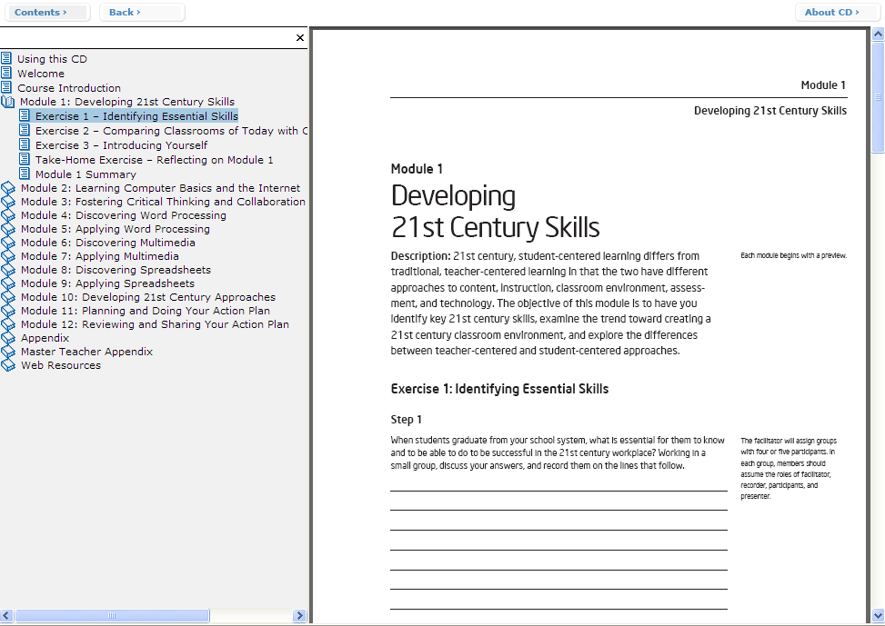

Note: In addition to testing the opening view, also be sure you check that all pages in the section appear.

Security:
All PDF documents are secured so they can be printed by the user, but not copied or edited. When you have a PDF document open, click your mouse on the PDF file, then press Ctrl-D to display the Document Properties. Review the Security tab. The setting should be as follows for each document:
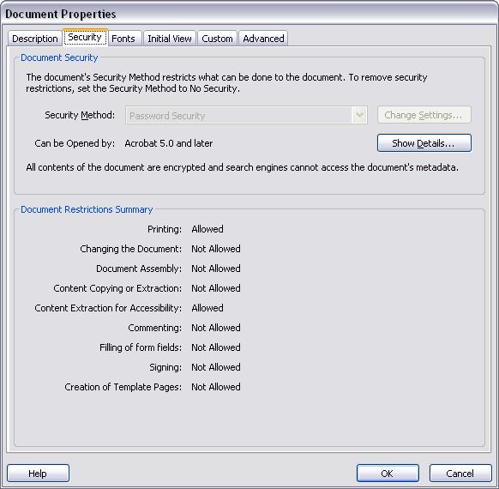

NOTE: If you are testing using Adobe Acrobat Professional*, you see additional fields included that are not present in the above screenshot. You may disregard these.

Below is a listing of the PDF files in each section of the CD. Review each file for the appropriate items, as noted below.

PDF Document | View correct | Security correct
Welcome | Yes  No  If no, describe: | Yes  No  If no, describe:
Course Introduction | Yes  No  If no, describe: | Yes  No  If no, describe:
Module 1 > Exercise 1 – Identifying Essential Skills | Yes  No  If no, describe: | Yes  No  If no, describe:
Module 1 > Exercise 2 – Comparing Classrooms of Today with Classrooms of Tomorrow | Yes  No  If no, describe: | Yes  No  If no, describe:
Module 1 > Exercise 3 – Introducing Yourself | Yes  No  If no, describe: | Yes  No  If no, describe:
Module 1 > Take-Home Exercise – Reflecting on Module 1 | Yes  No  If no, describe: | Yes  No  If no, describe:
Module 1 > Module 1 Summary | Yes  No  If no, describe: | Yes  No  If no, describe:
Module 2 > Pair and Share – Reflecting on Module 1 | Yes  No  If no, describe: | Yes  No  If no, describe:
Module 2 > Exercise 1 – Naming the Parts and Moving the Mouse | Yes  No  If no, describe: | Yes  No  If no, describe:
Module 2 > Exercise 2 – Working with the Operating System | Yes  No  If no, describe: | Yes  No  If no, describe:
Module 2 > Exercise 3 – Searching the Internet | Yes  No  If no, describe: | Yes  No  If no, describe:
Module 2 > Take-Home Exercise – Reflecting on Module 2 | Yes  No  If no, describe: | Yes  No  If no, describe:
Module 2 > Module 2 Summary | Yes  No  If no, describe: | Yes  No  If no, describe:
Module 3 > Pair and Share – Reflecting on Module 2 | Yes  No  If no, describe: | Yes  No  If no, describe:
Module 3 > Exercise 1 – Engaging in Higher-Order Thinking | Yes  No  If no, describe: | Yes  No  If no, describe:
Module 3 > Exercise 2 – Promoting Collaboration | Yes  No  If no, describe: | Yes  No  If no, describe:
Module 3 > Exercise 3 – Planning, Doing, Reviewing, and Sharing | Yes  No  If no, describe: | Yes  No  If no, describe:
Module 3 > Take-Home Exercise – Reflecting on Module 3 | Yes  No  If no, describe: | Yes  No  If no, describe:
Module 3 > Module 3 Summary | Yes  No  If no, describe: | Yes  No  If no, describe:
Module 4 > Pair and Share – Reflecting on Module 3 | Yes  No  If no, describe: | Yes  No  If no, describe:
Module 4 > Exercise 1 – Exploring Word Processing Software | Yes  No  If no, describe: | Yes  No  If no, describe:
Module 4 > Exercise 2 – Discussing Word Processing Skills | Yes  No  If no, describe: | Yes  No  If no, describe:
Module 4 > Exercise 3 – Using the Help Guide | Yes  No  If no, describe: | Yes  No  If no, describe:
Module 4 > Exercise 3 – Identifying Word Processing Resources | Yes  No  If no, describe: | Yes  No  If no, describe:
Module 4 > Exercise 4 – Using Word Processing Skills | Yes  No  If no, describe: | Yes  No  If no, describe:
Module 4 > Assessment Handout | Yes  No  If no, describe: | Yes  No  If no, describe:
Module 4 > Take-Home Exercise – Reflecting on Module 4 | Yes  No  If no, describe: | Yes  No  If no, describe:
Module 4 > Module 4 Summary | Yes  No  If no, describe: | Yes  No  If no, describe:
Module 5 > Pair and Share – Reflecting on Module 4 | Yes  No  If no, describe: | Yes  No  If no, describe:
Module 5 > Exercise 1 – Creating Word Processing Productivity Tools | Yes  No  If no, describe: | Yes  No  If no, describe:
Module > Weekly Lesson Planner | Yes  No  If no, describe: | Yes  No  If no, describe:
Module > Newsletter | Yes  No  If no, describe: | Yes  No  If no, describe:
Module > Diagram | Yes  No  If no, describe: | Yes  No  If no, describe:
Module > Certificate | Yes  No  If no, describe: | Yes  No  If no, describe:
Module 5 > Exercise 2 – Being a Critical Friend | Yes  No  If no, describe: | Yes  No  If no, describe:
Module 5 > Exercise 3 – Showcasing Word Processing Productivity Tools | Yes  No  If no, describe: | Yes  No  If no, describe:
Module 5 > Take-Home Exercise – Reflecting on Module 5 | Yes  No  If no, describe: | Yes  No  If no, describe:
Module 5 > Module 5 Summary | Yes  No  If no, describe: | Yes  No  If no, describe:
Module 6 > Pair and Share – Reflecting on Module 5 | Yes  No  If no, describe: | Yes  No  If no, describe:
Module 6 > Exercise 1 – Exploring Multimedia Software | Yes  No  If no, describe: | Yes  No  If no, describe:
Module 6 > Exercise 2 – Discussing Multimedia Skills | Yes  No  If no, describe: | Yes  No  If no, describe:
Module 6 > Exercise 3 – Identifying Multimedia Resource | Yes  No  If no, describe: | Yes  No  If no, describe:
Module 6 > Exercise 4 – Using Multimedia Skills | Yes  No  If no, describe: | Yes  No  If no, describe:
Module 6 > Curriculum Preview | Yes  No  If no, describe: | Yes  No  If no, describe:
Module 6 > Take-Home Exercise – Reflecting on Module 6 | Yes  No  If no, describe: | Yes  No  If no, describe:
Module 6 > Module 6 Summary | Yes  No  If no, describe: | Yes  No  If no, describe:
Module 7 > Pair and Share – Reflecting on Module 6 | Yes  No  If no, describe: | Yes  No  If no, describe:
Module 7 > Exercise 1 – Creating Multimedia Productivity Tools | Yes  No  If no, describe: | Yes  No  If no, describe:
Module 7 > Student of the Week | Yes  No  If no, describe: | Yes  No  If no, describe:
Module 7 > Instructional Lesson | Yes  No  If no, describe: | Yes  No  If no, describe:
Module 7 > Classroom Rules and Expectations | Yes  No  If no, describe: | Yes  No  If no, describe:
Module 7 > Yearbook | Yes  No  If no, describe: | Yes  No  If no, describe:
Module 7 > Exercise 2 – Showcasing Multimedia Productivity Tools | Yes  No  If no, describe: | Yes  No  If no, describe:
Module 7 > Take-Home Exercise – Reflecting on Module 7 | Yes  No  If no, describe: | Yes  No  If no, describe:
Module 7 > Module 7 Summary | Yes  No  If no, describe: | Yes  No  If no, describe:
Module 8 > Pair and Share – Reflecting on Module 7 | Yes  No  If no, describe: | Yes  No  If no, describe:
Module 8 > Exercise 1 – Exploring Spreadsheets Software | Yes  No  If no, describe: | Yes  No  If no, describe:
Module 8 > Exercise 2 – Discussing Spreadsheets Skills | Yes  No  If no, describe: | Yes  No  If no, describe:
Module 8 > Exercise 3 – Identifying Spreadsheets Resources | Yes  No  If no, describe: | Yes  No  If no, describe:
Module 8 > Exercise 4 – Using Spreadsheets Skills | Yes  No  If no, describe: | Yes  No  If no, describe:
Module 8 > Grade Booke | Yes  No  If no, describe: | Yes  No  If no, describe:
Module 8 > Take-Home Exercise – Reflecting on Module 8 | Yes  No  If no, describe: | Yes  No  If no, describe:
Module 8 > Module 8 Summary | Yes  No  If no, describe: | Yes  No  If no, describe:
Module 9 > Pair and Share – Reflecting on Module 8 | Yes  No  If no, describe: | Yes  No  If no, describe:
Module 9 > Exercise 1 – Creating Spreadsheets Productivity Tools | Yes  No  If no, describe: | Yes  No  If no, describe:
Module 9 > Classroom Inventory | Yes  No  If no, describe: | Yes  No  If no, describe:
Module 9 > Seating Chart | Yes  No  If no, describe: | Yes  No  If no, describe:
Module 9 > Pictograph | Yes  No  If no, describe: | Yes  No  If no, describe:
Module 9 > Roll Book | Yes  No  If no, describe: | Yes  No  If no, describe:
Module 9 > Exercise 2 – Showcasing Spreadsheets Productivity Tools | Yes  No  If no, describe: | Yes  No  If no, describe:
Module 9 > Take-Home Exercise – Reflecting on Module 9 | Yes  No  If no, describe: | Yes  No  If no, describe:
Module 9 > Module 9 Summary | Yes  No  If no, describe: | Yes  No  If no, describe:
Module 10 > Pair and Share – Reflecting on Module 9 | Yes  No  If no, describe: | Yes  No  If no, describe:
Module 10 > Exercise 1 – Facilitating Learning | Yes  No  If no, describe: | Yes  No  If no, describe:
Module 10 > Exercise 2 – Accepting Change | Yes  No  If no, describe: | Yes  No  If no, describe:
Module 10 > Exercise 3 – Promoting Key Skills | Yes  No  If no, describe: | Yes  No  If no, describe:
Module 10 > Take-Home Exercise – Reflecting on Module 10 | Yes  No  If no, describe: | Yes  No  If no, describe:
Module 10 > Module 10 Summary | Yes  No  If no, describe: | Yes  No  If no, describe:
Module 11 > Pair and Share – Reflecting on Module 10 | Yes  No  If no, describe: | Yes  No  If no, describe:
Module 11 > Exercise 1 – Understanding Action Plans | Yes  No  If no, describe: | Yes  No  If no, describe:
Module 11 > Exercise 2 – Planning Your Action Plan | Yes  No  If no, describe: | Yes  No  If no, describe:
Module 11 > Exercise 3 – Doing Your Action Plan | Yes  No  If no, describe: | Yes  No  If no, describe:
Module 11 > Module 11 Summary | Yes  No  If no, describe: | Yes  No  If no, describe:
Module 12 > Exercise 1 – Reviewing Your Action Plan | Yes  No  If no, describe: | Yes  No  If no, describe:
Module 12 > Exercise 2 – Sharing Your Action Plan | Yes  No  If no, describe: | Yes  No  If no, describe:
Module 12 > Exercise 3 – Developing Collaborative Work Groups | Yes  No  If no, describe: | Yes  No  If no, describe:
Module 12 > Exercise 4 – Concluding the Course | Yes  No  If no, describe: | Yes  No  If no, describe:
Module 12 > Module 12 Summary | Yes  No  If no, describe: | Yes  No  If no, describe:
Appendix A: Frameworks for Describing Thinking | Yes  No  If no, describe: | Yes  No  If no, describe:
Appendix B: Resources | Yes  No  If no, describe: | Yes  No  If no, describe:
Appendix C: Index | Yes  No  If no, describe: | Yes  No  If no, describe:
Appendix D: Course Delivery Guidelines | Yes  No  If no, describe: | Yes  No  If no, describe:
Appendix E: Training Preparation Checklist | Yes  No  If no, describe: | Yes  No  If no, describe:
Appendix F > Pair and Share | Yes  No  If no, describe: | Yes  No  If no, describe:
Appendix F > Required Activities | Yes  No  If no, describe: | Yes  No  If no, describe:
Appendix F > Word Processing | Yes  No  If no, describe: | Yes  No  If no, describe:
Appendix F > Multimedia | Yes  No  If no, describe: | Yes  No  If no, describe:
Appendix F > Spreadsheets | Yes  No  If no, describe: | Yes  No  If no, describe:

Part 5: Testing the Web Resources

The Web Resources pages contain links to external Web sites. Each link should open in a new browser window so students do not lose their place on the CD. Please review each page as outlined below to verify that all links are working properly.

Web Resources > 21st Century Skills Resources

URL | Opens in a new window | Correct page displayed
www.ets.org | Yes  No  If no, describe: | Yes  No  If no, describe:
www.ncrel.org/engauge/skills/engauge21st.pdf | Yes  No  If no, describe: | Yes  No  If no, describe:
www.21stcenturyskills.org/index.php?option=com_content&task=view&id=29&Itemid=42 | Yes  No  If no, describe: | Yes  No  If no, describe:

Web Resources > Bloom’s Taxonomy of Thinking Skills Resources

URL | Opens in a new window | Correct page displayed
http://coe.sdsu.edu/eet/articles/bloomrev/index.htm | Yes  No  If no, describe: | Yes  No  If no, describe:
www.stedwards.edu/cte/resources/bwheel.htm | Yes  No  If no, describe: | Yes  No  If no, describe:
www.nwlink.com/~donclark/hrd/bloom.html | Yes  No  If no, describe: | Yes  No  If no, describe:
www.teachers.ash.org.au/researchskills/dalton.htm | Yes  No  If no, describe: | Yes  No  If no, describe:

Web Resources > Facilitation Skills Resources

URL | Opens in a new window | Correct page displayed
http://cri.cps.k12.il.us/workshop_materials/classroom_observations.ppt | Yes  No  If no, describe: | Yes  No  If no, describe:
www.cdtl.nus.edu.sg/link/mar2002/tm4.htm | Yes  No  If no, describe: | Yes  No  If no, describe:
www.4teachers.org/testimony/webb/index.shtml | Yes  No  If no, describe: | Yes  No  If no, describe:
http://discovery.rp.edu.sg/home/CED/facilitators/skills.htm | Yes  No  If no, describe: | Yes  No  If no, describe:
www.youthlearn.org/learning/teaching/directions.asp | Yes  No  If no, describe: | Yes  No  If no, describe:
www.sda-uk.org/statements.html | Yes  No  If no, describe: | Yes  No  If no, describe:
www.learningpod.com/article/0,1120,5-2166,00.html | Yes  No  If no, describe: | Yes  No  If no, describe:

Web Resources > Other Resources

URL | Opens in a new window | Correct page displayed
www.ascd.org/cms/index.cfm?TheViewID=1112 | Yes  No  If no, describe: | Yes  No  If no, describe:

Part 6: Testing the Using this CD Page

The Using this CD page is designed to provide technical information and tips for using the CD. Please test this page to ensure the jump links and hyperlinks are functioning properly.

- On the left navigation pane, click Using this CD. Does the page open properly in the right pane? Yes No If no, provide details:

- The bulleted links at the top are jump links to sections further down the page. Test each of the jump links. Do they go to the corresponding sections?
Yes No If no, provide details:

- Below each of the sections is a back to top link. Test this link for each section. Does it return you to the top of the page? Yes No
If no, provide details:

- In the System Requirements section, there is a link to the Microsoft Internet Explorer Download Web site (http://www.microsoft.com/windows/ie/downloads/default.mspx). This link should open in a new browser window. Does this link function properly?
Yes No If no, provide details:

- In the System Requirements section, there is a hyperlink to Adobe’s Web site to download Acrobat Reader (http://www.adobe.com/products/acrobat/readstep2.html). This link should open in a new browser window. Does this link function properly?
Yes No If no, provide details:

- In the Customizing Your Browser Window section, there is a hyperlink to the System Requirements section. Does this link function properly?
Yes No If no, provide details:

