Education Login and Registration Translation Document

Index | Page #
Instructions | 2
Login Page | 2
Common Footer Fields | 3
Buttons | 3
Registration Page | 3
Forget Login ID Page | 6
Email Login ID Confirmation Page | 7
Forgot Password Page | 8
Email Password Confirmation Page | 9
Common Error Messages | 9
CPM Error messages | 11
Password Confirmation Email | 11
Registration Confirmation Email | 12
Forgot Login ID Confirmation Email | 13
e-Mail rules Help file | 14
Login ID Help file | 15
Password Rules Help file | 15

Instructions
Please translate and localize each of the phrases listed here in column called “English”. If the meaning would be ambiguous, feel free to substitute language that will convey the meaning more clearly. The screen shots will help you see how the phrase is used in context.

Note: Common words for all pages such as footers, buttons, Common Error messages, CPM Error messages are placed in one location to avoid repeating translation.

Login Page: Login.aspx/Login.aspx.cs
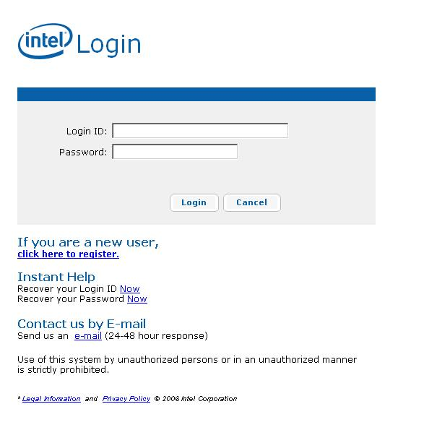
Login Page: Login.aspx/Login.aspx.cs

Control Name | Resource Key Name | English | Localization
imageLogin | imageLogin
LoginTitle | LoginTitle | Intel® Login
lblNewUser | NewUser | If you are a new user,
LoginLogoText | LoginLogoText | Login
hrefRegister | Register | click here to register.
 | RegisterLink | http://www.intel.com
lblLoginID | username | Login ID
lblPassword | password | Password
 | login | Login
 | rememberMe | Remember Me?
instanthelp | instanthelp | Instant Help
RecoverLogin | recoverlogin | Recover your Login ID
lblforgotlogin | RecoverLoginText | Now
RecoverLoginLink | RecoverLoginLink | http://www.intel.com
RecoverPwd | recoverpwd | Recover your Password
lblforgotpwd | RecoverPwdText | Now
RecoverPwdLink | RecoverPwdLink | http://www.intel.com
ContactUs | ContactUs | Contact us by E-mail
SendUs | SendUs | Send us an
EmailLink | EmailText | e-mail
ResponseText | ResponseText | (24-48 hour response)
WarningText | WarningText | Use of this system by unauthorized persons or in an unauthorized manner is strictly prohibited.

Common Footer Fields:

Control/ Variable Name | Resource Key Name | English | Localization
LeagelInfoLink | LeagelInfoText | Legal Information
 | LeagelInfoLink | http://www.intel.com/sites/corporate/tradmarx.htm
AndText | AndText | and
PrivacyPolicyLink | PrivacyPolicyText | Privacy Policy
 | PrivacyPolicyLink | http://www.intel.com/sites/corporate/privacy.htm
CopyRightText | CopyRightText | © 2006 Intel Corporation

Buttons:

Control/ Variable Name | Resource Key Name | English | Localization
btnCancel | btnCancel | Cancel
btnLogin | btnLogin | Login
btnSubmit | btnSubmit | Submit
btnRegister | btnRegister | Submit

Registration Page: Registration.aspx/ Registration.aspx.cs

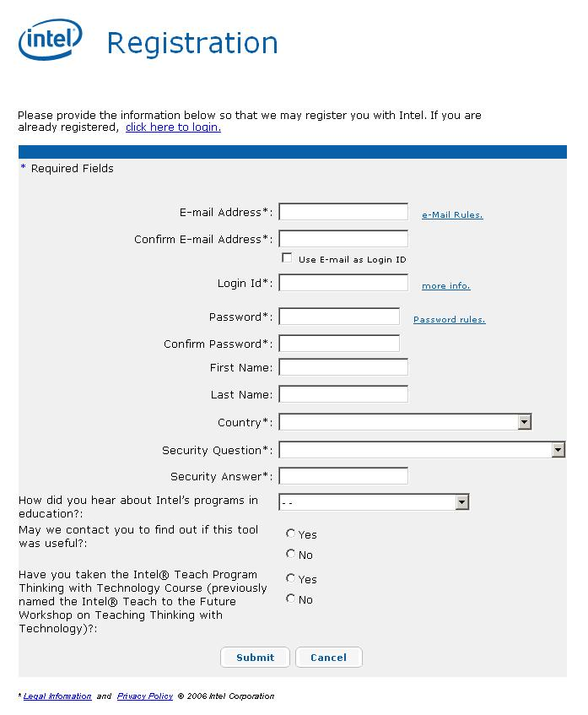

Control Name | Resource Key Name | English | Localization
RegistrationTitle | RegistrationTitle | Intel® Registration
RegistrationLogoText | RegistrationLogoText | Registration
lblrequiredtext | requiredtext | Required Fields
lbluserinfo | userinfo | Please provide the information below so that we may register you with Intel. If you are already registered,
lblregemail | regemail | E-mail Address
lblregemailconfirm | regemailconfirm | Confirm E-mail Address
lblreguseemail | reguseemail | Use E-mail as Login ID
lblregloginid | regloginid | Login Id
Localizedliteral1 | regpwd | Password
Localizedliteral5 | oldregpwd | Old Password
Localizedliteral4 | newregpwd | New Password
Localizedliteral3 | regconfirmpwd | Confirm Password
lblregsecquestion | regsecquestion | Security Question
lblregsecanswer | regsecanswer | Security Answer
lblregcountry | regcountry | Country
LocalizedFirstname | regfirstname | First Name
LocalizedLastname | reglastname | Last Name
EmailRulesLink | EmailRulesLinkText | e-Mail Rules.
EmailRulesLink | EmailRulesLink | https://ssl1.speedera.net/cache-ssl-o.intel.com/plt/reg/htmlpopups/ENG/Email_rules.htm
LoginMoreInfoLink | LoginMoreInfoLinkText | more info.
LoginMoreInfoLink | LoginMoreInfoLink | https://ssl1.speedera.net/cache-ssl-o.intel.com/plt/reg/htmlpopups/ENG/login_info.htm
PassWordRulesLink | PassWordRulesLinkText | Password rules.
PassWordRulesLink | PassWordRulesLink | https://ssl1.speedera.net/cache-ssl-o.intel.com/plt/reg/htmlpopups/ENG/password_rules_public.htm
ClickHereToLoginLink | ClickHereToLoginLinkText | click here to login.
extQuestions | CPM extended question#1 | How did you hear about Intel’s programs in education?
extQuestions | CPM extended question#1 Ans | Another web site
extQuestions | CPM extended question#1 Ans | Conference or event
extQuestions | CPM extended question#1 Ans | Direct mail
extQuestions | CPM extended question#1 Ans | Email
extQuestions | CPM extended question#1 Ans | Intel® Innovator Email newsletter
extQuestions | CPM extended question#1 Ans | Intel® Education Initiative Web site
extQuestions | CPM extended question#1 Ans | Intel representative
extQuestions | CPM extended question#1 Ans | Media or news story
extQuestions | CPM extended question#1 Ans | Professional associate
extQuestions | CPM extended question#1 Ans | Unaware of Intel programs
extQuestions | CPM extended question#1 Ans | Other
extQuestions | CPM extended question#2 | May we contact you to find out if this tool was useful?
extQuestions | CPM extended question#2 Ans | Yes
 | CPM extended question#2 Ans | No
extQuestions | CPM extended question#3 | Have you taken the Intel® Teach Program Thinking with Technology Course (previously named the Intel® Teach to the Future Workshop on Teaching Thinking with Technology)?
extQuestions | CPM extended question#3 Ans | Yes
extQuestions | CPM extended question#3 Ans | No

Forgot Login ID page: ForgotLoginId.aspx/ ForgotLoginId.aspx.cs

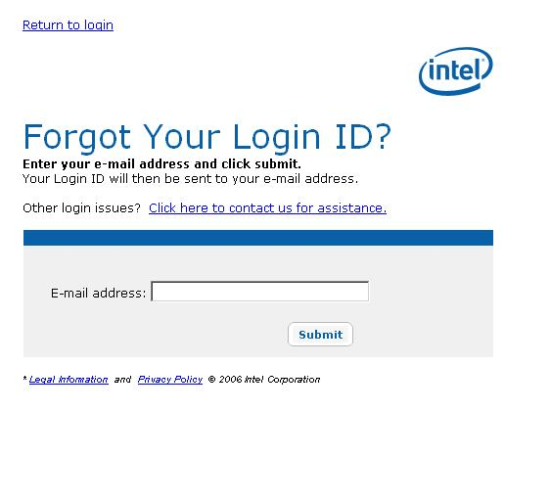
Forgot Login ID page: ForgotLoginId.aspx/ ForgotLoginId.aspx.cs

Control Name | Resource Key Name | English | Localization
ForgetLoginIdText | ForgetLoginIdText | Forgot Your Login ID?
Forgetuserinfo | Forgetuserinfo | Enter your e-mail address and click submit.
Forgetuserinfo1 | Forgetuserinfo1 | Your Login ID will then be sent to your e-mail address.
Forgetuserinfo2 | Forgetuserinfo2 | Other login issues?
ContactusAssitance | ContactusAssitanceText | Click here to contact us for assistance.
ForgotLoginId | ForgotLoginIdTitle | Forgot Your Login ID?

Email Login ID Confirmation Page: Confirm.aspx/ Confirm.aspx.cs
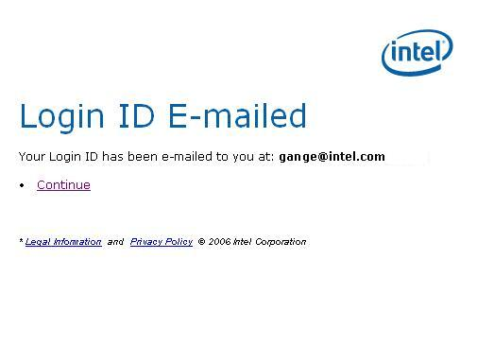
Email Login ID Confirmation Page: Confirm.aspx/ Confirm.aspx.cs

Control Name | Resource Key Name | English | Localization
lblConfirmationTitle | ConfirmationLoginIdTitle | Login ID E-mailed
lblConfirmationinfo | ConfirmationLoginIdText | Your Login ID has been e-mailed to you at
hrefConfirmation | ConfirmationLoginLinkText | Continue

Forgot Password Page : ForgotPwd.aspx/ ForgotPwd.aspx.cs

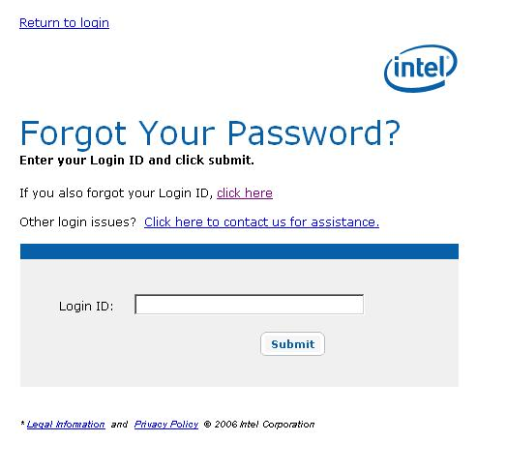
Forgot Password Page : ForgotPwd.aspx/ ForgotPwd.aspx.cs

Control Name | Resource Key Name | English | Localization
ForgotPwdTitle | ForgotPwdTitle | Forgot Your Password?
ForgetPwdText | ForgetPwdText | Forgot Your Password?
Forgetpwdinfo | Forgetpwdinfo | Enter your Login ID and click submit.
AlsoforgotLogin | AlsoforgotLogin | If you also forgot your Login ID,
ClickhereLoginLink | ClickhereLoginlinkText | click here
ReturnLoginLink | ReturnLoginLinkText | Return to login
lblregemail | forgotemail | E-mail address

Email Password Confirmation Page : Confirm.aspx/ Confirm.aspx.cs

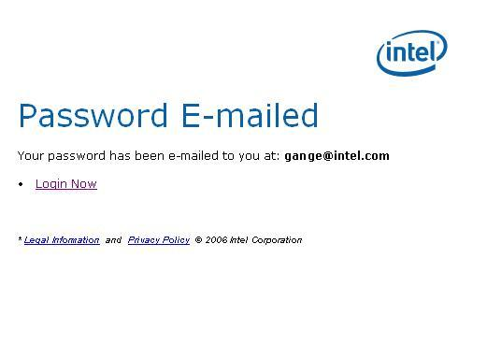
Email Password Confirmation Page: Confirm.aspx/ Confirm.aspx.cs

Control Name | Resource Key Name | English | Localization
lblConfirmationTitle | ConfirmationPasswordTitle | Password E-mailed
lblConfirmationinfo | ConfirmationPasswordText | Your password has been e-mailed to you at
hrefConfirmation | ConfirmationPwdLinkText | Login Now

Common Error Messages:

Control or Variable Name | Resource Key Name | English | Localization
vsLogin | validationheader | Please correct the following errors
rfvEmail,  reqEmailConfirm | emailrequired | Please enter an E-Mail Address
rfvUserName | loginidrequired | Please enter a LoginId
revUserName | invalidloginid | Please enter a Valid LoginId
Localizedregularexpressionvalidator1,  Localizedregularexpressionvalidator2  Localizedregularexpressionvalidator3, | invalidpassword | Please enter a Valid Password
 | ErrorValidEmail | Please enter a valid e-mail address.
lblCustomError | ErrorSendEmail | Error Sending Email, Try again later
rfvSecurity | reqsecurityquestion | Please select a Security Question
rfvAnswer | reqsecurityanswer | Please answer the Security Question
rfvLocation | reqlocation | Please select a Location
revEmail | notvalidemail | Invalid E-mail Address
valUserName | usernameRequired | Login ID required
rfvPassword,  reqPassword,  valPassword | passwordRequired | Password required
 | invalidLoginInformation | Your username/password could not be found
cvPasswords,  Localizedcomparevalidator2, | passwordmismatch | The "Password" and "Confirm Password" entries do not match. Please re-enter and confirm your password.
Localizedcomparevalidator1 | emailmismatch | The "Email" and "Confirm Email" entries do not match. Please re-enter and confirm your Email.
Label1 | loginidexist | Login identifier already in use, or may not be used.
lblCustomError | Error_BlankLoginID | Please enter your Login ID.
lblCustomError | Error_BlankEmail | Please enter an e-mail address.
lblCustomError | Error_InvalidEmail | Invalid E-mail Address
 | Error_GeneralFailure | GENERAL FAILURE ERROR
Label1 | Error_oldpassword | Either old password, new password or confirm password is blank.
Label1 | Error_formload | Unexpected error happened in loading the form.

CPM Error messages:

Control or Variable Name | Resource Key Name | English | Localization
vlLogin.ErrorMessage | CPMError_5005 | Password Expired
vlLogin.ErrorMessage | CPMError_5007 | Security Upgrade
vlLogin.ErrorMessage | CPMError_5001 | Either the Login ID or password you entered was not recognized. Please try again. If you cannot remember your password, click the "Forgot your password?" link for assistance.
vlLogin.ErrorMessage | CPMError_5003 | Your attempt to login has not been successful. Your account has been locked. Please contact Intel customer support for assistance.
vlLogin.ErrorMessage,  Label1 | CPMError_5006 | The system is currently unavailable, please try again later. We apologize for the inconvenience.
vlLogin.ErrorMessage | CPMError_5101 | The system is currently unavailable, please try again later. We apologize for the inconvenience.
vlLogin.ErrorMessage | CPMError_5301 | CPM Error Message 5301
vlLogin.ErrorMessage,  Label1 | CPMError_5205 | Failed to change password; invalid user-id or current password.
 | CPMError_default | Default message

Password Confirmation Email:

Resource Key Name | English | Localization
CharSet | iso-8859-1
EmailFromAddress | Intel-Corporation@intel.com
EmailPasswordSubject | Password Information from Intel
EmailPasswordBody | Dear Intel Customer,  Your Intel Password that you requested is: %s  If you have any questions, please contact us at: https://welcome.intel.com/password_support.aspx?Lang=eng  Thank you,  Intel Corporation  ________________________________________________________________  Please DO NOT reply to this e-mail message. This is an automated response.  You received this message because you are registered with Intel.  Visit https://ssl.intel.com/ipc-app/?Lang=ENG at any time to  manage your Intel newsletter subscriptions and profile information.  Intel is committed to user privacy in our products and services.  See our privacy policy listed below for more information.  If you believe you have received this message in error,  please contact us at: http://www.intel.com/support/index.htm  * Legal Information and Privacy Policy:  http://www.intel.com/sites/corporate/tradmarx.htm  http://www.intel.com/sites/corporate/privacy.htm  (C) 2006 Intel Corporation

Registration Confirmation Email:

Email Parameters | English | Localization
From | Intel-Corporation@intel.com
Subject | Intel® Registration Confirmation
Body | Thank you for registering with Intel.  This e-mail is to confirm your login ID and e-mail address.  Please retain this e-mail for later reference.  Login ID: !%LOGINID%!  E-mail Address: !%EMAIL%!  Now that you have registered,  you are able to enroll in a number of different programs at Intel.  Your password should be protected as confidential.  Your use of the password and Intel's websites are governed  by Intel's Terms and Conditions of Use linked from the bottom  of each respective site's webpages.  After logging in to the Teacher Workspace, you may edit your profile information by clicking on the "Edit My Sign-In Profile" link.  If you have any questions, please contact us at:  http://www.intel.com/intel/nav/support.htm  Thank you,  Intel(R) Corporation  ________________________________________________________________  Please DO NOT reply to this e-mail message. This is an automated response.  You received this message because you are registered with Intel.  Visit https://ssl.intel.com/ipc-app/?Lang=ENG  at any time to manage your Intel® newsletter subscriptions and  profile information.  Intel is committed to user privacy in our products and services.  See our privacy policy listed below for more information.  If you believe you have received this message in error,  please contact us at: http://www.intel.com/intel/nav/support.htm  * Legal Information and Privacy Policy:  http://www.intel.com/sites/corporate/tradmarx.htm  http://www.intel.com/sites/corporate/privacy.htm  © 2005 Intel Corporation

Forgot Login ID Confirmation Email:

Email Parameters | English | Localization
From | Intel-Corporation@intel.com
Subject | Login ID Information from Intel
Body | Dear Intel Customer,  Your Intel Login ID that you requested is: !%LOGINID%!  If you have any questions, please contact us at:  http://www.intel.com/support/index.htm  Thank you,  Intel(R) Corporation  ________________________________________________________________  Please DO NOT reply to this e-mail message. This is an automated  response.  You received this message because you are registered with Intel.  Visit https://ssl.intel.com/ipc-app/?Lang=ENG at any time to  manage your Intel® newsletter subscriptions and profile information.  Intel is committed to user privacy in our products and services.  See our privacy policy listed below for more information.  If you believe you have received this message in error,  please contact us at: http://www.intel.com/support/index.htm  Legal information: http://www.intel.com/sites/corporate/tradmarx.htm  Privacy Policy: http://www.intel.com/sites/corporate/privacy.htm  (C) 2006 Intel Corporation

e-Mail rules Help file :
https://ssl1.speedera.net/cache-ssl-o.intel.com/plt/reg/htmlpopups/ENG/Email_rules.htm

 | English | Localization
Page Title | e-Mail
Header | e-Mail:
Body | Enter only one e-Mail address. e-Mail must contain: One at sign (@), a minimum of one dot (.); and, no spaces.  Special Characters not allowed, include: Back Slash (\);Forward Slash (/); Comma (,); Ampersand (&); Dollar sign ($);Number sign (#); and, Parentheses (()).  If the email address provided is set-up to automatically distribute or forward e-mails to other recipients. Intel cannot be held responsible for customer privacy.
Button Text | Close Window

Login ID Help file:
https://ssl1.speedera.net/cache-ssl-o.intel.com/plt/reg/htmlpopups/ENG/login_info.htm

 | English | Localization
Page Title | Login ID
Header | Login ID:
Body | Login ID is part of the login information you provide when you register. It can be an e-mail address or a custom text you provide.  The Login ID must be entered in English, limited to 20 characters, and does not allow the following characters shown in parentheses: Comma (,); Back Slash (\);Forward Slash (/); and, Asterisk (*).
Button Text | Close Window

Password Rules Help file:
https://ssl1.speedera.net/cache-ssl-o.intel.com/plt/reg/htmlpopups/ENG/password_rules_public.htm

 | English | Localization
Page Title | Password Rules
Header | Password Rules:
Body | - The password must be at least one (1) character long.  - Not greater than fourteen (14) characters.
Button Text | Close Window

