Sample Learning Log
Below is an example of a learning log for recording data from the Unit Plan, The Great Bean Race in Designing Effective Projects.

Plant Data Log

Name:____________________________ Group Member Names:________________________________________
Date Seeds Planted:_________ Date First Growth Appeared: _________ Final Measurement Date: _________

Week 1  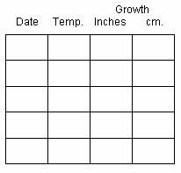 | Week 2 | Week 3

Notes:

Plant Growth Graph

2 ½ inches
2 ¼ inches
2 inches
1 ¾ inches
1 ½ inches
1 ¼ inches
1 inch
¾ inch
½ inch
¼ inch
 | Date | Date | Date | Date | Date | Date | Date | Date | Date | Date | Date | Date | Date | Date

